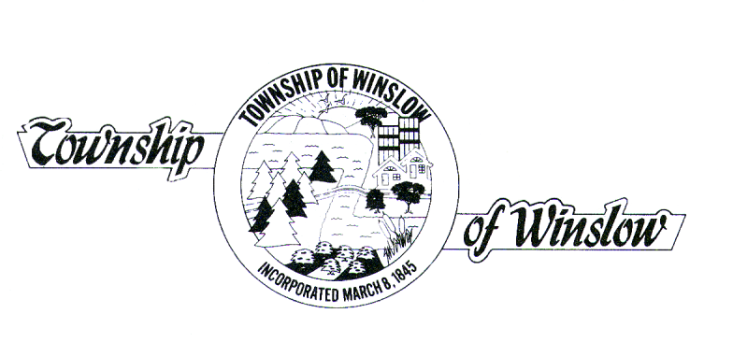
JOSEPH GALLAGHER Jr., MPA
TOWNSHIP ADMINISTRATOR

MEMORANDUM

To: Mayor and Township Committee
Stuart Platt, Esquire
Eric Riso, Esquire

From: Joseph Gallagher
Township Administrator

Subject: NovuSolutions Paperless Agenda

Date: May 10, 2012

Winslow Township is in the final stages of implementing its paperless agenda system. This system will allow users to access certain Township meetings all online. The goal is to soon have Winslow Township’s public meetings available to residents on this new site, as well as various other meetings available to the designated Committee/Board Members. The system will enable users to access not only upcoming meeting agendas but will also provide them with the ability to search past meetings and past specific agenda items as well.

The paperless agendas that will be available to board members include:
- Administrative SubCommittee
- Water and Sewer SubCommittee
- General Township Committee Meeting (including Workshop/Business, Workshop/Budget)
- Planning Board
- Zoning Board
*The agenda’s in bold/underlined are those that will be available at this time on the review site

The agenda’s that will be available to the public include:
- General Township Committee Meetings (including Workshop/Business, Workshop/Budget)
- Planning Board
- Zoning Board

Enclosed you will find the website addresses and your own Username and Password login information to access the review sites. Please familiarize yourselves with the sites so that, once fully implemented, it will be a smooth transition for all. Please protect your Username and Password as you would any other confidential information.

You will continue to receive a hard copy of the agenda while we finalize the review sites.

Thank you for your cooperation, and if you have any questions please contact my office.

JG/kb

cc: Deborah Iannaco, RMC

