Community or School Gardens

In your certification application, upload:
1. Narrative Summary of support provided from the municipal government.
2. Qualitative Assessment found in the action on our website.
3. Samples of the community or school garden program materials, assembled in one .pdf file (lesson plans, articles, flyers, etc.).

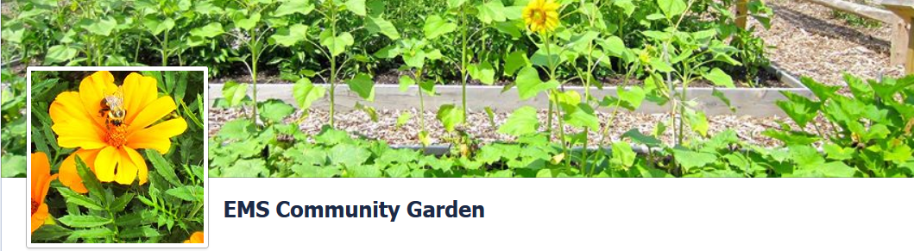
Eisenhower Middle School Community Garden - Wyckoff, NJ
The idea for the school garden project began to take form in April 2010 and was headed by Mrs. Chen, a science teacher at the school. This community – school garden was provided funding and resources for its creation from a number sources including the Town of Wyckoff through the Wyckoff BOE expenditures, non-profit organizations (City Green), and community service organizations (Boy Scouts of America, and the Rotary Club). The Wyckoff Dept of Public Works has provided composted soil for beds and wood chips for landscaping around the garden. The continuation of the garden for education of both middle school students and the greater community is ensured by the Town of Wyckoff support of the Wyckoff Board of Education program. The Eisenhower Middle School Community Garden is presently maintained by the school staff and resident volunteers.
At Eisenhower Middle School students are taken into the garden to cultivate and harvest the garden for food for home, donations to the local food bank, and even lettuce and radishes are taken for the schooI cafeteria to serve in school lunches. Several science classes and TIEE (enriched study hall) groups use the garden for instruction and practice. Using the community –school garden a curriculum has been developed that emphasizes healthy food sources for Health classes teaching nutritional. TIEE promotes independent student research in gardening using the garden.

Qualitative Assessment Template

Name of Action: Community School Gardens

In a few short sentences, please describe the action and identify your partners.

The Action was the creation of school based community garden for purposes of educating middle school students on the importance of knowing the sourcing and cultivation of agricultural crops for food sources and practical nutrition. Partners for this action included the staff and administration of Eisenhower Middle School, the Town of Wyckoff, the Wyckoff BOE, Wyckoff Environmental Commission – Green Team, non-profit organizations (City Green), commercial company donations (Wayside Fence, Seeds of Chance) community service organizations (Boy Scouts of America, and the Rotary Club) and The Wyckoff Dept. of Public Works.

Even if the action was performed by volunteers, or you got in-kind donations, please estimate your costs and the time commitment required to complete the action.

Fence $1,500 (Donations to Scouting, Student ReAct Club)
Soil, lumber, and hardware for the project $1,500 est. (School Board)
Tools and Storage Locker $500 (Wyckoff Rotary Club)
Wood chips, compost $200 est. (Wyckoff DPW)
Seeds $120 (Seeds of Change, Wyckoff Green Team – donations)
Labor to install the beds (City Green – Non-profit organization)
Total Time commitment – estimated 400 people hours

Assess what worked and what could be done if this action is tried again in the community.

Through this project a viable and self-sustaining, community-based garden demonstration site was established. This garden is providing a real life educational resource for teaching the principles of agricultural growing for producing healthy, natural nutrition sources underscoring the vital connection between the environment and human existence.

Currently all public schools in Wyckoff are undertaking garden and plant growing demonstration projects at their schools. The Community Garden at Eisenhower Middle School is serving as a model for the other elementary schools in their similar themed projects and such is accelerating their implementation in the community’s primary education system.

What are the next steps for this action?

The next area of exploration for the Town of Wyckoff Green Team resulting from the outcome of this action is the examination of creating a community garden space within the town, administered by the town, but available to all residents wishing greater availability to garden growing space. The creation of this space will promote a healthy recreational activity, that will promote the smart land use of town land, and lower negative externalities of distant commercial farming heavily reliant on intensive farming practices requiring high chemical and energy inputs.

The Wyckoff Community Garden as a means of promoting its work to the community uses a Facebook site.
https://www.facebook.com/EMSCommunityGarden
Representative pages from this site are shown below:
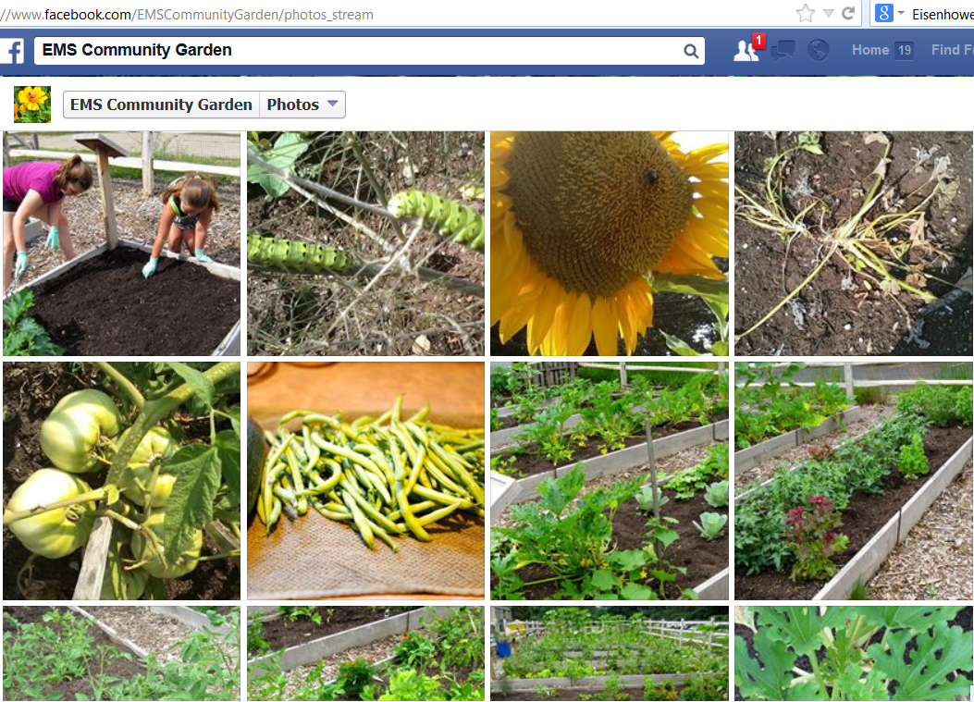

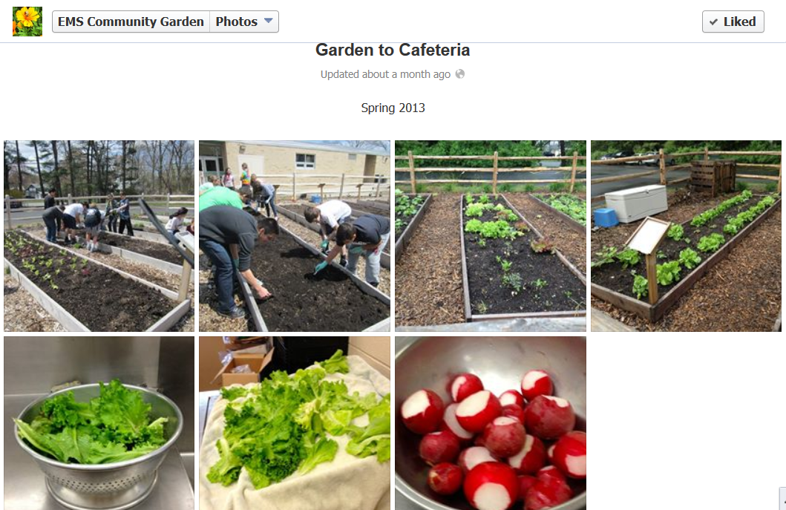

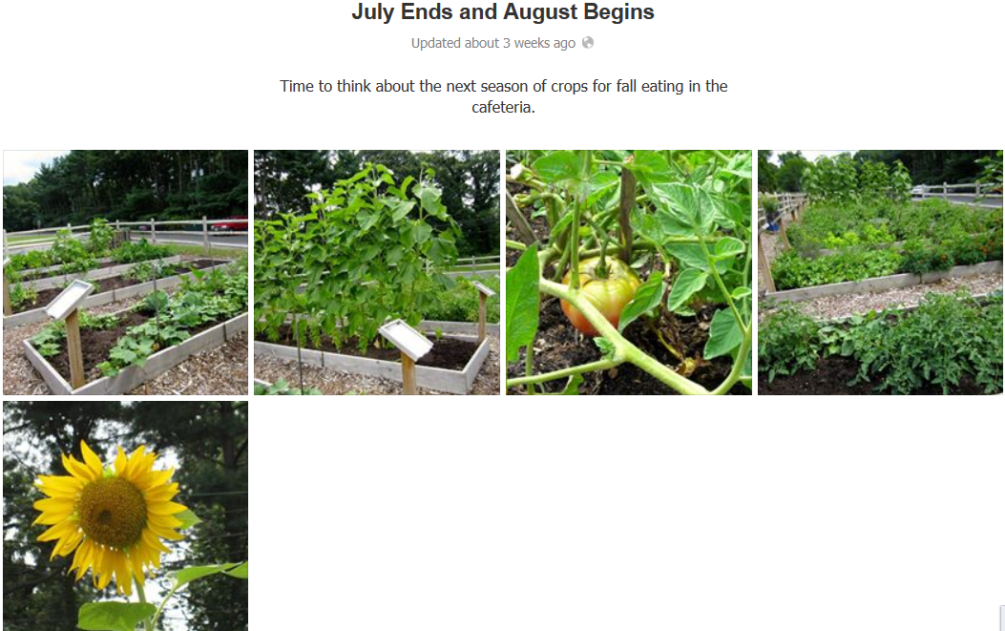
Questionnaire presented to Louis Chen, science teacher at Eisenhower Middle School, and lead instigator of project:
When did the garden program start at EMS?
The school garden project began modestly April 2010 when the New Jersey Landscape Contractors Association adopted the courtyard makeover as their PLANET Day of Service. During the fall of 2010, superintendent of schools, Mr. Richard Kuder announced that two temporary buildings on the EMS campus would be removed. With his encouragement, I contacted City Green for a feasibility assessment for a community garden on one of the plots of land. City Green provided a cost estimate for installation of ten 4 foot X 20 foot 8-inch deep raised beds with organic soil. A final proposal was submitted to the BOE buildings and grounds committee.
What was involved with getting funding for this program at the school? Was there special funding request required for EMS school garden?
City Green donated the labor to install the beds. The Board of Education financed the soil, lumber, and hardware for the project. This was part of the funds to be used for site remediation after the removal of the trailers. The beds were installed during November 2011. At the same time, former EMS student Matthew Martone approached Mr. Raimo regarding an Eagle scout project. Matt's project involved researching a deer-resistent fence that could be lined with a wire fence to deter small animals. The fence was funded by the EMS PTO. The Wayside Fence company provided the fence at cost for $1500 with delivery included. Through Matt's efforts, the Wyckoff Rotary donated funds for a tool chest and garden tools that are stored inside the fence. EMS REACT raised $300 for our first crop that was planted in June 2012 and harvested in September 2012. Food was used in the EMS food science classes.
Did you have to submit a detailed project proposal? Would there be anything written down in a proposal about the resources needs for the garden (i.e. fences, top soil, tools, watering access, seeds, fertilizers, etc. )
Irrigation was part of the site remediation. We have not be successful as of yet in implementing rain water capture, but we're working on it. The soil was purchased from Adma's Farm and is organic. We do not use fertilizers, pesticides, or fungicides in the garden. We have concentrated compost tea that will be added to the soil fall of 2013.
About fertilizers, did the Wyckoff DPW ever provide the EMS garden compost?
Wood chips for the garden pathways and around the fence came from DPW. Matt Martone included that in his Eagle project. We are starting to compost garden waste. Students built a composter from shipping pallets. It's a work in progress, but we'll be studying it's effectiveness over the next year.
Was this garden project funded directly by the school, grant, or Town of Wyckoff in any way? Town obviously funds the middle school, but was there any additional line of funding made available by the Town? Is there an annual budget for operating the garden? Where does this come from?
Funding came from the BOE, EMS PTO, and EMS REACT. City Green continues to provide in-kind donations to help us start the garden. Seeds of Change donated seeds. The Green Team gave us $70 for seeds and plants. I donate about $150 each year to buy supplies that we need but don't fit the school budget. Staff members often bring in plants left from their home gardens.
Is the garden administered only by paid school staff? Are there unpaid volunteers that can help out?
Food science teacher Cindy McNamara and I are currently the leadership for the garden. We are reaching out to the community, but volunteers have been slow to come forward.
Is there a curriculum available for students that helps teach the connection between gardening and generating food? Would you have any printed course materials covering this?
Mrs. McNamara has taken children into the garden to harvest food for home etc. I take the science classes and TIEE (enriched study hall) groups out to the garden. We have integrated gardening into the curriculum in Health classes. I don't have hard copies of course materials. It's been more student research driven than textbook or worksheets.
During May through the last week of school, we served lettuce and radishes from the garden in the lunchroom.

Wyckoff School Board Recognition of Eagle Scout Project facilitating the creation of Community Garden
WYCKOFF BOARD OF EDUCATION
WYCKOFF, NEW JERSEY
April 18, 2013 Minutes

WHEREAS
Martone’s Eagle Service Project was the creation and completion of the Eisenhower Middle School Community Garden located at the former site of the temporary trailers, and
WHEREAS
, Matthew worked with Mrs. Loris Chen, Science Teacher, to determine how to make the garden viable for use to support the
science program. Matthew led the project that involved clearing and
leveling the area; covering the area with landscaping cloth and wood
chips; designing, building and installing sign boxes for students to
keep project information handy; and constructing a fence around the
garden in order to keep small animals away. A large toolbox holds an
array of garden tools that Matthew acquired through a donation
drive, and
WHEREAS
, Matthew L. Martone served with distinction, and
THEREFORE, BE IT RESOLVED
, that the members of the Wyckoff Board of Education express their appreciation in recognition of his high standards of performance to Matthew L. Martone for his
attainment of the Eagle Scout Award, and BE IT FURTHER RESOLVED , that the Wyckoff Board of Education
present Matthew L. Martone with a framed copy of this resolution as
an expression of their appreciation, and BE IT FURTHER RESOLVED
, that a copy of the resolution be recorded in the minutes of this meeting.

