Haddon Township department of Public Works
504 Oneida Ave.
Westmont, NJ 08108
Hours of Operation Monday –Friday 7 AM till 3PM

Waste Oil Collection
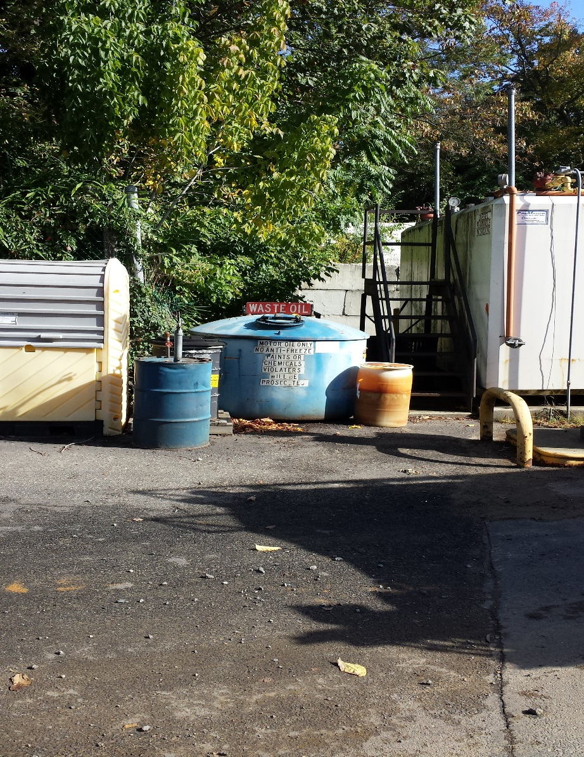

E-Waste

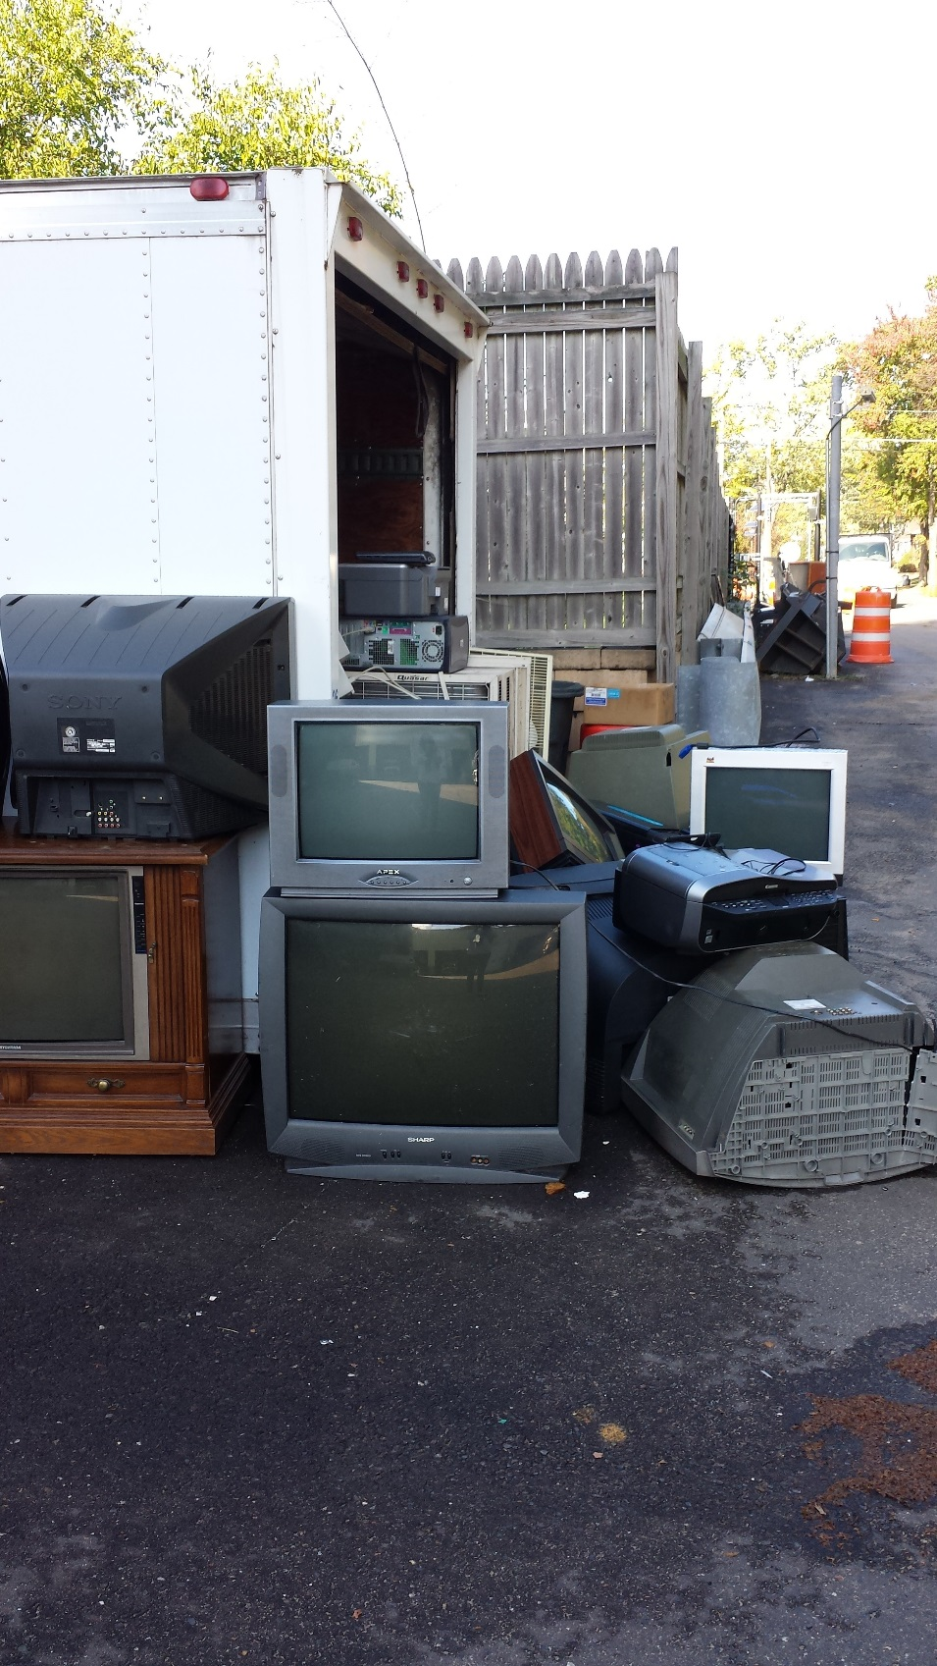

Concrete
