Recycling is the easiest thing we can all do to improve our community, conserve natural resources, and create green jobs.

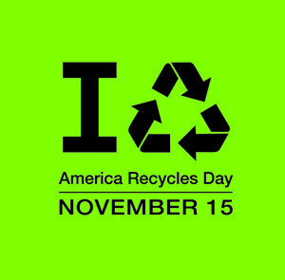
Haddon Township and Audubon Park will host a paper shredding and pharmaceutical collection event to celebrate
America Recycles Day 2014
Haddon Township and Audubon Park residents may bring documents for secure shredding, and pharmaceuticals to be collected by the Township Police Department on November 15th 2014. No businesses, please.
WHEN: Saturday, November 15 2014
WHERE: Audubon Park Municipal Building
TIME: 10AM till 2PM
For more information, contact bprince@haddontwp.com or call 856-854-1825

