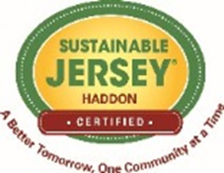
IS YOUR LIFE TOO PLASTIC?

DO YOU KNOW THAT THE AVERAGE AMERICAN
USES ABOUT 500 PLASTIC BAGS EACH YEAR,
FOR ABOUT TWELVE MINUTES EACH?

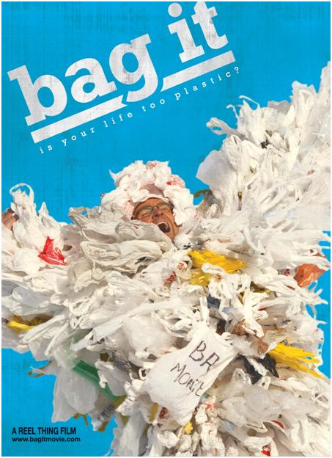
Single-use mentality has led to the formation
of a floating island of plastic debris in the
Pacific Ocean more than twice the size of Texas.

FREE MOVIE SCREENING!
Join community leaders from Sustainable Haddon Township for a free movie screening of the new, award-winning environmental documentary “Bag It”. “Bag It” follows “everyman” Jeb Berrier as he tries to make sense of our dependence on plastic bags. Although his quest starts out small, Jeb soon learns that the problem extends past landfills to oceans, rivers and ultimately human health. For more information and to register, contact Matt McCarthy at mattjmccarthy@hotmail.com

BAG IT EVENT DETAILS

WHEN? May 29th at 7 PM
WHERE? Haddon Township Historic and Environmental Center
143 E. Ormond Ave., Haddon Township 08107

We are very excited that a local company United by Blue will be attending our screening. UBB is focused on ocean and waterway conservation. For every product sold, United By Blue removes one pound of trash from oceans and waterways through company organized and hosted cleanups.

There will also be a drawing to give away a Eco-Friendly basket of goodies.

