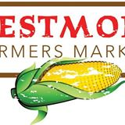

Westmont Farmers Market
Community
Liked
FollowFollowingMessage
More options

LikeLike ·
ready for market .
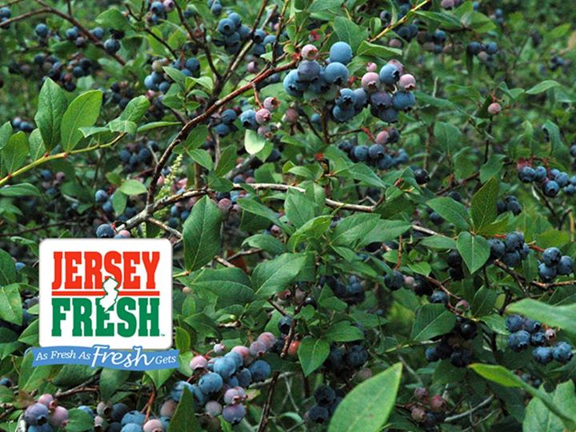

MAY post

Viereck Farms will be at the market. And is bringing NJ FRESH STRAWBERRIES!!!!

12 Shares
September 26, 2013
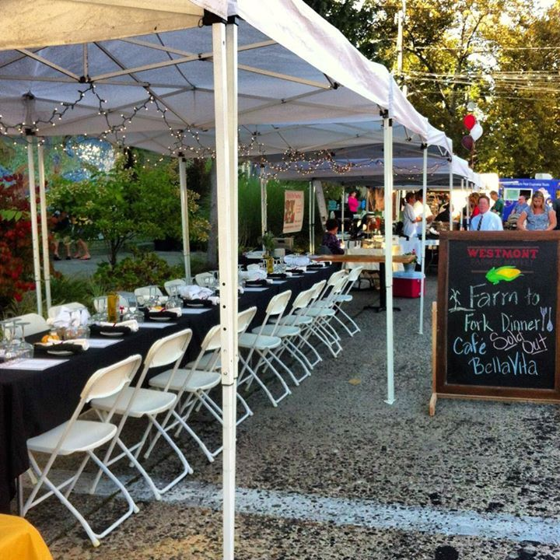

153LikeLike · · Share

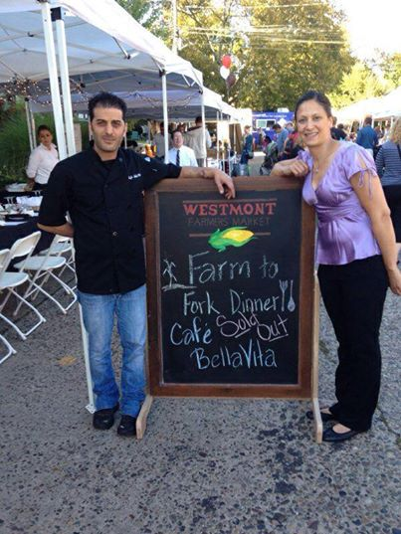

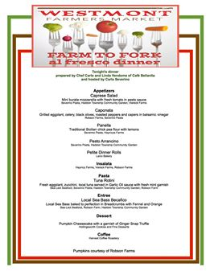

Top of Form
153LikeLike · · Share
15 people like this.
Westmont Farmers Market
September 17, 2013
Take a look at the menu for the Farm to Fork Event occuring at the Westmont Farmers Market Wednesday September 25, 2013, 6:00 pm
This outdoor dinner will include many of the vendors of Westmont Market. Call Cafe BellaVita, 856-665-8388 and make your reservations today!
Appetizers:
Caprese Salad
Mini burata mozzarella, fresh tomato garnished with pesto sauce
Caponata
Grilled eggplant, celery, blac...k olives, roasted peppers, capers in a balsamic and vinegar
Panella
Traditional Sicilan street food: chick pea flour cooked and served with lemons
Pesto Arrancino
insalata:
Pasta Course:
Rotini Pasta
With Fresh eggplant, zucchini, Yellow fin tuna served in a Garlic Oil sauce and Garnished with Fresh mint.
Entree:
Bronzino Becafico
White Mediterrian fish, baked to perfection in Breadcrumbs. Served with Fennel and Orange.
Dessert*:
Mecca Chocolate
Coffee and Hot Tea
*Subject to change
$50 pp See More
Top of Form
Bottom of Form
Westmont Farmers Market
August 29, 2013
Did you try the peaches . So Good !!!!!

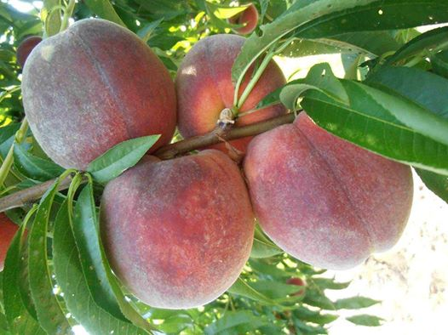

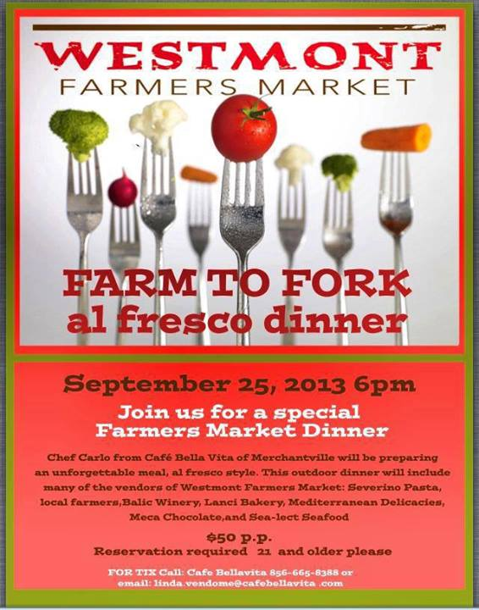
Westmont Farmers Market
August 27, 2013

