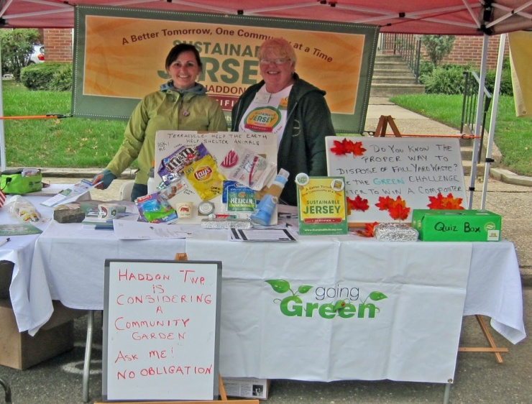
Municipal Sustainable Jersey Coordinator and Resident Sustainable Jersey Coordinator gauge community interest for the garden, and promote greening Haddon Township at the fall 2012 Block Party held in September.

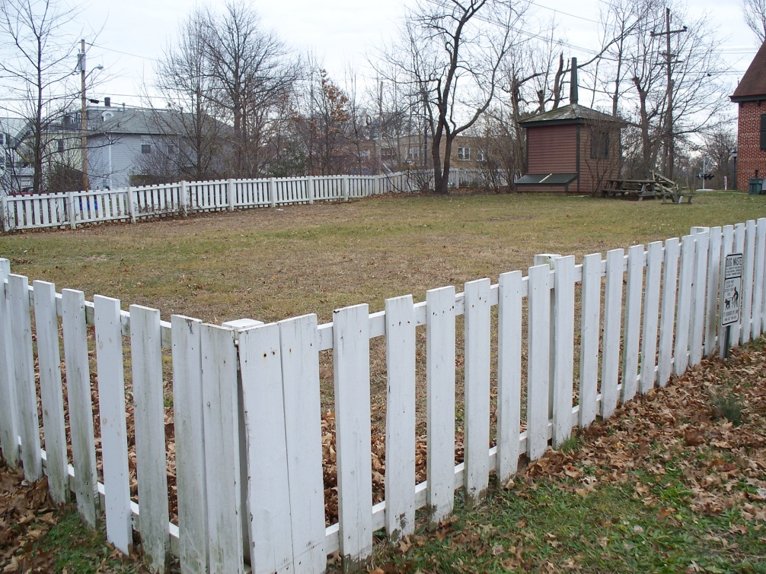
After visiting other local, community gardens and various sites within the Township, the Executive Garden Committee chose the Champion School property located on Collings and Lynne Avenues. The group presented a proposal to the Mayor and Commissioners for formal approval of the location.
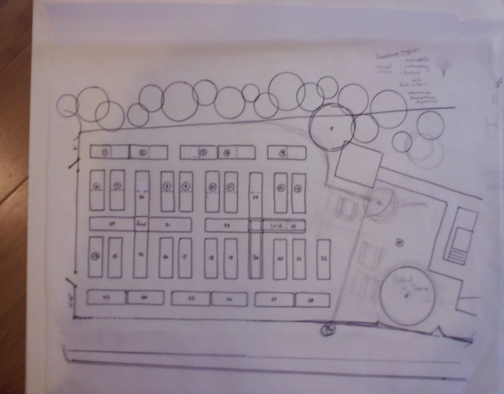
The beautiful and historically accurate garden layout was designed by Executive Committee Member, Catherine Turcich.

.

PHASE 1: In early spring, volunteers placed cardboard in the garden, hosed down the cardboard with water, and placed mulch on top of the cardboard with the assistance of DPW.
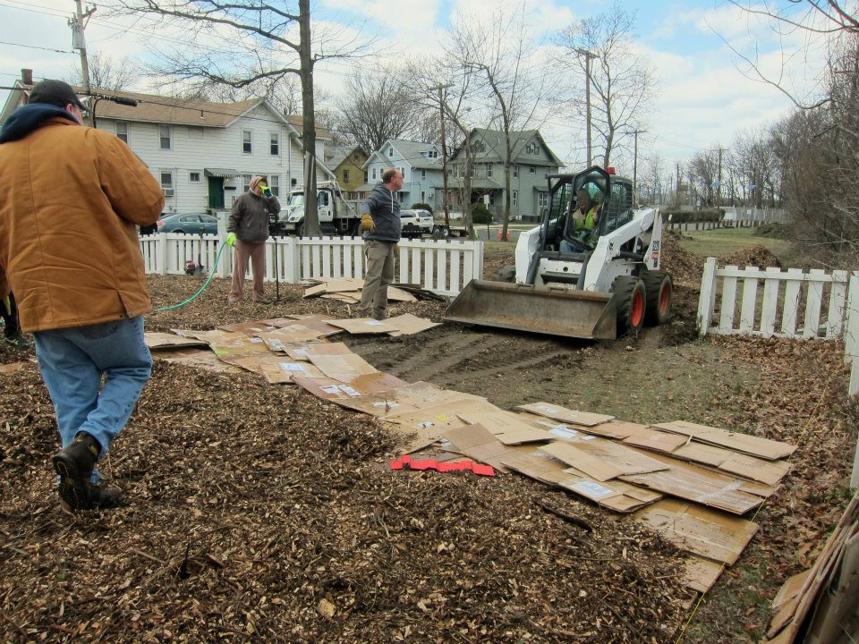

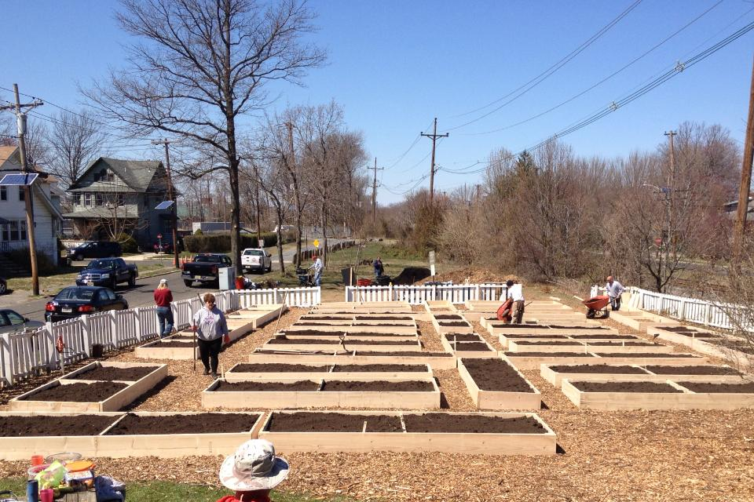

PHASEII: Volunteers with the direction of Master Gardeners build raised beds and fill with topsoil and compost.

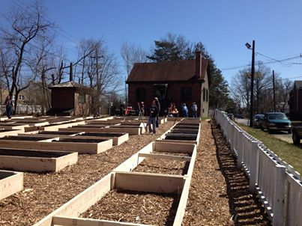

Phase III : Garden in full bloom
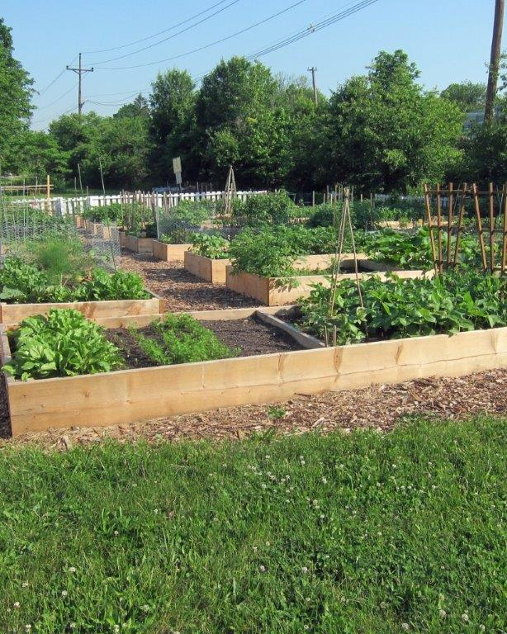

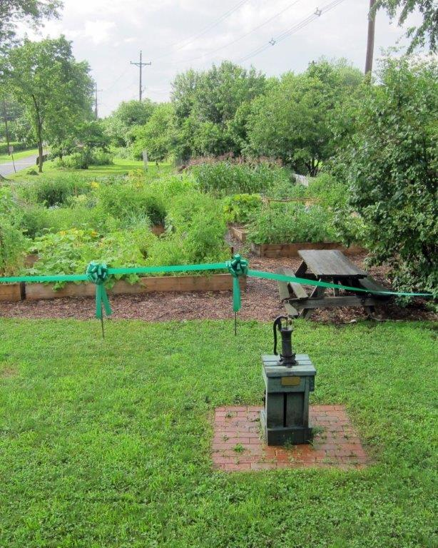
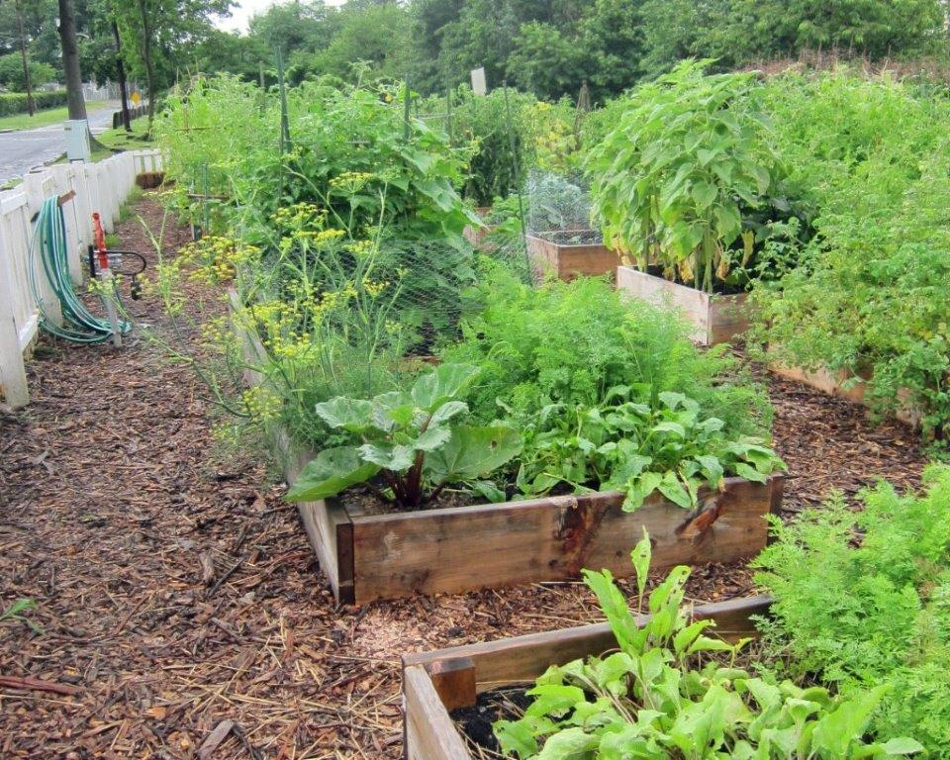
The garden is prepared for the
ribbon-cutting ceremony

