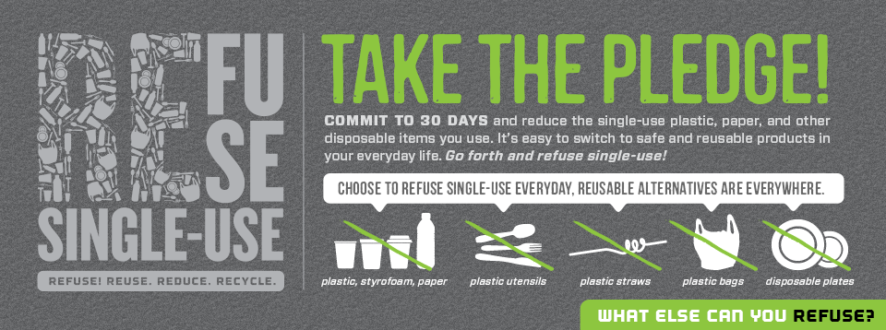

Join the Haddon Township Green Team and take the Kleen Kanteen pledge to “REFUSE TO USE” single use plastics!
Bring your pledge to the “go green event” on April 26th in Westmont Theatre parking lot and win and eco-goodie!
I commit to do my part to rise above plastics and protect the world's oceans, waves and beaches from plastic pollution. I will do this by: (check one or ALL)
- Using reusable bottles for my water and other drinks. By using just one reusable bottle, I will keep 167 single-use plastic bottles from entering the environment.
- Using cloth bags for groceries and other purchases. For each reusable bag I use, I will save approximately 400 plastics from being used.
- Recycling the plastic bags and bottles I already have. For every thirteen plastic bags I don't use, I will save enough petroleum to drive a car one mile.
Name _____________________________Address___________________________________________________
Email, if you would like updates on Haddon Township green happenings_________________________________

