http://www.courierpostonline.com/story/news/local/south-jersey/2014/06/16/haddon-township-map-highlights-outdoors/10567525/

Haddon Township map highlights outdoors
CHL 12:33 a.m. EDT June 16, 2014
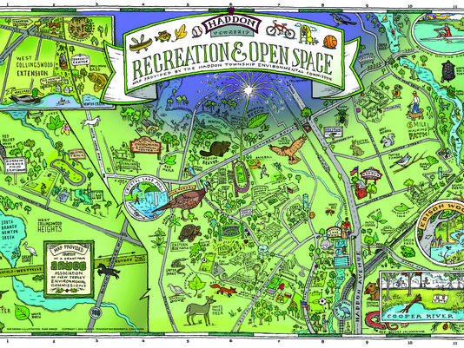
The Haddon Township map was created by volunteer artist-in-residence Mark Parker.
CONNECTTWEETLINKEDINCOMMENTEMAILMORE
HADDON TWP. – A new map shows open space and recreational facilities in Haddon Township, along with examples of local wildlife.
The map was created for the township’s Environmental Commission by Mark Parker, who holds a voluntary position as Haddon Township’s artist-in-residence. The months-long project was funded with a $1,500 grant from the Association of New Jersey Environmental Commissions.
Members of the local commission researched open space and recreation areas, then created a legend for the map’s reverse side that promotes outdoor activities across the township. The legend includes contact information for all fields, playgrounds, trails, pools and lakes.
A copy of the map is on display at the Environmental and Historical Center on Ormond Avenue. Paper copies can be obtained at the municipal building.
Read or Share this story: http://on.cpsj.com/1q2xqdK

More Stories

