Westmont Farmers Market Greening Awards
The Haddon Township farmers market is honoring businesses that are environmentally friendly.
Posted by Bill Duhart (Editor) , October 04, 2013 at 03:53 AM
Comment00
0
More
- Repost
- Print this page
- Email
- Flag as inappropriate
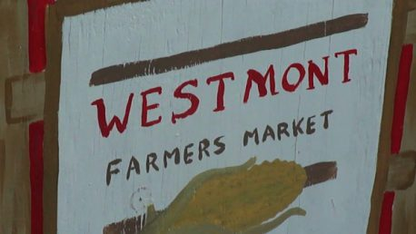
The Westmont Farmers Market is open each Wednesday through October from 4 to 7 p.m. at Haddon and Stratford avenues.
Loading...
x
×
Next Previous Slideshow Download
The most sustainable and environmentally friendly vendors at the Westmont Farmers Market in Haddon Township will be honored Wednesday.
The Greening the Restaurants and Farmers Market Task Force of Sustainable Haddon Township will present the awards. A total of 10 prizes will be given, which is about 1/3 of the vendors.
The market is located at Haddon and Stratford avenues. It has the atmosphere of a spontaneous block party and is held between 4 to 7 p.m. on Wednesdays

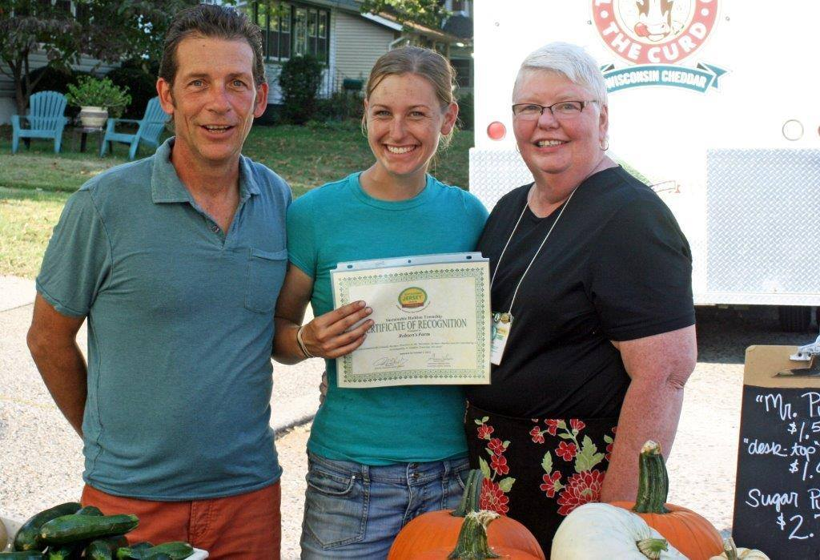
Pictured above is Westmont Farmer’s Market Director Doug Kelly with local farmer and vendor alongside Gwenne Baile, community Chair to Sustainable Haddon Township.

l

Market Director Doug Kelly helps Gwenne Baile and Matt McCarthy award another certificate of recognition to green business vendor at the Westmont Farmer Market.

