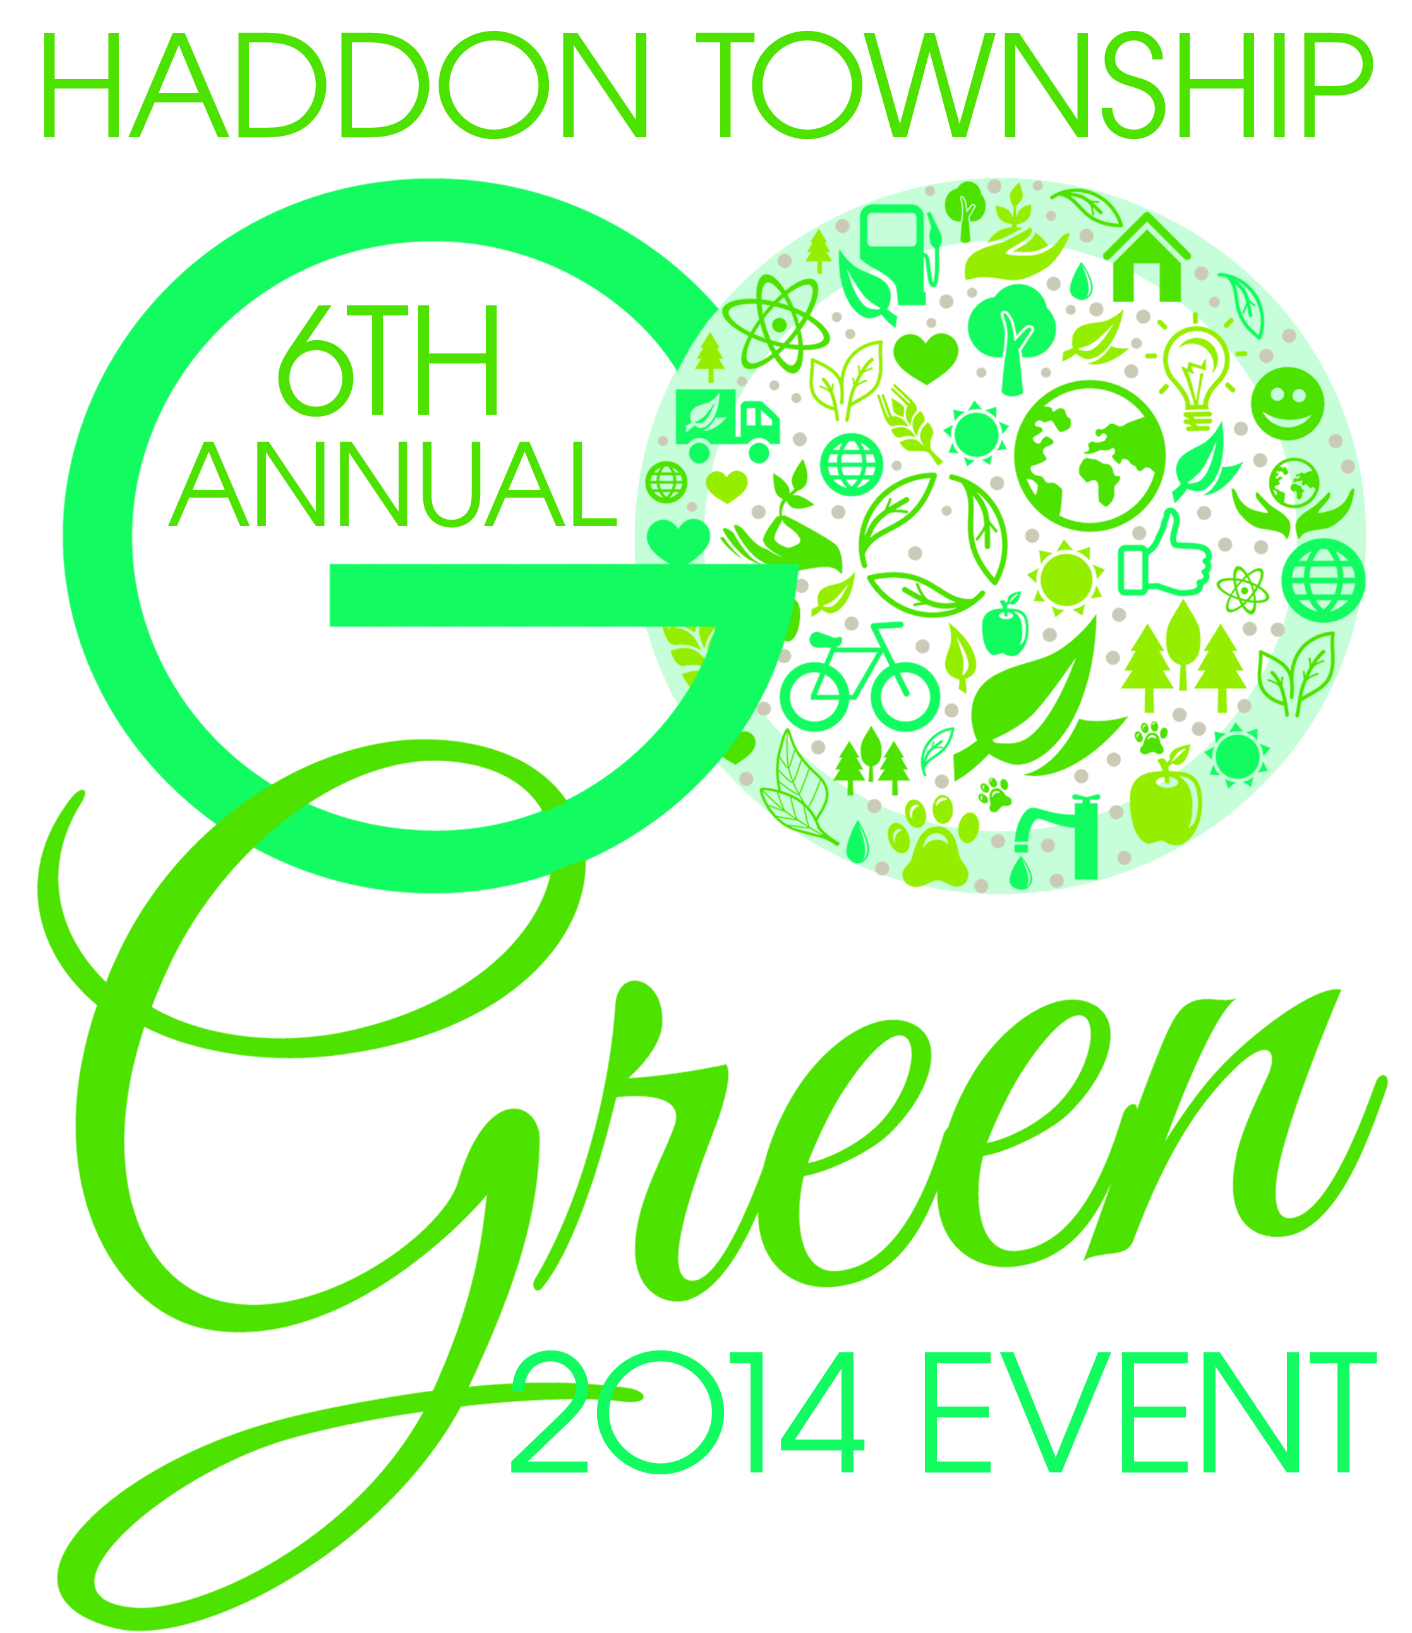
Haddon Township’s
“Go Green” Event 2014

VENDORS:

- Farmers Market Vendors: Sold fresh fruit, vegetables, plants, and locally hand-made goods.

Sweet Pea Homemade Ice cream
Dalla Mia Mano, unique handcrafted jewelry.
Balic Winery, local winery
Revolution Coffee
VanDyk Flowers
Allison’s Massage
Haynics Orchardview Farm
JoBie Bags, repurposed material
Fandessa Gourmet
Pat’s Pets Pastries
Mecha Artisan Chocolate (local)
Hot Dog Man
Robson Farm
Beaucycled
LoveLola
Harvest Roastery
Ginko Girls
Sockitz

- Team Vendors:

Center For Environmental Transformation: Sold heirloom seedling vegetables and herbs.
Tower Gardens by Juice Plus
My Green
Haddon Township Community Garden
Retail food cooperative market for south jersey
CCCMUA
Viridian Energy
Trinity Solar: solar panel install vendor
Cooper River Fest Cleanup

TOWNSHIP OF HADDON:

- Haddon Township Governing Body: Representative Commissioner John Foley sold composters and offered free composting seminars. Sold composters to enable/encourage residents to remove organics from our MSW. In attendance, Mayor Teague and Commissioner Dougherty.

- Haddon Township Green Team: Promoted the screening of Bag It and spoke to residents about taking “the pledge” for making sustainable changes as part of the certification process. They also spoke to resident about team activities including Plastic Ocean Project Education thru Art Program, Terracycle Campaign, and Sustainable Haddon’s team activities for Sustainable Jersey.

- Township BID: Township Business improvement district representative promoted local business (shop local campaign) along with Broadway Mortgage promoting “work where you live program.” Green Business: Kimco Pest Natural Pest control also promoted their services.

- Township of Haddon Police Department: Collected pharmaceuticals for environmentally responsible disposal as part of National Operation Medicine Cabinet Day. They also auctioned off bicycles that had not been claimed over the past year. Six officers assisted with the activities.

- Volunteer Organizations: Distributed information regarding volunteer opportunities and environmental issues in the Township.

- Shade Tree Commission
- Environmental Commission
- Saddler’s Woods
- Haddon Township Historical Society
- Sustainable Haddon Township ( Green Team)( Community Garden task Force)

RECYCLING:

- Soles4Souls: Green Team collected 200lbs of shoes for reuse, 244 pairs.

- E-waste collection: over 7,000 lbs

- Safe Shredding: secure document recycling, approximately 4tns.

- New Jersey Aid For Animals: Promotion and adoption of shelter animals. Promote spay and neuter campaigns and fundraising activities. Collected old blankets/towels etc. for reuse at local shelter.

- Goodwill Industries: Collection of clothing and household items for reuse, filled large container truck.

Entertainment:

- Rizzo’s Reptiles: Children’s show: Discover Green: Blending nature, environment and conservation to teach you how humans impact the environment. Meet various animals and reptiles to understand what we can do to save the earth. The Discover Green program teaches us to CARE about our planet. Conserve, Awareness, Recycling, Environment!
- Funny Face, face painting
- The Bug Lady, Susanne Lypka

