pop: innovative community, collaboration project
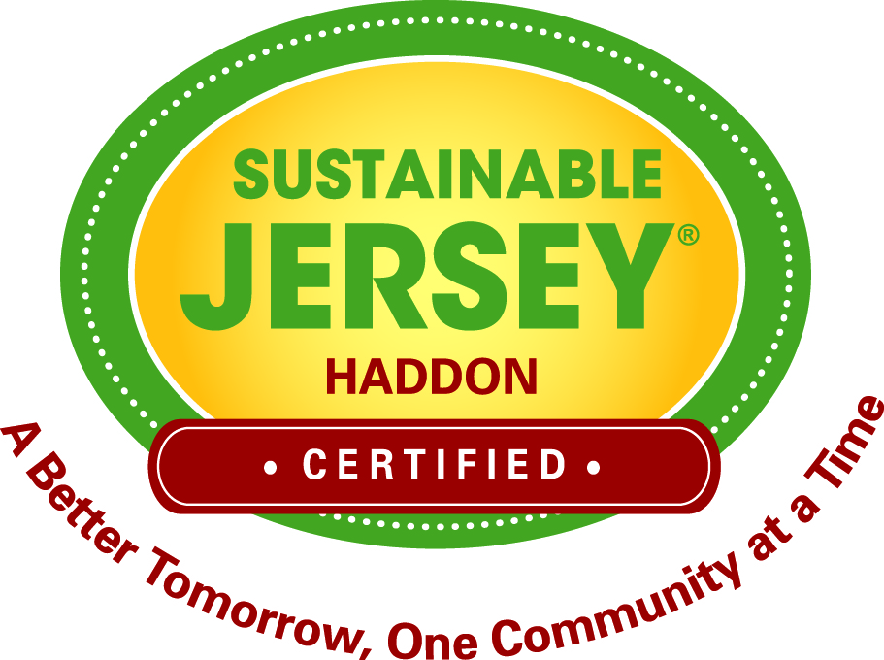 |  | Sustainable Haddon Township  2014 MARCH – APRIL

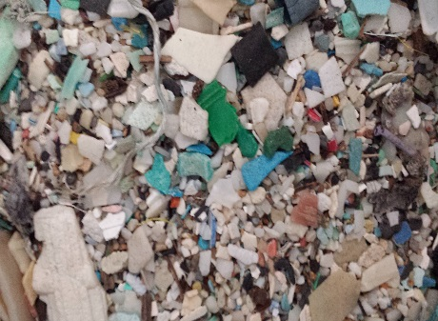  The above image is of micro plastics which washes up on many of the world most beautiful shores. |  | The Plastic Ocean Project: Travelling Art Exhibit  “The traveling art exhibit "What Goes Around, Comes Around" is an art initiative to bring awareness regarding the problems with the over-use of one-time use plastics, why it matters, and what can be done about it. Collecting plastics from nearly 10,000 nautical miles in three oceans, the art consists of plastic items morphed into the famous print, "The Great Wave of Kanagawa" by Katsushika Hokusai circa 1830. It systematically illustrates how the oceans are very different than what Hokusai saw less than 200 years ago. The work beautifully depicts the ocean and the menace of plastics, how all of us are part of the problem, and how we are the only solution.”

WHAT IS THE PLASTIC OCEAN PROJECT?

OPPORTUNITY:
We are bringing the best and brightest leaders to the table to take on the challenge of removing plastics from our oceans
while creating sustainable businesses in the process. This includes leaders from the Military, Federal Government,
Entrepreneurial Thinkers, Businesses Leaders, Scientists, Researchers, Artists, Celebrities, Fisherman, Veterans, and Students. Our intention is to create a collective community focused on innovation and collaboration around “mining” for plastic on and off-shore and reusing it”.

THE CHALLENGE:
Removing plastics from the ocean is complex and arduous but are not reasons to neglect the issue and here’s why. According
to the EPA, outside of the small amount of plastics incinerated, every bit of plastic ever manufactured still exists today and is compounding by increasing global production. Every piece of plastic you have ever used is most likely still here somewhere. Up to 80% of marine debris is plastic and comes from runoff creating a steady stream of plastic finding their way into the ocean. The ocean is downhill from everywhere. In the marine environment, plastics do not biodegrade, they photo-degrade breaking up from recognizable items of all sizes and shapes into tiny little particulates. The challenge is to innovate novel ways to “mine” for plastics, both large and small, remembering that the smaller pieces of plastic are the most challenging ones to capture, and they are also the most easily ingested by marine life. Do you eat fish? Fish eat plastic!

OUR MISSION
The mission of Plastic Ocean Project, Inc. 501(c)3 is to educate through field research, implement progressive outreach initiatives, and incubate solutions to address the global plastic pollution problem. Working with and for the next generation to create a more sustainable future.
Our long term goals are to actively and collectively incubate 5 solutions toward the prevention and removal of marine plastics on and off-shore. We intend to bring together a community of world leaders focused on innovation, collaboration, education and outreach, while spearheading and mobilizing focused research and innovation projects to meet the challenge of removing man-made debris from our oceans in support of our next generation, while also creating new sustainable businesses.

WHO:
Rear Admiral Len Hering, Sr., US NAVY: Champion at the Helm, San Diego, CA
Diana Dehm: Director of Marketing & Media, Sustainability Innovation, Huntington Beach, CA
Bonnie Monteleone: Director of Science, Research & Academic Partnerships, Wilmington, NC
Martha Lyons: Director of Technology and Innovation, Palo Alto, CA
Kellie Johansen: Director of Operations and Outreach, Exeter, NH
Dr. Bill Cooper: Advisory Board Member, University of Irvine, CA
We believe assembling a collaborative team representative of all stakeholders is the key to the success of our mission.
The collaborative team will focus on solution incubation for marine debris prevention and removal. The five targeted groups we include in the collaboration model include: Academics, Corporate America, Government, NGOs &
Non-profits, & Individuals/Entrepreneurs.

OUTReach through art:
Like the AIDS Memorial Quilt that traveled across this country successfully bringing awareness to the AIDS pandemic, POP’s Bonnie Monteleone wants to bring awareness to marine plastics pandemic through the heartland of the US from North Carolina to California leaving it on display at public venues for people to enjoy the beauty, question the scourge, and make the connection that we all contribute to this growing problem just as every river connects to an ocean. "What Goes Around, Comes Around" puts the viewer instantly on the ocean as they stand in front of 25' of ocean waves on canvas. Five large window panes serve as educational panels revealing the science behind the art. Five bins of ocean trash allow viewer to find the plastic pieces in the art, and a 4'x6' sculpture portrays the wave of the future if we ignore the plastic plague. This art installation has traveled over 3,700 miles. Currently, it is at the University of Nevada, Reno in the Mathewson Knowledge Center and will be there until September 30, 2014. On July 13, Bonnie Monteleone will be presenting at the Mathewson-IGT Knowledge Center at 3pm. It was last seen at McCormick's Creek State Park, Nature Center, and Spencer, Indiana until June 14th, 2014.
Previously, it was at the Student Center, Rutgers University, Camden, NJ until April 26, 2014. It has been on display in Cortland, NY at the Beards Building, Guilford College Gallery, NC, at The Gathering, in New Bern, NC, and NC Cameron Art Museum. The show originally went on display at the Boseman Gallery at University of North Carolina Wilmington in fall 2011 with day exhibits at Cape Fear River Watch, Friends School of Wilmington, Center for Life Long Learning, Surfrider Rise Above Plastic Event, and the Wilmington Art Association, NC. Pieces of the show have been published in the French magazine Stradda, and is the CD cover to the Spanish popular band Ruidoblanco.

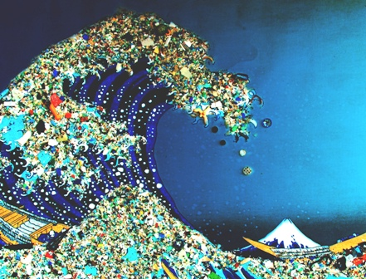

IT TAKES A VILLAGE:
Bringing the Plastic Ocean’s Traveling Art exhibit to the South Jersey Region took the hard work and the coordinated efforts of municipal and county entities, non-profits, inspired citizens, and educational institutions.

OUR PARTNERS:
Sustainable Cherry Hill (SCH)
SCH Regional Urban Task Force (RUPS)
James Johnson School
Kingston School
Township of Haddon
Sustainable Haddon Township
Van Sciver Elementary School
Camden County
Sustainable Haddon Heights
Haddon Heights
Glenview Ave School
Urban Promise
Rutgers University

THE BACKSTORY:
How the Plastic Ocean Project, based in Wilmington, North Carolina came to be in the South Jersey area.
Do you see what I see? Paradise Lost.

Horseshoe Bay, Bermuda.

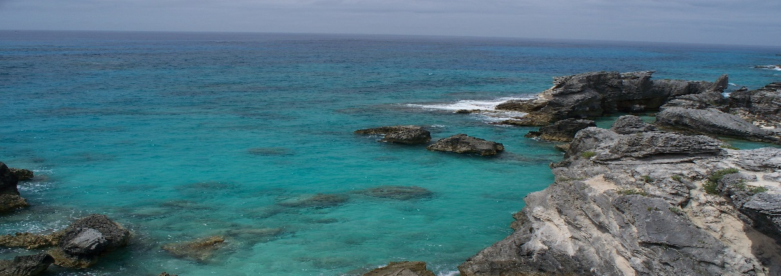

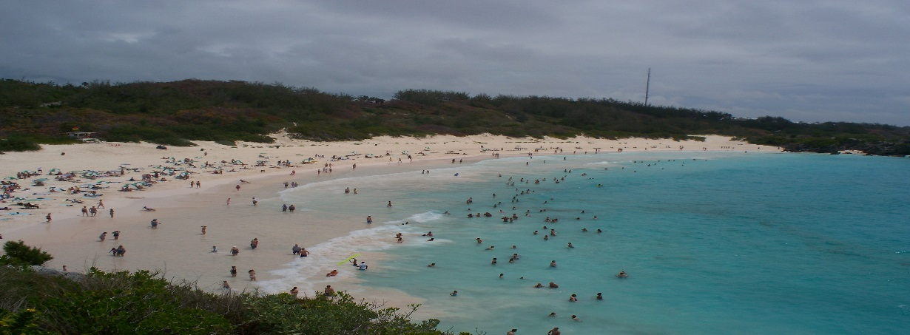

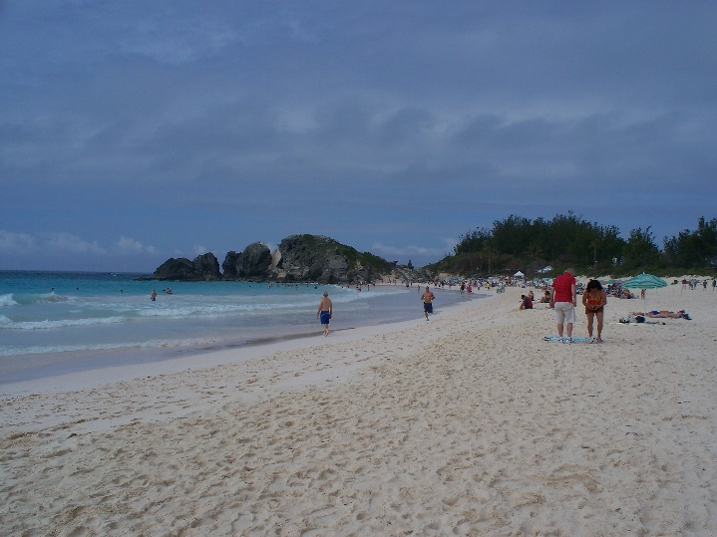

In 2012, Haddon Township’s recycling coordinator took a family vacation to Bermuda. Looking for the iconic pink sands, she discovered that beach was littered with micro- plastics. She felt compelled to research this issue when she returned home, and found the Plastic Ocean Project (POP) on the web. The coordinator Facebooked the researcher in charge of the organization, Bonnie Monteleone.

THE POWER OF SOCIAL MEDIA FOR CHANGE
May 30, 2012 1:30 pm
“Dear Bonnie, We don't know each other, but I could not help but to reach out to you and give you and your team so many thanks for what you are doing. I am a Sustainability Coordinator in Haddon Township, NJ and have spent a good deal of time talking with residents and students about these issues. I felt compelled to contact you because I recently returned from Bermuda with my family from a much needed vacation. We went to the amazing Horseshoe Bay Beach. As I was looking down at the beautiful pink sands I was horrified to see what I knew to be pieces of gyre trash. I immediately recognized the odd color pieces along the shore...how insidious these tiny pieces of trash are...I was the only one in our group to notice...how terribly sad...Thank you to your team, education about this issue is vital! Regards, Barbara Prince.”

Despite messaging Ms. Monteleone and not hearing back from her, the Township coordinator continues to monitor the POP Facebook page and discovers the organization has a traveling art education program. Art as a vehicle for communication is part of the green team’s agenda and the coordinator reached out to Ms. Monteleone again (one year later):

May 6, 2013 9:51 am
“any chance you want to bring your amazing art to Haddon Twp, NJ on your way thru? I just finished an annual video contest I did with the high schoolers on litter/recycling and this year we focused on plastic bags...what was so interesting is that for the most part that just missed the mark...ugh”

Patience pays off…

May 6, 2013 2:09 pm
Hi Barbara, I apologize, I see that you texted me almost a year ago and I did not respond. I truly hate when that happens. I don't know how I missed it but am thrilled to see you reaching out again. I would welcome the opportunity to bring the installation to NJ, though it might have to be in the fall. It is currently booked until June and you probably would like to have it up during the school year. We can explore options if you are interested.
I know exactly what you are talking about regarding people not noticing plastic on the beach in Bermuda - a total blind eye to something so unnatural. When we do our beach samples in Bermuda, it is the same thing. People will ask us what we are doing and when we tell them they look around and it hits them square between the eyes. They will make comments like "What plastic?", and then they will look around and see it for themselves and be mortified If you would like to talk more about the possibility of housing the show, you can call me at (deleted). And thanks again for contacting me and sharing your story.
5/6, 2:16pm
Barbara Prince
No worries...I assume you are off in the ocean somewhere...and yes, I would love for your exhibit to come here! I have quite a few contacts in the sustainable community in town, and the surrounding communities. ...it is so important! Let me know when a good time to talk about the details is.

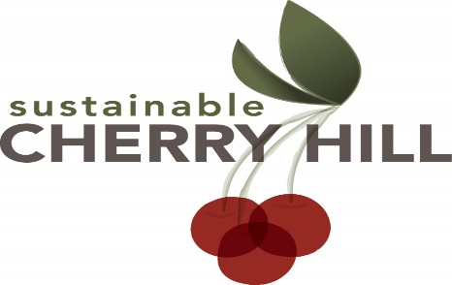

SUSTAINABLE CHERRY HILL and RUPS
(Regional Urban Partnership for Sustainability)
As a member of RUPS, the Haddon Township Sustainable Coordinator had been discussing the possibility of bring POP to the South Jersey area and working with Sustainable Cherry Hill and RUPS members to make this happen since returning from her vacation in 2012. Finally, 2 years later, she had something to report. Bonnie from the Plastic Ocean Project would be coming to our area. Barbara had neither met Bonnie, nor had seen her artwork, nor even heard her presentation. Clearly, a leap of faith was required. Lori Braunstein, founder and president of Sustainable Cherry Hill, and RUPS members understood the importance of the POP’s mission, and what a unique opportunity to have this presentation in our area. All immediately set to work planning a community, evening event and reaching out to local schools for POP presentations.
The Schools: Not only did the RUPS members have faith, so too did the many, participating school districts. RUPS members from Burlington, Camden, and Gloucester Counties reached out to their school, environmental champions to gauge interest in the having a POP presentation. The response was overwhelming, and many schools had to be turned away as Bonnie’s schedule was tight. She was traveling from Wilmington, NC and arriving on Tuesday, March 11- presenting on the afternoon of arrival, and twice a day until leaving on Friday morning. RUPS members and their green team members volunteered their time escorting Bonnie and her exhibit to local schools, and assisting with carrying the many exhibits and audiovisual equipment to ensure that not a moment of educational time was lost. Nearly 1,000 students participated in the project!

