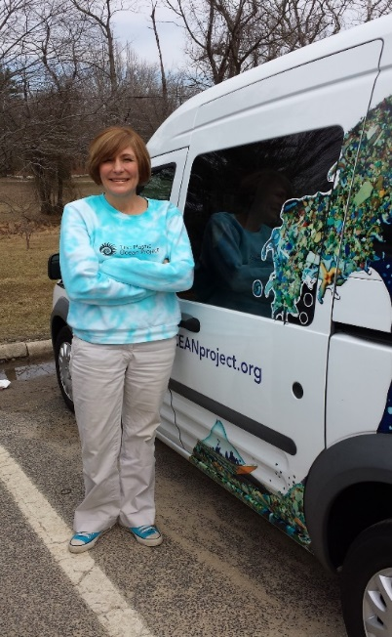
Bonnie hits the ground running, arriving in Cherry Hill, NJ at 12 PM on 3/11 for a two hour presentation. (Pictured to the right, Bonnie Monteleone of the Plastic Ocean Project; below, Johnson Elementary students listen attentively.)

Tuesday, March 11
1:30 - 3:30PM
Johnson Elementary,
500 Kresson Road, Cherry Hill, NJ 08034, Approximately 230 students,
Grades 3-5

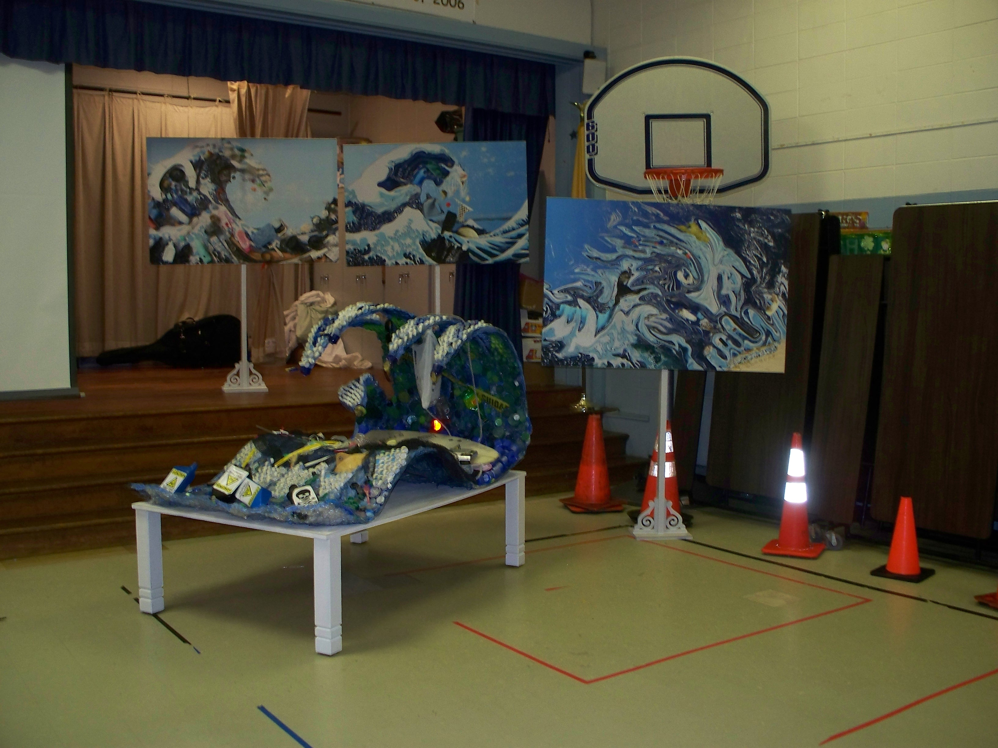

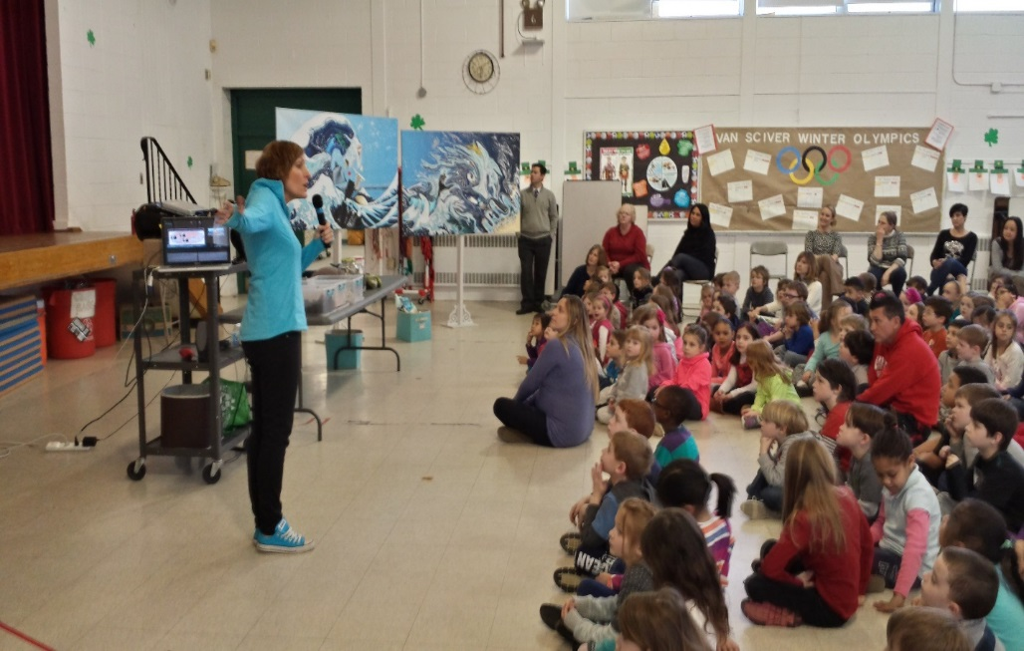

As part of the RUPS’s commitment to environmental justice, equity, and diversity, Urban Promise was chosen to receive n a POP presentation.

Wednesday, March 12

*8:30-10AM
Urban Promise, Ecological Learning, 3700 Rudderow Street, Pennsauken, NJ 08001, Approximately 35 students

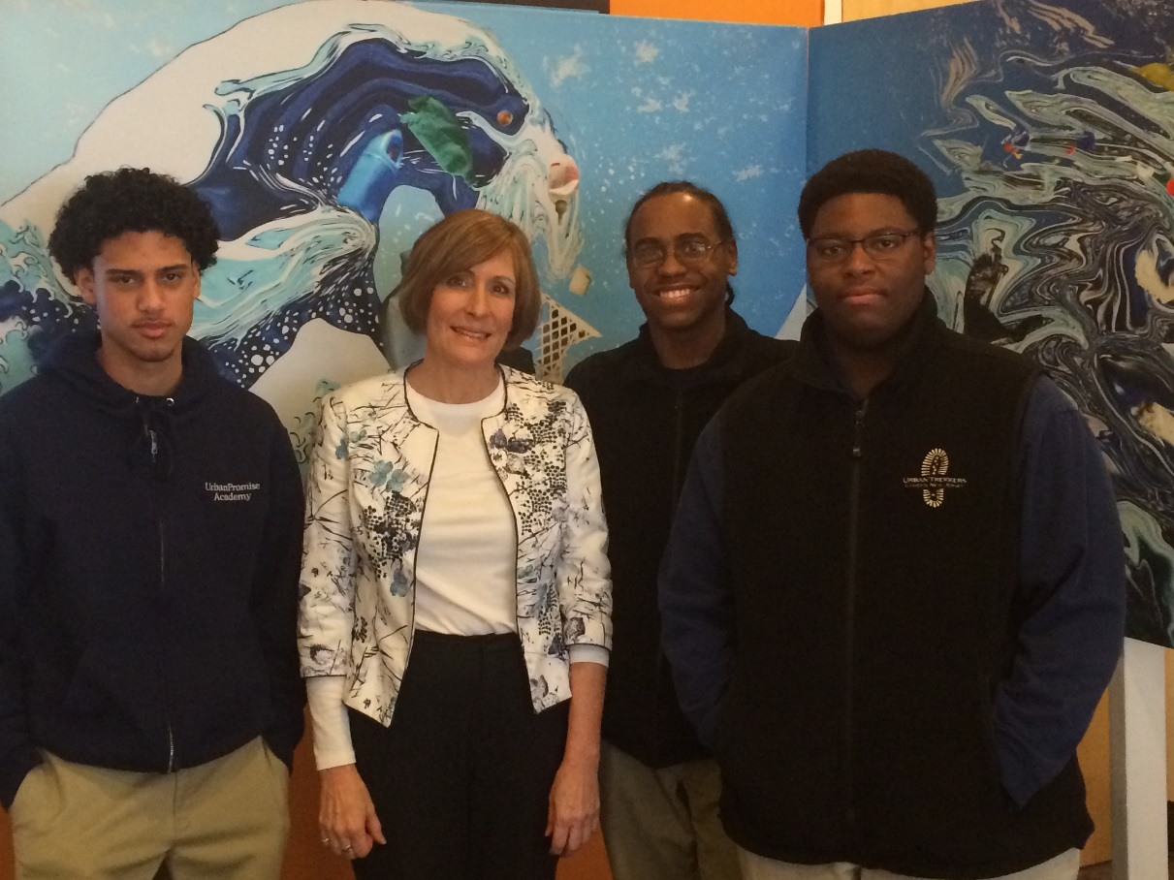

1:15-3:00PM
Kingston Elementary, 320 Kingston Rd, Cherry Hill, NJ 08034, Approximately 200 students, Grades 3-5

Thursday, March 13

9:15AM
Glenview Elementary School, 1700 Sycamore Street, Haddon Heights, NJ 08035, Approximately 200 students, Grades 1-6

1:00-3:30PM (2 presentations)
Van Sciver Elementary School, 625 Rhoads Ave, Haddon Twp, NJ 08033

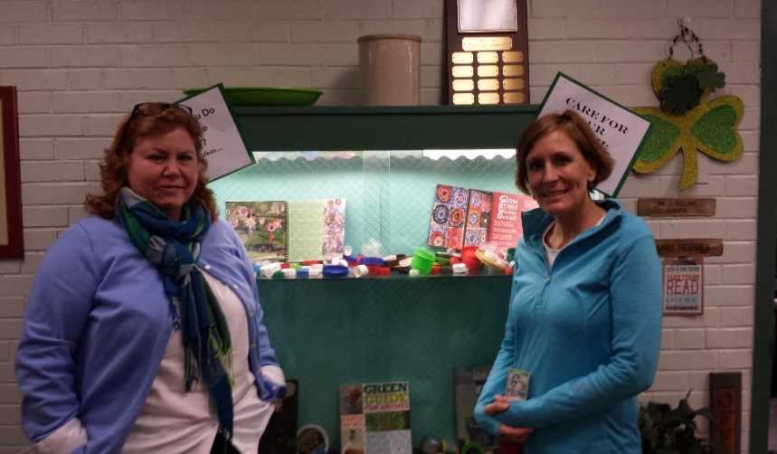
Pictured to the right, Bonnie Monteleone and teacher, champion Leslie Ries from VanSciver School; below, VanSciver students learn about environmental stewardship and how to protect our oceans.
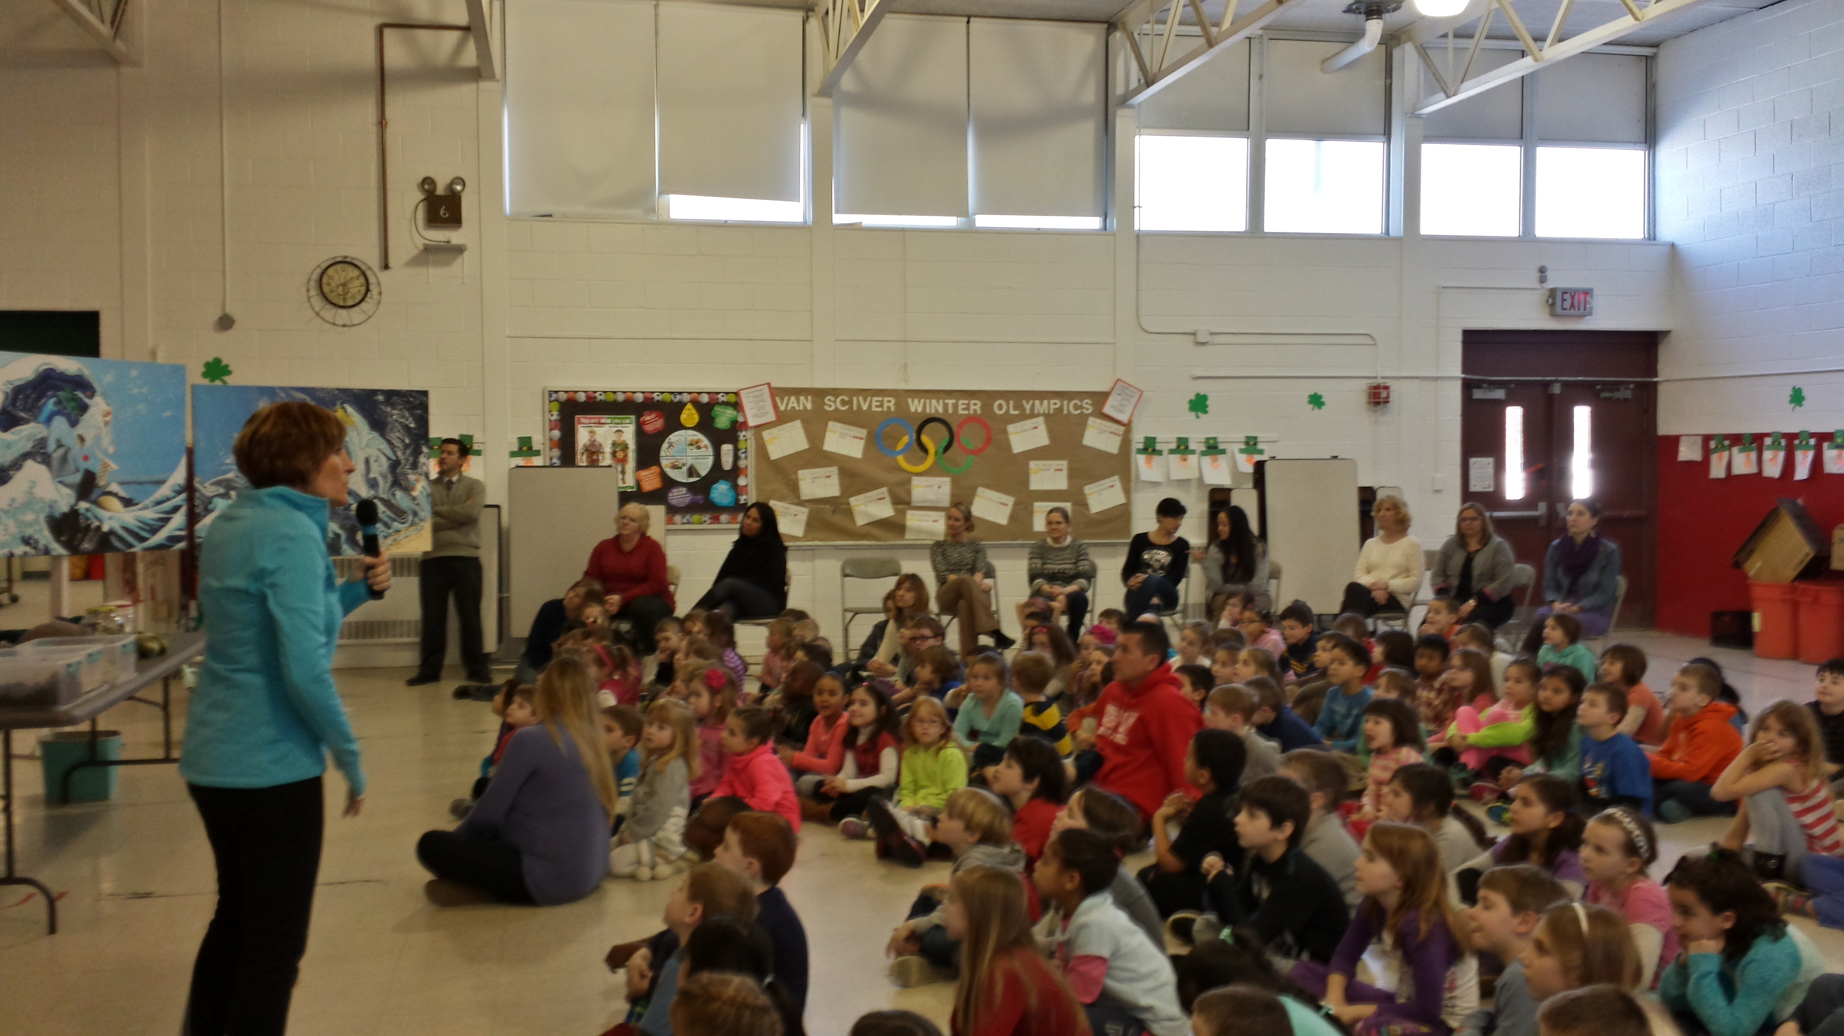

The Evening Presentation: Not only did the RUPS members and their green teams work diligently on bringing POP to school children across the region, they ensured that community members also had the opportunity to view the artwork and listen to the lecture on the problems of single-use plastics. The Camden County Office of Environmental Affairs assisted with a meeting space, and donated the time of an employee to help with any technical services needed. Lori Braunstein of SCH was invaluable as an experienced, successful event organizer, and with media outreach.

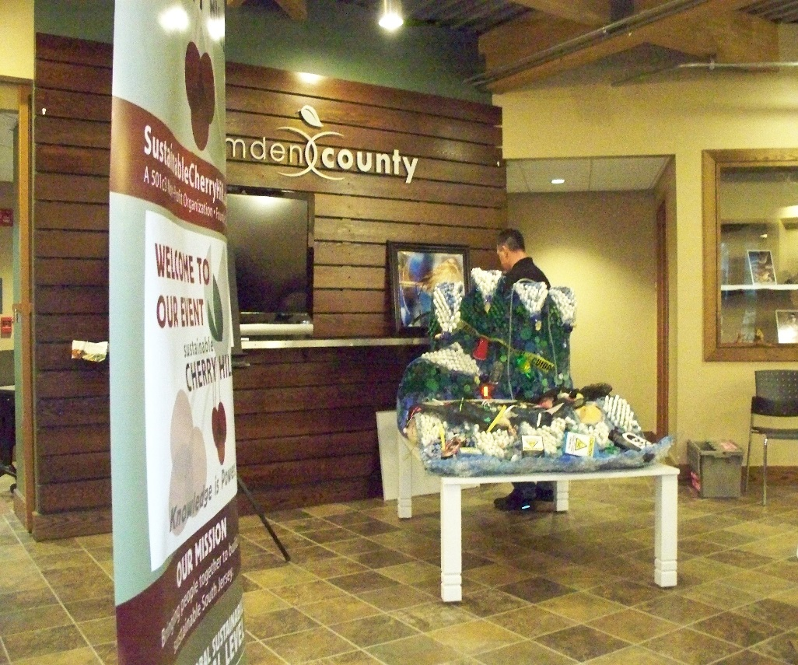

Sustainable Cherry Hill/Sustainable Haddon Township Community Program, Camden County Environmental Center, 1301 Park Blvd, Cherry Hill, NJ 08034

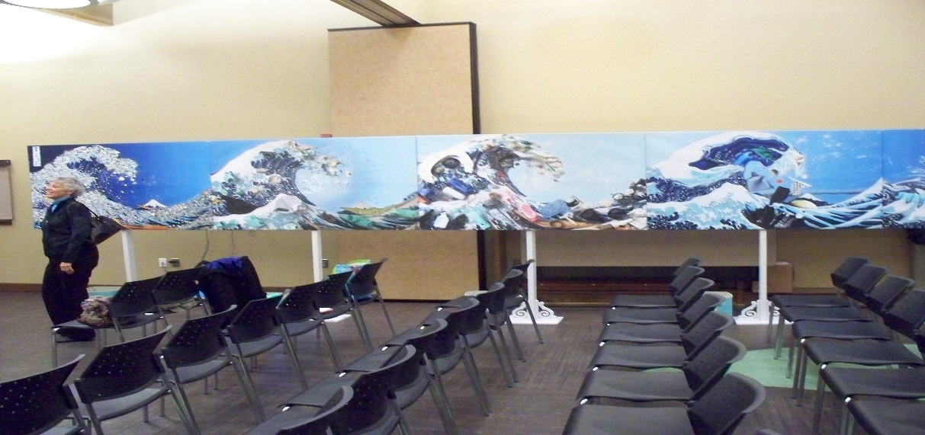
(Above, pre-presentation artwork displayed for the community to get up close and personal)
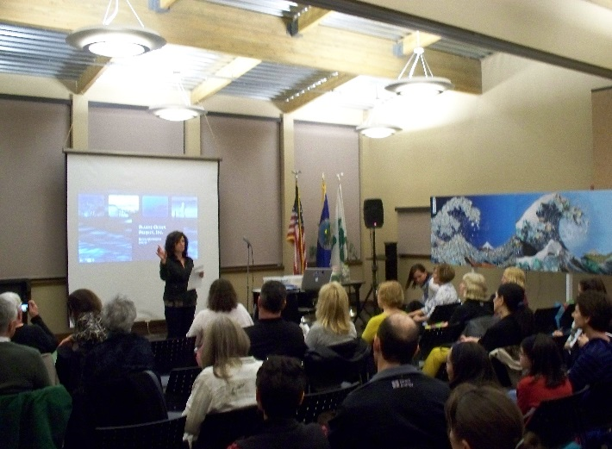
Pictured left, Lori Braunstein of Sustainable Cherry Hill introduces Bonnie Monteleone to a full house at the Camden County Environmental Affairs Building.
(Pictured below, the POP power point presentation details the problem in all of the world’s ocean gyres, not just the infamous Great Pacific Garbage Patch)
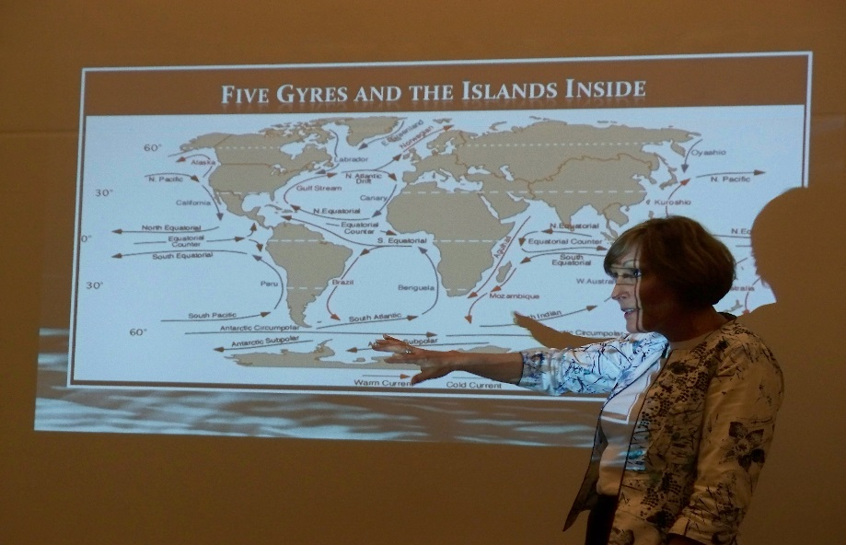

But wait, there’s more…

As the details of the Plastic Ocean Projects’ schedule are being finalized, Bonnie informs Barbara that they artwork may be left for display for a month. Barbara reached out to several institutions, including Rutgers University in Camden. The artwork was displayed for a month in Student Center where college students and local area schools had the opportunity to learn more about the problems of single –use plastic and the consequences and impact on our environment. The response from this exhibit was overwhelming, and many school inquired about having POP presentations.

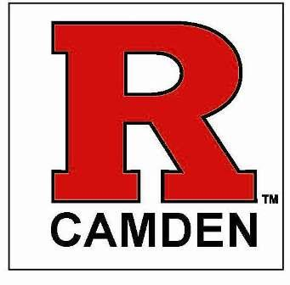

RUTGERS COORDATED EFFORTS:
- Barbara Prince, Sustainable Haddon Township
- Nathan Levinson, Rutgers
Director, Student Experience Center
Chair, Rutgers-Camden Sustainability cabinet
School of Business-Camden

- Patrick Wallace,
Associate Director of the Campus Center
Rutgers University - Camden

- Bonnie Monteleone, POP

- Tricia Monteleone, POP

From: Barbara Prince [bprince@haddontwp.com]
Sent: Thursday, December 12, 2013 9:51 AM
To: rugreen@camden.rutgers.edu
Subject: Plastic Ocean Project
To whom it may concern,
I am contacting you regarding a traveling education through art project that will be in our area in mid-March 2014. I will be the recipient of this display for several weeks and would love to share the exhibit with RU. As an alumni of Rutgers Camden, I feel a debt of gratitude to the university and this would be a great way to give back. I have also been involved with a number of other projects in the Camden area from partnering with Center for Environmental Transformation to the Art for Animals event held recently at the William Butler Gallery. For more information about the Project itself, go to http://theplasticocean.blogspot.com/ and http://www.plasticoceanproject.org/#/. Additionally, I please to announce that the Project was one of six winners of the international Ocean Project grant recipients ( and the ONLY US winner)!
I would love to speak with you about displaying the Project at Rutgers.
Sincerely,
Barbara Prince
Haddon Township Sustainability Coordinator

Barbara -

I got your email and your phone message. Thank you for bringing this to my attention as I am always looking for an opportunity to expose our students (and faculty and staff) to issues related to our environment, sustainability and global warming.

What I would like to do is first meet with the Director of our Student Center which is where I would like this displayed for the most exposure. Then if not there, I can look at other locations on campus.

I will be back in touch very soon and am certain we can have this great project on display here at Rutgers-Camden.

Nathan

Nathan Levinson
Director, Student Experience Center
Chair, Rutgers-Camden Sustainability cabinet
School of Business-Camden
nathan.levinson@rutgers.edu

Bonnie and Rutgers’ staff unload the exhibit for the final South Jersey exhibit!

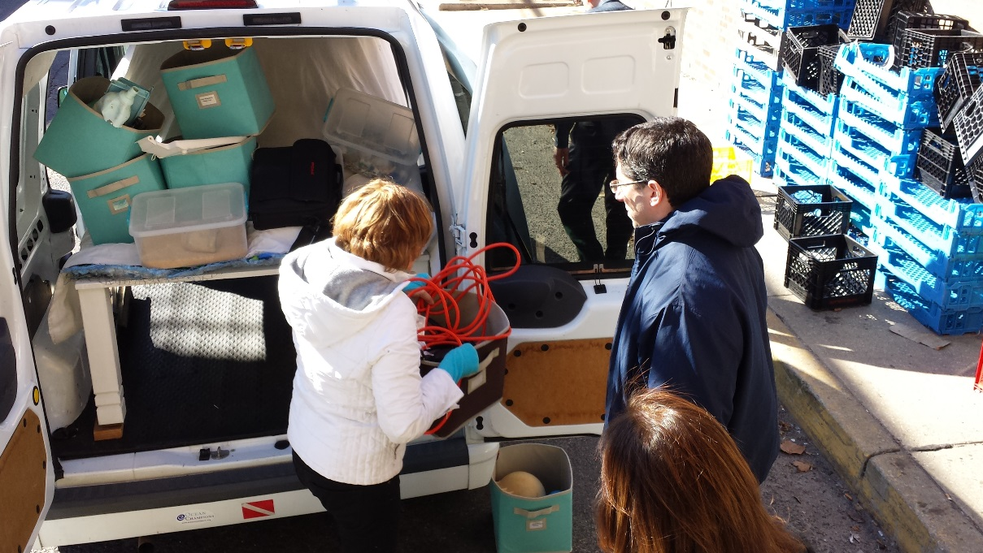

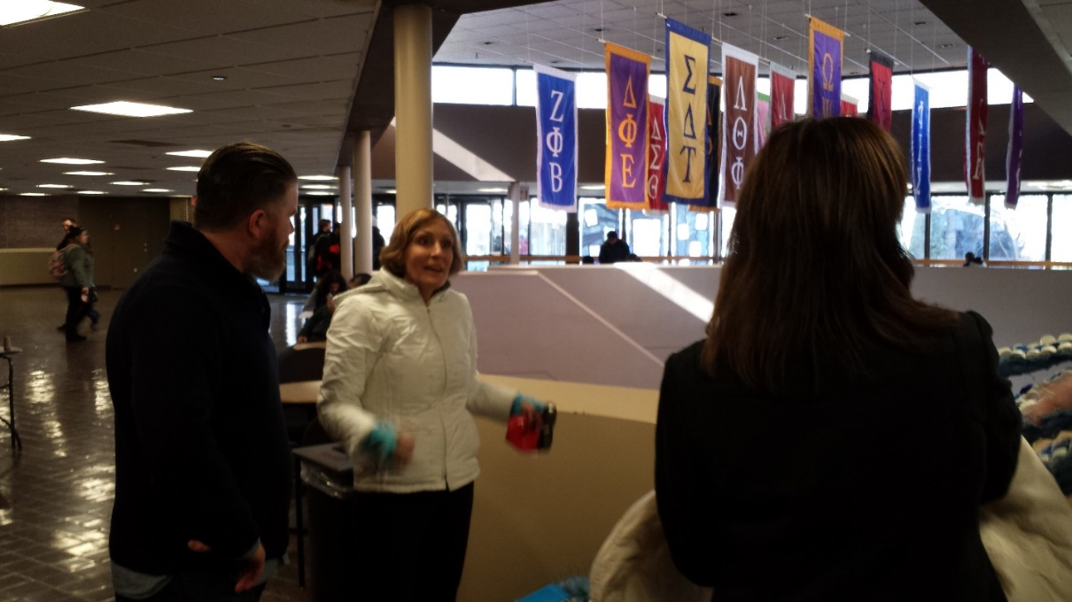
Bonnie with Patrick Wallace at the RU Student Center preparing for the POP art display.

