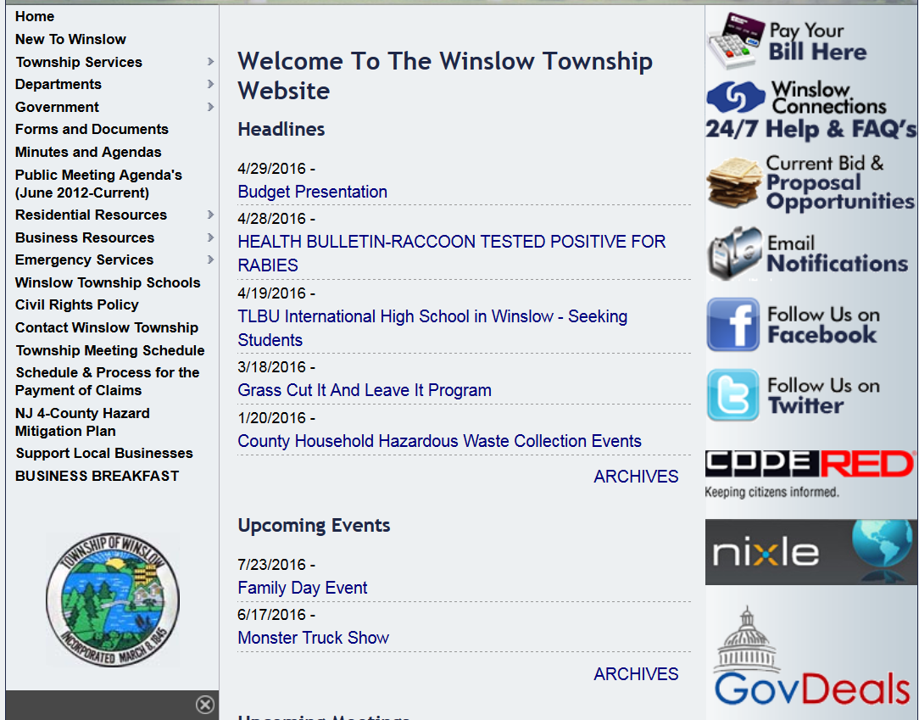
Township Website reflecting link to Hazard Mitigation Plan
Link on Township website for access to Winslow Hazard Mitigation Plan, and the plan as a whole for the 4 counties included.

