Stakeholder Involvement – Ewing Community Visioning 2014/2015

A significant part of the early work of the Ewing Green Team preparatory work in our Community Visioning process was the identification of stakeholders to invite to our Community Visioning, Community Conversation: Preserving Our Past; Transforming Our Future. We worked with our facilitators, Lori Braunstein and Natalie Barney in an exercise to identify stakeholders from all areas of township activities. We looked to identify government officials, both local and county, township staff, members of appointed boards and committees, school representatives, business owners, the faith community, local organizations, youth, non-profits, law enforcement, health advocates, the arts, and members of our neighboring communities who have worked with us in the past. The Stakeholder Master Matrix is uploaded.
Once identified, we mailed invitations to 228 people for the initial visioning day on June 7th. Approximately 5o people attended. The final “Ask” is uploaded.
Following the initial visioning day, the monthly meetings focused on refining the actions that we arrived upon on June 7th. Team members were specifically encouraged to attend the monthly meeting that related to their action, along with the general public.
Our second Visioning Day was held on January 12, 2015 to summarize the strategic plan as it had been worked on to that point and ask for final feedback before publication. About 30+ people attended. All initial Visioning attendees were re-invited to attend this final session, along with a number of others who we picked up during our process.
Included here:
- Screenshots of first pages of monthly meeting minutes after the Visioning Day and through the Visioning 2 which contain attendees for each meeting.
- Visioning 2 attendees – Spreadsheet screenshot.
- Photos of Visioning attendees at various meetings.

Meeting Minutes
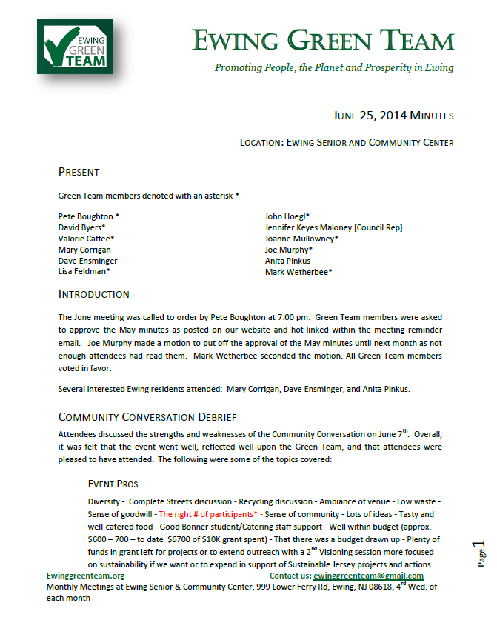
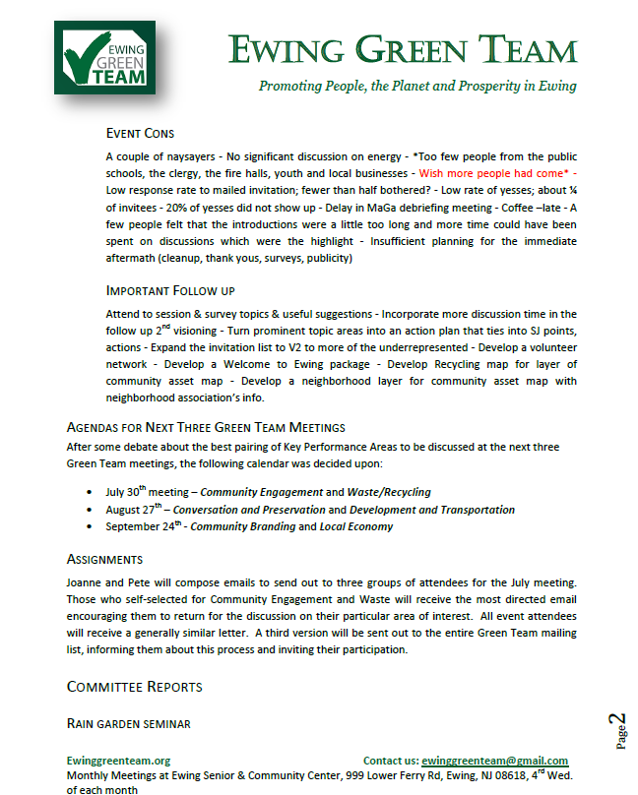

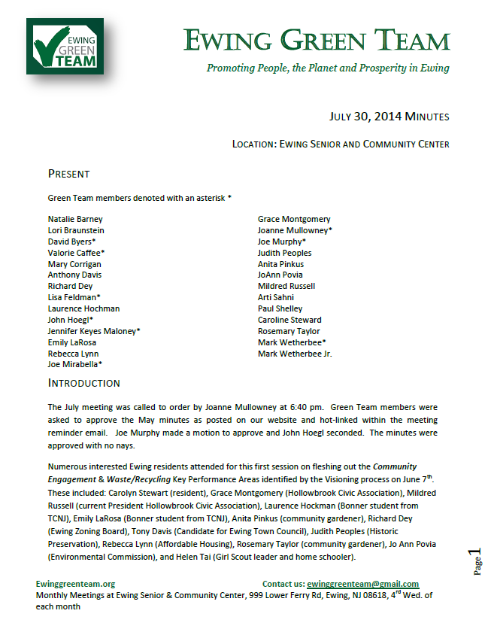
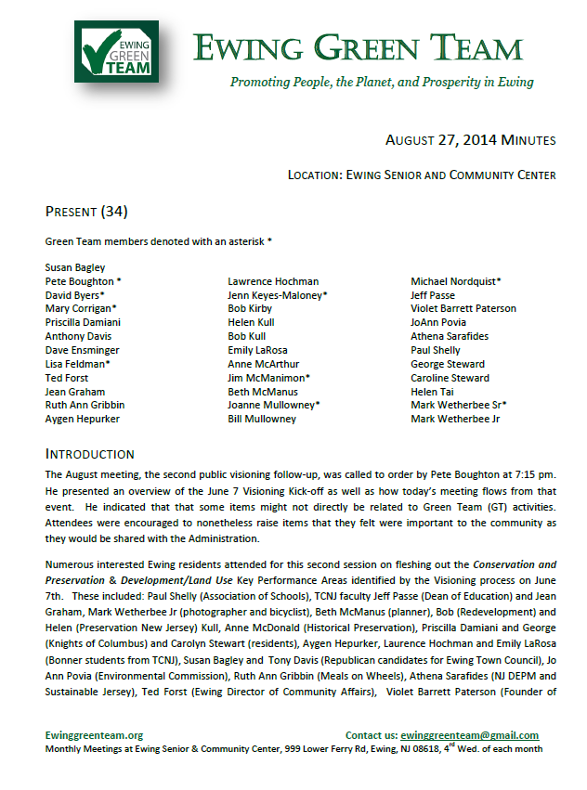
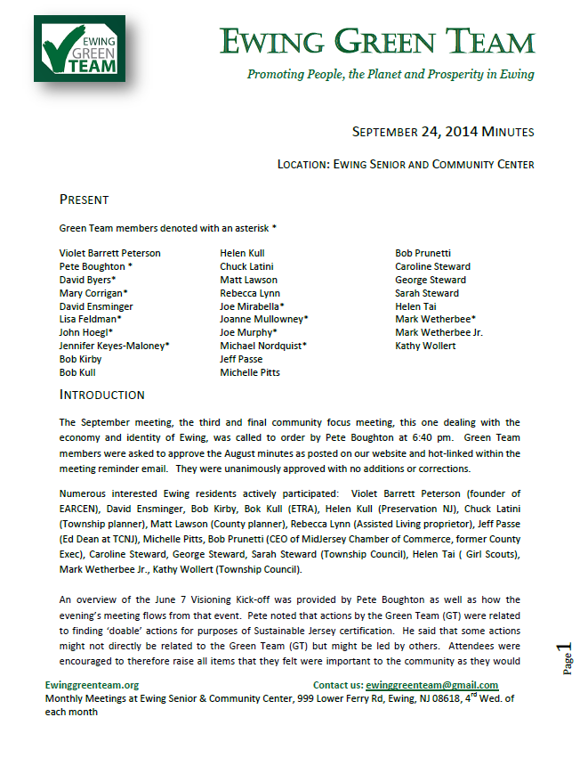
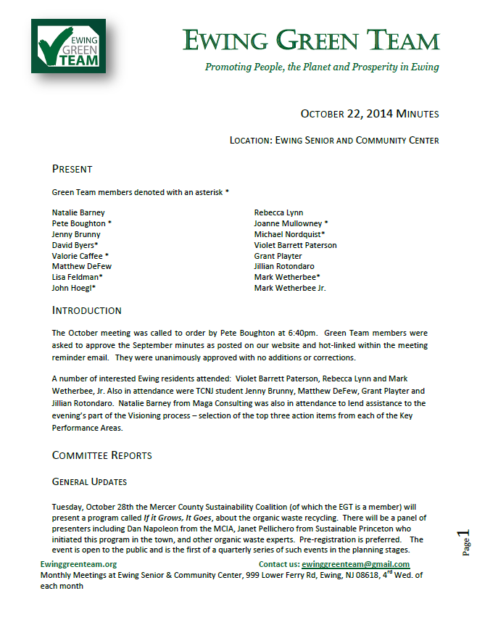

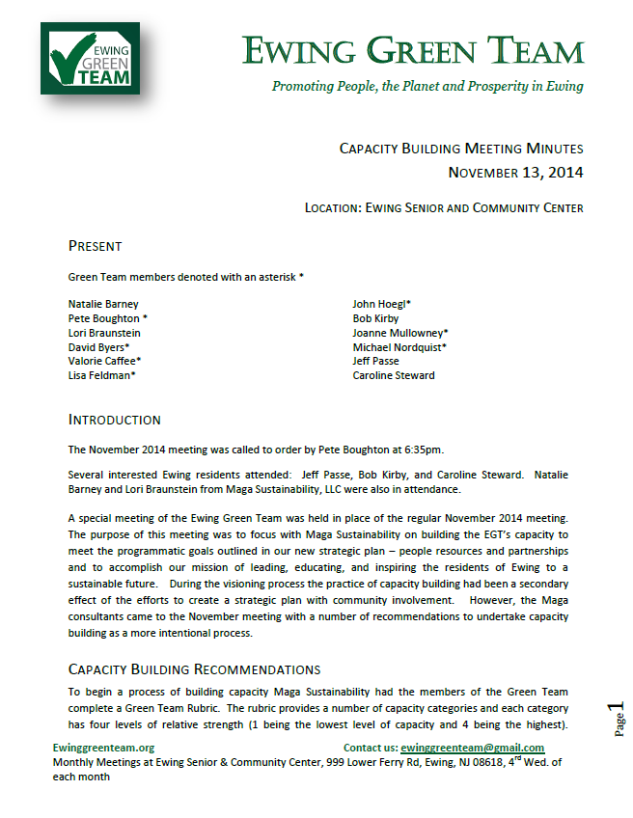
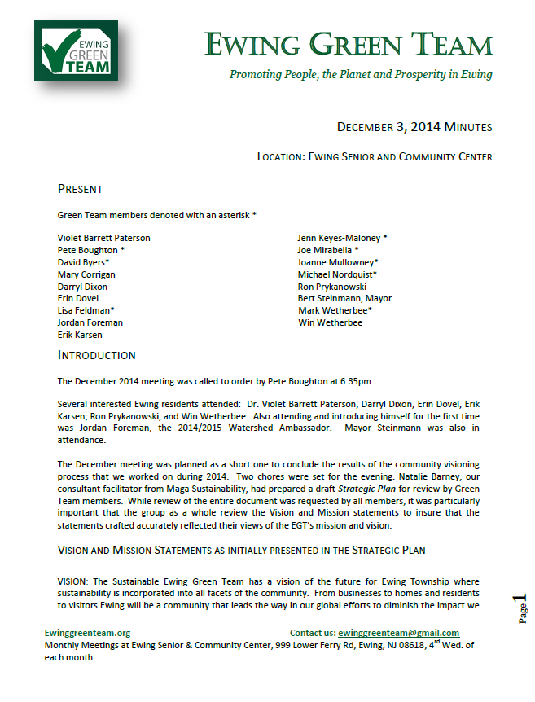

Visioning 2 Attendees – January 12, 2015

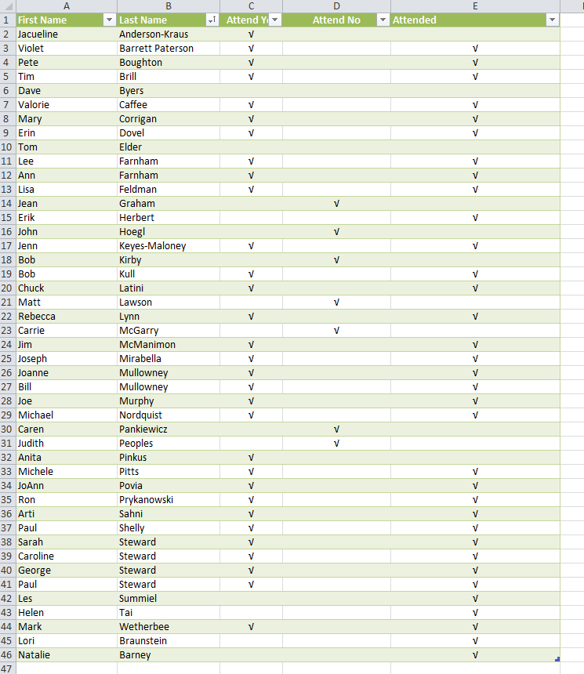

Visioning Photos

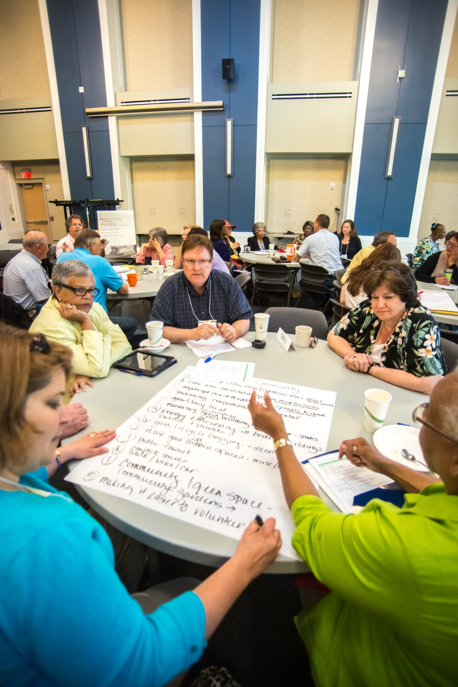
Figure 1- Community Visioning Day June 7

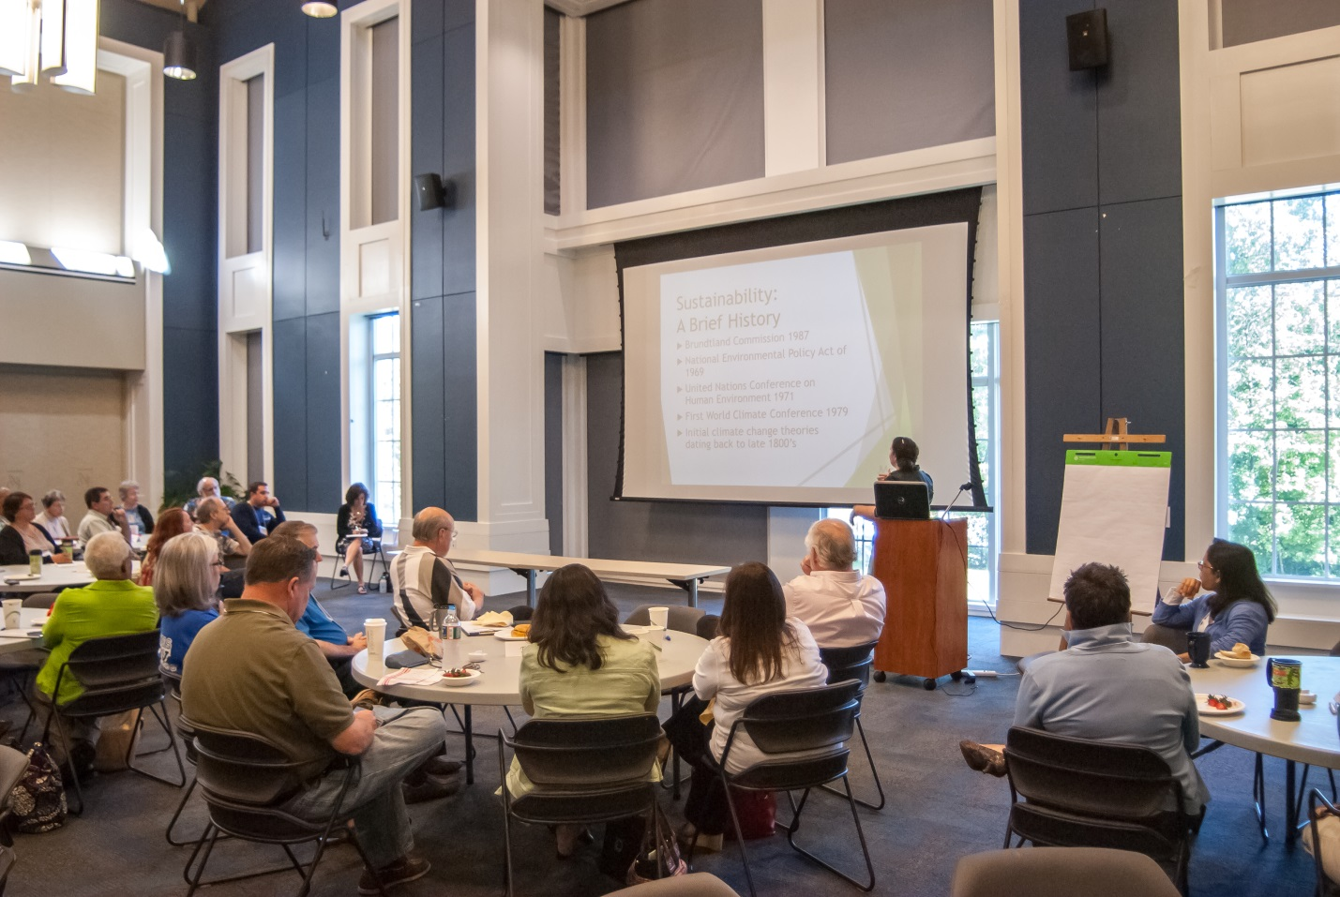
Figure 2 - Community Visioning Day June 7
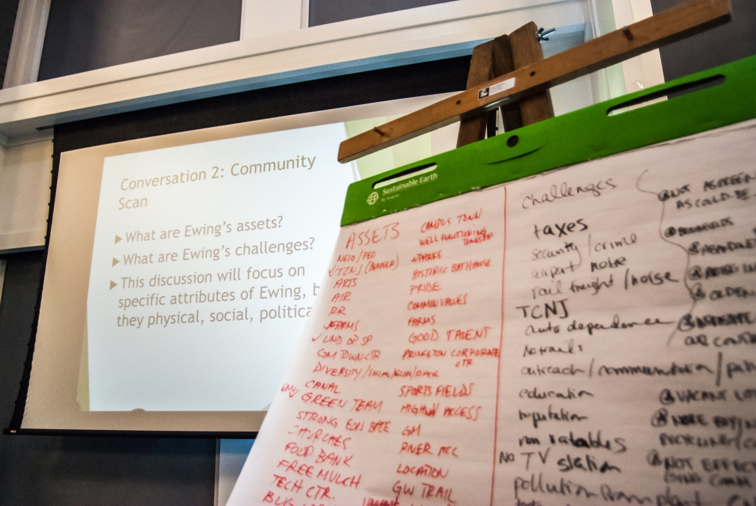
Figure 3 - Community Visioning Day June 7
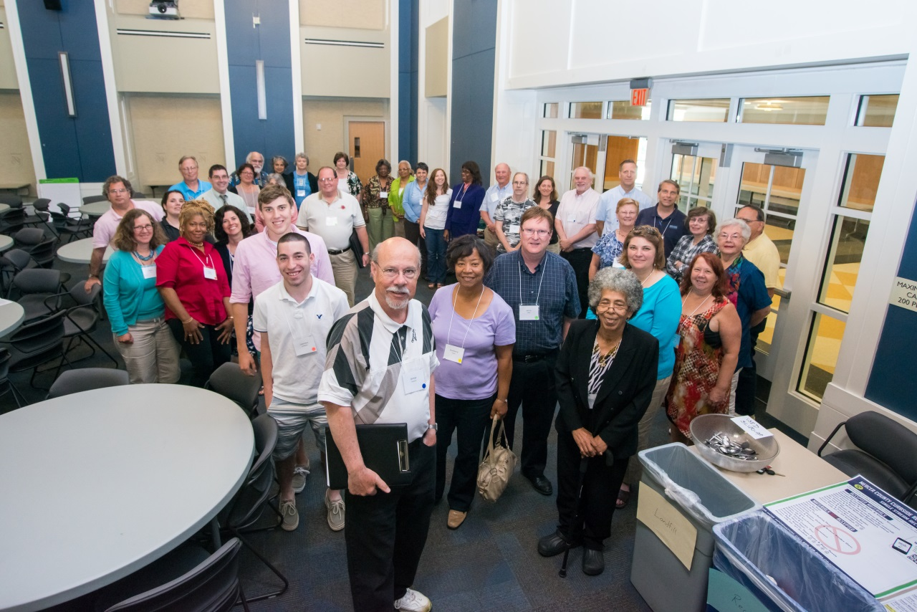
Figure 4 - Community Visioning Day June 7
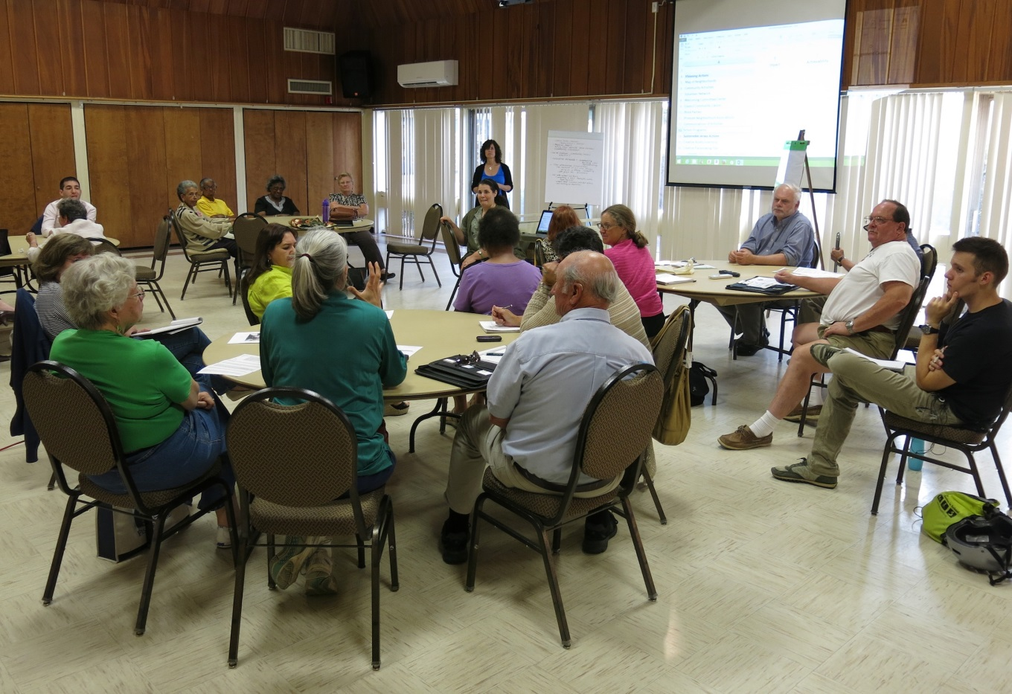
Figure 5 - Monthly meeting refinements
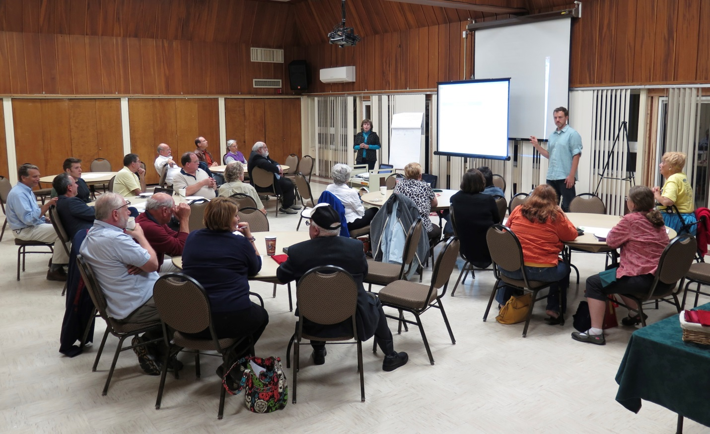
Figure 6 - Monthly Meeting refinements

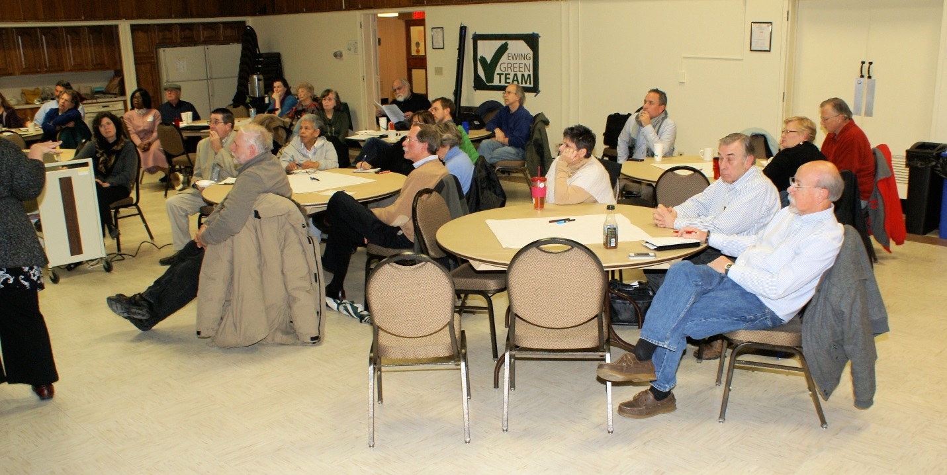
Figure 7 - Visioning 2 Attendees
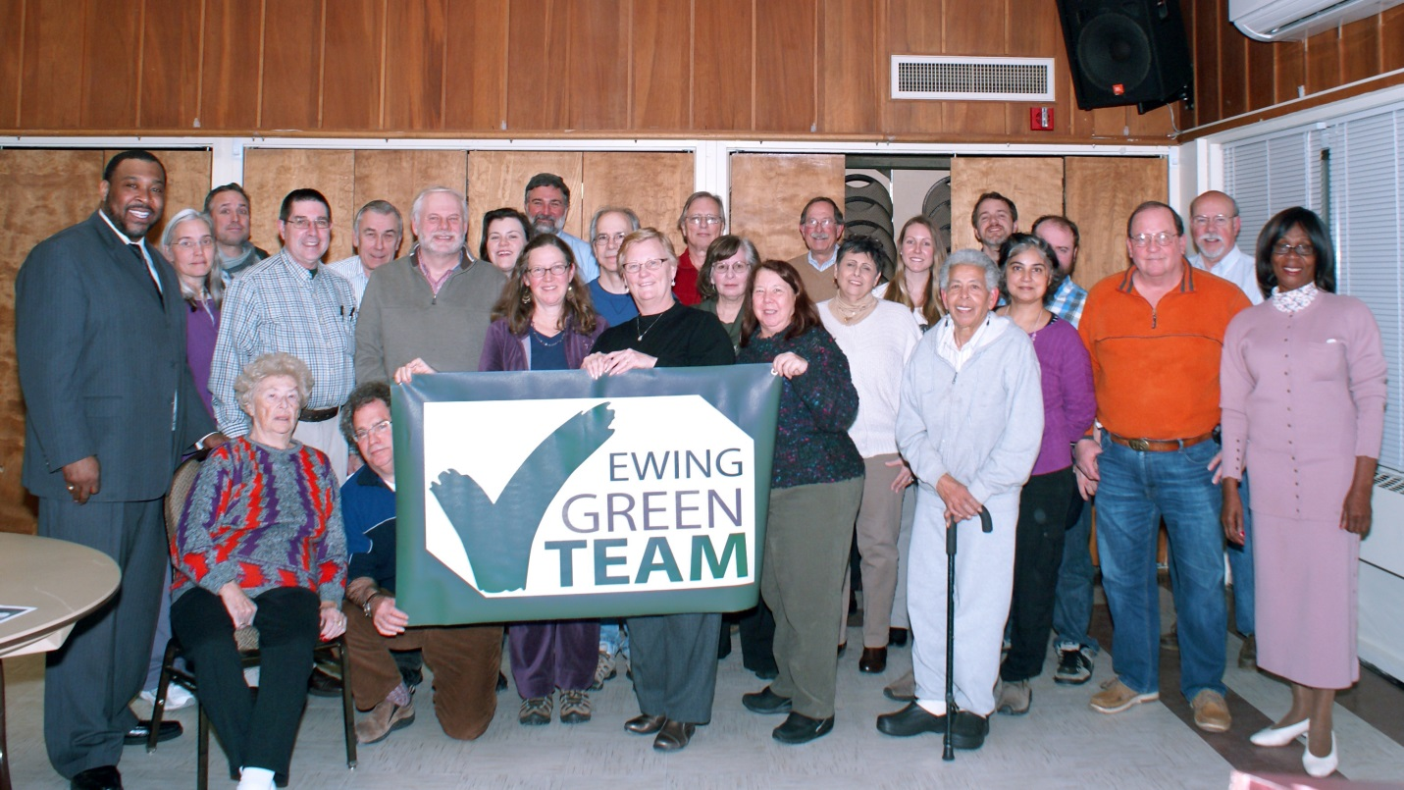
Figure 8 - Wrap Up Photo

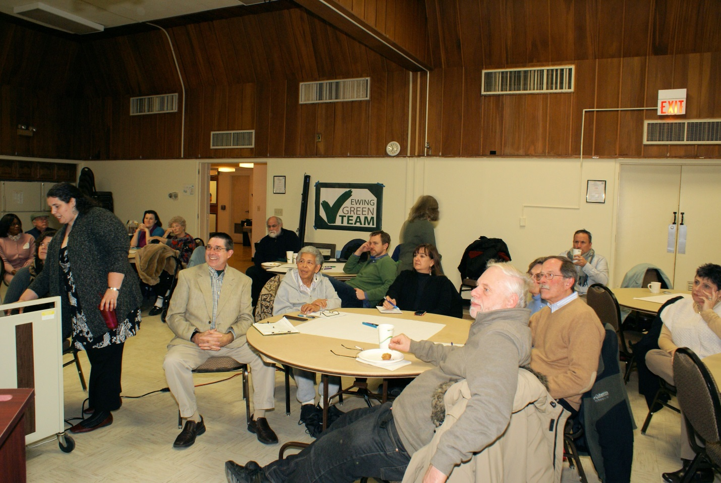
Figure 9 - Visioning 2 cont'd

