Shade Tree Explorers

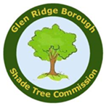

Mission BOOKLET
Assignment
Number One

Brought to you by the
Glen Ridge Shade Tree Commission

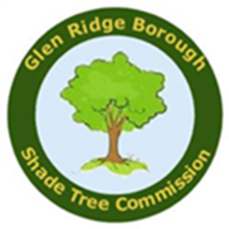
TO: Glen Ridge Shade Tree Explorers
FROM: Commissioner Baker
RE: Mission Assignment
Number One

Congratulations on becoming a Glen Ridge Shade Tree Explorer. To get started, you will need a Smartphone with a QR code reader app (example: QR Code Reader) and your Explorer Packet which includes:
- Glen Ridge Tree Explorer Mission Booklet
- Tape Measure
- Glen Ridge Shade Tree
Mission Passport Book

Have fun and good luck!

MISSION ASSIGMENT NUMBER ONE

- Find the trees identified on the Mission Map.

- Scan the QR Code Tag found on each tree identified on the Mission Map to learn more.

- Measure the identified trees’ circumference and use the Tree Age Decoder to determine the trees’ age.

- Answer the Mission Questions.

- Bring your completed Mission Booklet back to the Shade Tree Commission’s table at the EcoFair and have it stamped complete!

Mission One Map

Tree Age Decoder
6.
5.
4.
3.
2.
1.

Use the following steps to determine a tree’s age

- Use your tape measure to find the tree’s circumference approximately 4 ½ feet up from the ground.

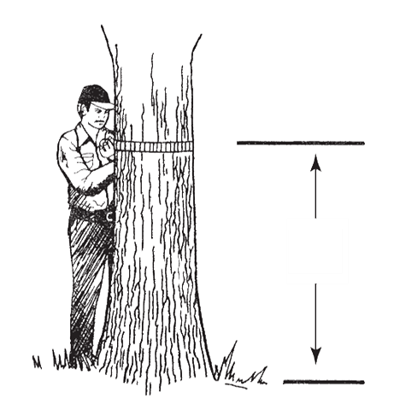
4 ½’

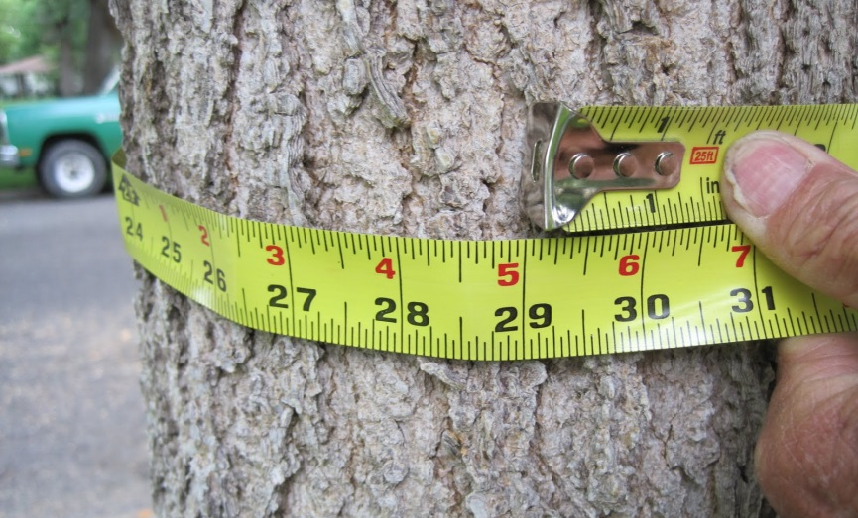

- Calculate the tree’s diameter

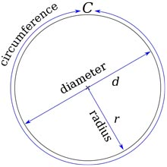

Circumference ÷ 3.14=Diameter

- Scan the QR code found on the tree and determine the tree’s species

This is an example of a QR code. A unique tag with a QR code can be found on each tree identified on the
Mission Map
- Find the species growth factor on the chart below

Tree | Growth Factor
American beech | 6
American elm | 4
American sycamore | 4
Black cherry | 5
Black maple | 5
Black walnut | 4.5
Bradford pear | 3
Common horsechestnut | 8
Colorado blue spruce | 4.5
Cottonwood | 2
Douglas fir | 5
European beech | 4
European white birch | 5
Green ash | 4
Ironwood | 7
Kwanzan Cherry | 2
Kentucky coffee tree | 3
Littleleaf linden | 3
London Plane | 4
Northern red oak | 4
Norway maple | 3.5
Plum | 2
Pin oak | 3
Redbud | 7
Red maple | 4.5
Red pine | 5.5
River birch | 3.5
Scarlet oak | 4
Shagbark hickory | 7.5
Shingle oak | 6
Shumard oak | 3
Silver maple | 3
Sugar maple | 5.5
Sweet gum | 4
Tulip tree | 3
White ash | 5
White fir | 7.5
White oak | 5
Yellow buckeye | 5
5. Multiple the diameter by the growth factor and you have the tree’s age!

Diameter calculated in Step 2 times
Growth Rate found in Step 4 equals Tree Age

D x GR = Tree Age

Mission Work Sheet

Tree No. | Circumference |  | Pi |  | Diameter |  | Growth Rate |  | Age
1 |  | ÷ | 3.14 | = |  | x |  | =
2 |  | ÷ | 3.14 | = |  | x |  | =
3 |  | ÷ | 3.14 | = |  | x |  | =
4 |  | ÷ | 3.14 | = |  | x |  | =
5 |  | ÷ | 3.14 | = |  | x |  | =
6 |  | ÷ | 3.14 | = |  | x |  | =

Mission Questions
- Which tree is the largest tree identified on the Mission Map? 1. 2. 3. 4. 5. or 6.

B. Where is the oldest tree identified on the Mission Map? 1. 2. 3. 4. 5. or 6.

C. What is your favorite tree? 1. 2. 3. 4. 5. or 6.

D. Which tree on the Mission Map is threatened by a species of beetles from Asia?
1. 2. 3. 4. 5. or 6.

E. Which tree on the Mission Map features white and pink flowers in the spring?
1. 2. 3. 4. 5. or 6.

Mission Complete!
Congratulations! Bring your booklet back to the Shade Tree Commission table at the EcoFair for review of your answers and get your Mission Booklet stamped.

_________________________________________
Official Stamp and Signature

Shade Tree Commission

Elizabeth K. Baker, Chair
Sally Ellyson, Vice Chair
Larry Stauffer
Eric Hanan
Andrew Tedesco

http://glenridgenj.org/shadetree.htm

