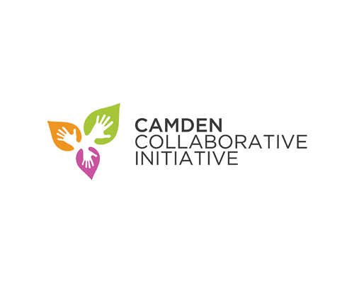
Green Team Partners Meeting
April 25, 2016
2pm-4pm
@ CCMUA

Attendees: Chris Waldron, Valeria Galarza, Rudisha Beattie, Dana Dobson, Riche, Sarah Joslin

- Sustainable Jersey
  - Action Item Responsibilities

- Additional Discussion

Follow-Up: Caroline, Chris would like to know what if any information has you completed for the actions within the spreadsheet. Please follow up with him.

- June 5, 2016 is the deadline for actions anticipated to be completed application submission
- September 11, 2016 is the deadline for full application to be completed
- May 21, 2016 asking all contributors to have information gathered for actions to be applied to

Next Steps: Val will follow up with Meishka about Kresge grant providing points for place-making points

Next Steps: Caroline is there still a shredding day held within the city?

Next Steps: Chris will update Actions along with responsible parties for each action and send out to Caroline, Caroline can you send this out to the group?

Next Steps: Caroline can you create a doodle poll for a meeting before the next monthly meeting to address sustainable jersey steps and completed actions. Group would like to meet May 16, 2016 at 2pm for this meeting.

