Camden County Municipal Utilities Authority,

Executive Director/Chief Engineer Andrew Kricun

- presents –

2015
Green Ambassadors Internship Program Guide
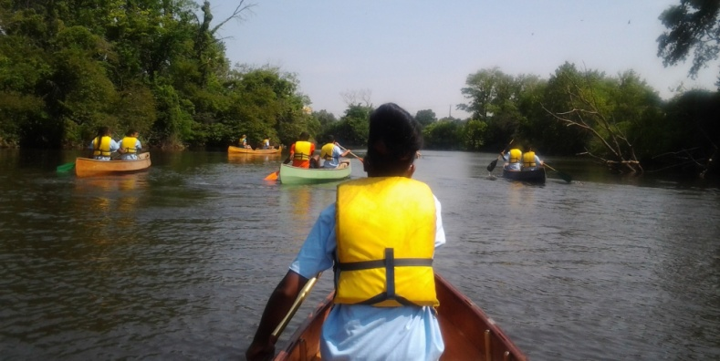
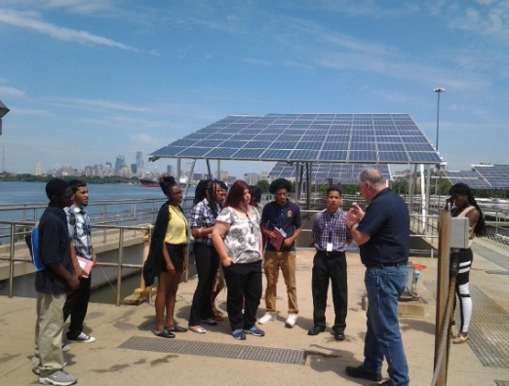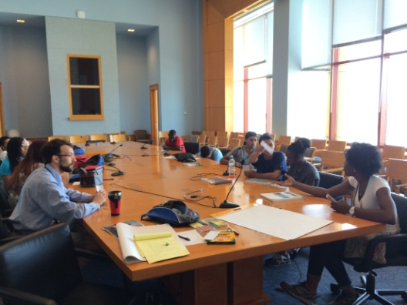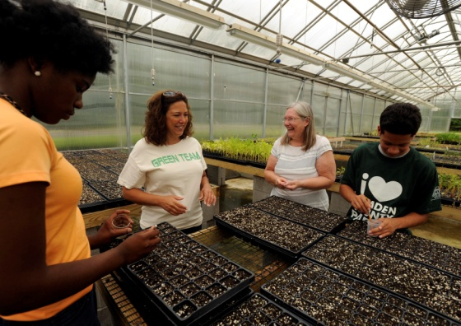
Daily Itinerary and Instructions
July 7-August 8, 2015
Message from the Green Ambassadors Counselor:
Hello Green Ambassador Interns of 2015!
Thank you for applying yourself and being selected for this year’s Green Ambassadors Internship Program. This is the second year of this program, and with our shared efforts it will be even greater than last year. We will spend the next 5 weeks together meeting with environmental organizations in the Delaware Valley and developing our skills in the Green Arts. It is our job, as Ambassadors, to learn what we can from each of our Partners and determine how to best share what we learn with our communities.
Last year’s Ambassadors developed a plan to share what they learned with their friends and family. They designed an event they called the Camden Green Fair & 3-on-3 Basketball Tournament. This event, they imagined, would smartly combine an athletic competition with a fun and engaging Green Fair to allow Partners to share their knowledge and services with the community.
This year, for your final project you will be tasked to organize and host the first annual Camden Green Fair & 3-on-3 Basketball Tournament! We will spend one morning each week reviewing the information we learned from our Partners and consulting with them on how to present their services and knowledge at our Green Fair. We might make up educational games, help pick out the most interesting information to share, or select photos that we took of their projects that we’d like to share. Our Intern-in-Chief, Donta Rose will help assist us to make sure we are on track to deliver a great day on August 5th.
Additionally, you will be given an Adviser to assist you in developing your skills as a Green Ambassador. Among this year’s Advisers are skilled farmers, artists, musicians, community activists, and former Peace Corps Volunteers. Your Adviser will check-in with you via a weekly phone call to hear about your experience with our Partners and assist you in getting the most out of this internship program.
Moreover, this guide is here to help us in our day to day activities. Inside, you will find an outline for our schedules, as well as a detailed description of our daily Check-In and Check-Out Routine. These routines are designed to build teamwork and at the same time encourage each person to grow as an eco-social leader. They will help us develop the skills we need to host a successful Camden Green Fair & 3-on-3 Basketball Tournament and truly serve as Green Ambassadors in the community!
I am very lucky to be leading this program for another year and I look forward to getting to know each of you on this journey!
Matt Bennett
Green Ambassadors Opening Routine
Time | Activity
8:45 AM | Counselor arrives
 | Gets van key from Office
 | Drives to Plant, parks, and picks up van and parks by CCMUA Office
 | Signs In, Says Hello to James
 | Unlocks Laptop & Cameras, sets up laptop
 | Checks Email
 | Studies Day Plan
 | Share Expectations for the Day
8:50 AM | Greets Interns upon arrival, reminds them to sign in, say hi, reflect, study Day Plan
9:05 AM | Opening Board Room Meeting
 | Thanksgiving for safe travels, full attendance, good weather, full bellies, AC, pay, etc
 | Morning Check-In to share individual statuses (feeling, thinking, sensing, needs)
 | Review Standouts & Further Reflection from Prior Day (Popcorn Style)
 | Discuss Day Plan – different intern reads, augmented w/ new info from counselor
9:15 AM | Daily Expectations - share individual hopes, fears, ‘curiosities’ about the Day Plan
 | Inspirational quote, or joke of the day, or what have you
 | Intern volunteers for co-pilot, if needed and receives printed directions
 | Board Van
9:20 AM | Leave for Destination

Green Ambassadors Closing Routine
Time | Activity
1:15 PM | Brief Closing Circle for Site with Program Representatives
 | Counselor-led Thanksgiving via summary of day, standouts, questions
 | Interns share Standouts, Most Relevant Info/Services for Community, questions
 | Ask Program Reps for their impressions, suggestions, recommendations for us
 | Thank Program Reps and discuss following up with them
 | Board Van
 | Ensure all equipment returns in van
1:30 PM | Travel back to CCMUA
 | Intern reads schedule for tomorrow while on the road
 | Interns send pictures, videos, other media to Counselor for review at end of week
1:45 PM | Van arrives – parks at CCMUA Office
 | Interns gather belongings and exit van
 | Assign intern to ‘sweep’ van to ensure all belongings taken
 | Enter CCMUA Office, Review day with Jackie
2:00 PM | Sign out
 | Intern-In-Chief downloads photos & videos onto laptop
 | Place cameras, camcorders, and any other CCMUA equipment on back table
 | Counselor returns to conference room
2:30 PM | Writes brief summary & ‘Standouts’ of day and emails to Scott & Kim
3:00 PM | Phone next day’s Partner to check-in, review plan
 | Locks up electronics
 | Signs out with James
 | Drives van to Plant and parks, drives back to Office
 | Places Van Key back in Office
 | Counselor Departs

Tuesday
July 7, 2015

Host Organization | Camden County Municipal Utilities Authority
Time | 9:00 a.m. – 2:00 p.m.
Location | Camden County Municipal Utilities Authority
Location Address | 1645 Ferry Ave  Camden, NJ
Activity | Meet the Team! Today we will get to know each other and our Advisers for the program. In the afternoon, we will take a tour of the Water Pollution Control Facility. What happens to everything that goes down our sinks and gets flushed away? Today we learn these answers, and more, from our tour of the CCMUA treatment plant.
Notes | Please remember to bring your folders and working papers.
Contact Person | Scott Schreiber (856-583-1261)  Kim Michelini (856-583-1282)
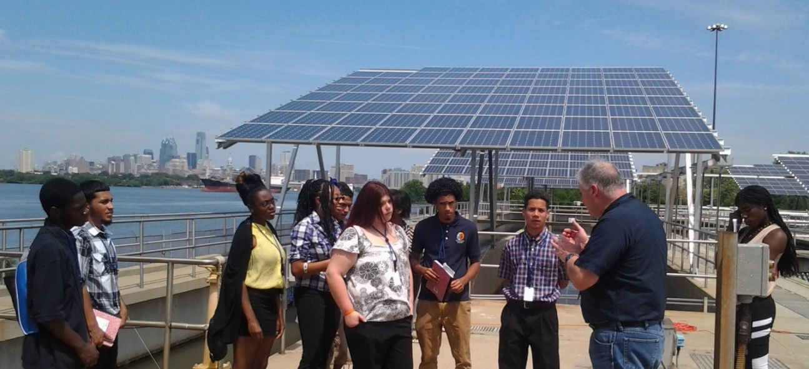

Wednesday
July 8, 2015

Host Organization | Kroc Center and the NJ Department of Environmental Protection
Time | 9:00 a.m. – 2:00 p.m.
Location | Kroc Center
Location Address | 1865 Harrison Ave  Camden, NJ 08105
Activity | Today we will visit the Kroc Center and learn about its transformation from a waste disposal site into a world class community asset. We will learn about Environmental Remediation, Green Construction, and get a tour of the Farragut Marina.
Notes | Wear Work Clothes, we will get dirty
Contact Person | Frank McLaughlin (609-633-8227)  Demetrius Marlowe (856-338-1700)
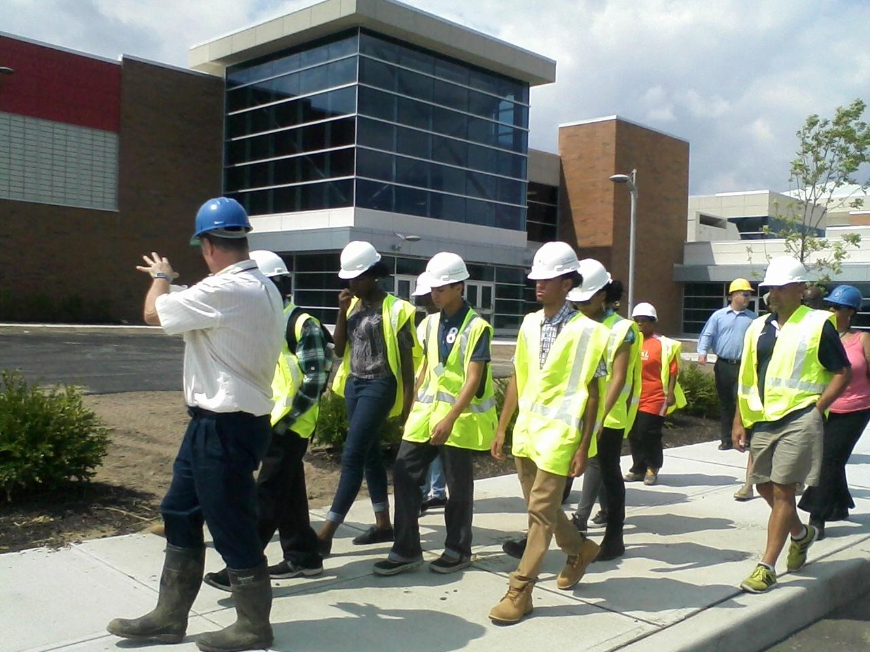

Thursday
July 9, 2015

Host Organization | New Jersey Conservation Foundation
Time | 9:00 a.m. – 2:00 p.m.
Location | Gateway Park
Location Address | Admiral Wilson Blvd & Baird Blvd
Activity | The mission of New Jersey Conservation Foundation is to preserve New Jersey’s land and natural resources for the benefit of all. They protect threatened natural areas and farmland through land acquisition and stewardship, promote strong New Jersey land use policies and forge partnerships to help safeguard water and other natural resources. They partnered with the CCMUA to open Camden’s much-anticipated Gateway Park. Today we will learn about the history of the organization and look at some maps of their conservation work. Lastly, we will take a tour of Gateway Park to see firsthand their efforts here in Camden.
Notes | Dress Business Casual, yet be prepared to take a walk in the park
Contact Person | Olivia Glenn (908-997-0731)

Friday
July 10, 2015

Host Organization | Center for Environmental Transformation
Time | 9:00 a.m. – 2:00 p.m
Location | CFET Greenhouse
Location Address | 1729 Ferry Avenue  Camden, NJ
Activity | We will work and learn in CFET’s Greenhouse Classroom. Here CFET grows seedlings for their gardens, to sell to area gardeners, and to give to neighborhood residents interested in growing their own produce. We will be helping to prepare for their weekly farmer’s market by harvesting produce, cleaning it, and helping to set up the market stand.
Notes | Wear comfortable shoes and clothing you don’t mind getting soiled*
Contact Person | Dean Buttacavoli (732-861-4666)
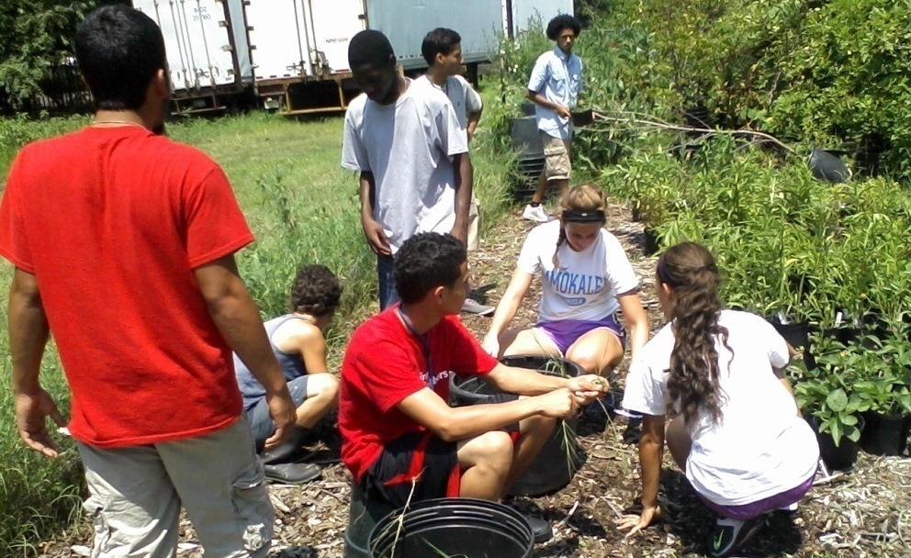
*gardening joke
Monday
July 13, 2015

Host Organization | Urban Trekkers/ Urban Promise Academy
Time | 12:00 p.m. – 4:00 p.m
Location | Cooper River
Location Address | Kaighn Ave Dam
Activity | Today we will be paddling down the tidal portion of the Cooper River to get to see Camden from a natural perspective. We will drive to the Kaign Avenue Dam and put our boats in there. We will paddle all the way down to the back channel of the Delaware River and take out at Pyne Poynt Park in North Camden. We’ll eat a late lunch there then come back.
Notes | Bring a bagged lunch and wear clothes and shoes okay to get wet!
Contact Person | Jim Cummings (856-382-1875)
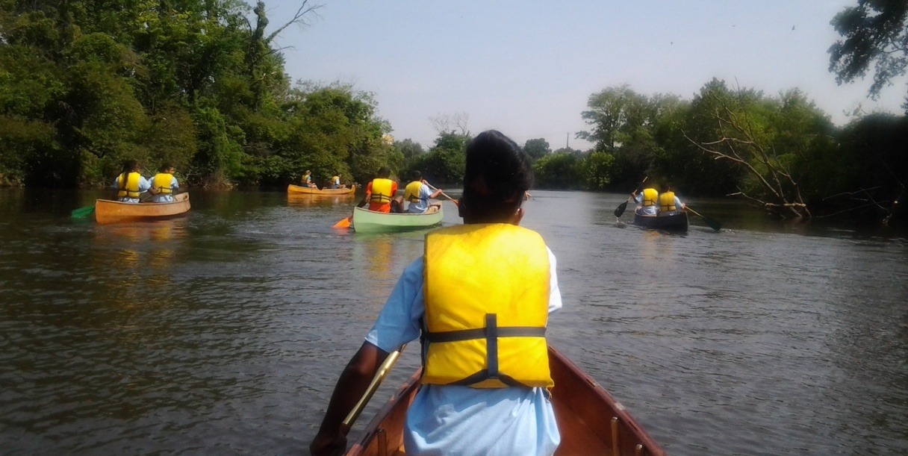

Tuesday
July 14, 2015

Host Organization | Camden County Municipal Utilities Authority
Time | 9:00 a.m. – 2:00 p.m
Location | Camden County Municipal Utilities Authority
Location Address | 1645 Ferry Ave, Camden, New Jersey
Activity | Camden SMART rain garden maintenance day. We will visit two of the rain gardens, which help to catch, store, and filter storm-water, and keep it out of our combined-sewer system. The day includes weeding, pruning, and caring for these special plantings that are both useful and beautiful.
Notes | Wear gardening clothes and bring a water bottle.
Contact Person | Doug Burns (856-583-1260)
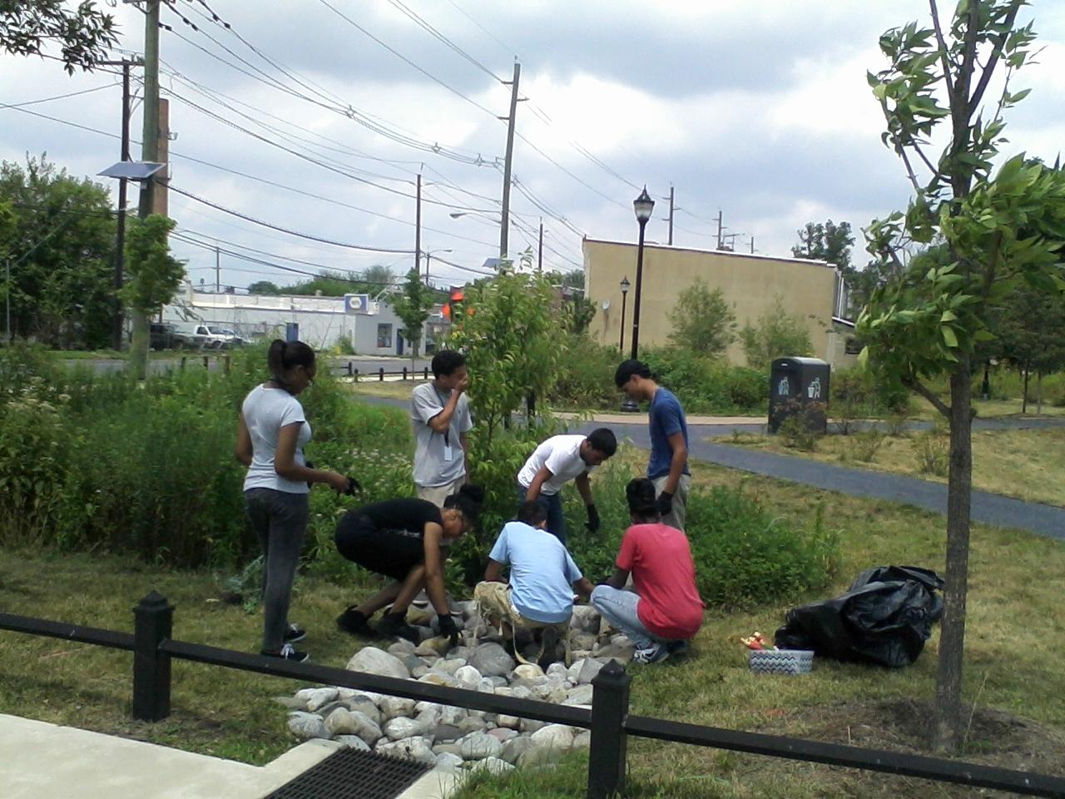

Wednesday
July 15, 2015

Host Organization | Cooper’s Ferry Partnership
Time | 9:00 a.m. – 2:00 p.m.
Location | Cooper’s Ferry Executive Boardroom
Location Address | One Port Center  2 Riverside Drive, Suite 501
Activity | Cooper’s Ferry Partnership facilitates community redesign by working collaboratively with Camden’s governments, residents, artists, engineers, companies and designers. Today Ambassadors will showcase their artistic side by designing their own pop-up park, a Connect-the-Lots Initiative spearheaded by Cooper’s Ferry Partnership. Ambassadors will learn from this example what it takes to turn a vacant lot from grass and dirt into passive and active recreational centers for the residents of the City.
Notes | Dress Business Casual. *Time permitting we’ll go to 3rd & Birch’s pop-up skate-park*
Contact Person | Caroline Gray (856-757-9154)

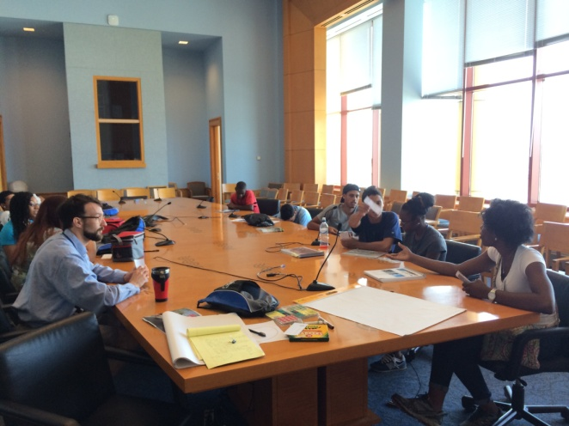
Thursday
July 16, 2015
Host Organization | Experimental Farm Network
Time | 9:00 a.m. – 2:00 p.m
Location | Experimental Farm Network
Location Address | Elmer, NJ
Activity | Adviser Dusty Hinz co-manages the Experimental Farm Network, an open source plant breeding program to encourage the development of healthier and easier to manage food plants. Here we will get an overview of their work and spend a day helping out on the farm where they grow many unique and rare varieties of edible plants. Additionally, Meko Freeman will share his story in the environmental movement and music therapy and lead us in a chant and work song creation.
Notes | Wear gardening clothes and your CCMUA shirt.
Contact Person | Dusty Hinz (612-834-7502)

Friday
July 17, 2015

Host Organization | Camden County Environmental Center
Time | 9:00 a.m. – 2:00 p.m.
Location | Camden County Environmental Center
Location Address | 1301 Park Boulevard  Cherry Hill, NJ
Activity | Green Arts Development Day with Advisers  Jean-Jacques, an expert on Nutrition and Yoga, and Charlyn Magdaline, a teaching artist and entrepreneur. First, Donta Rose will lead us in reviewing our partners from the past week to assist in their presentations at the Camden Green Fair and 3-on-3 Basketball Tournament. After a quick dance work-out from James, we will head to the Camden County Environmental Center. There, Jean-Jacques will share some science and story behind healthy eating and we will make some smoothies together. Additionally, he’ll lead us in some yoga! Charlyn will share some stories of her travels around the world and lead us in a creative activity to help us reflect and envision a never-before-seen future.
Notes | Wear clothes for athletics & yoga
Contact Person | Matt Bennett (856-345-9453)

Monday
July 20, 2015

Host Organization | Camden County Municipal Utilities Authority.
Time | 9:00 a.m. – 2:00 p.m.
Location | CCMUA
Location Address | 1645 Ferry Ave, Camden, New Jersey
Activity | Camden SMART rain garden maintenance day. We will visit another two of the rain gardens. The day includes weeding, pruning, caring for the plants.
Notes | Dress ready to garden!
Contact Person | Doug Burns (856-583-1260)
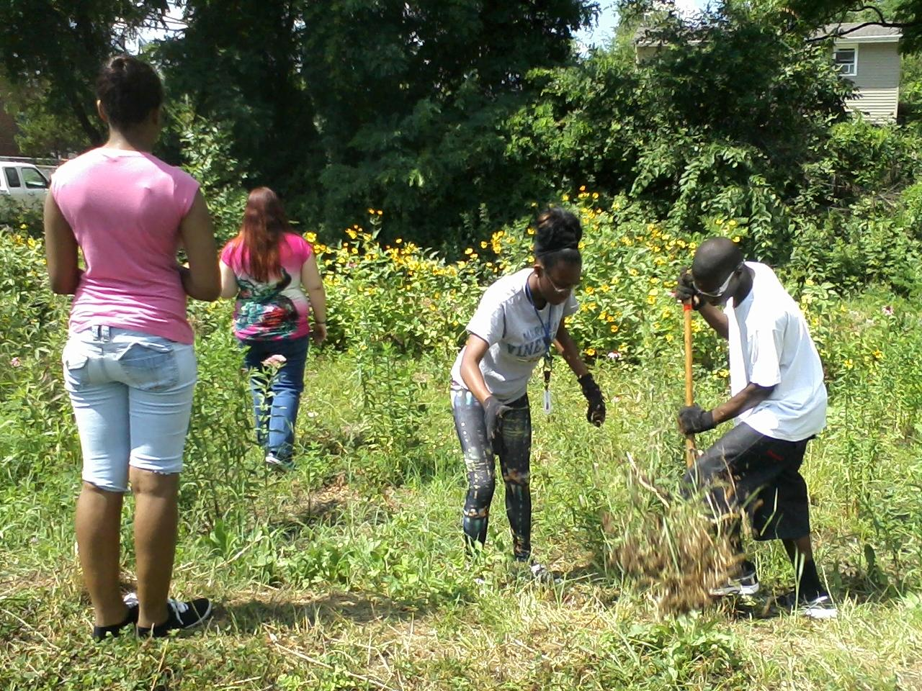

Tuesday
July 21, 2015

Host Organization | Haddon Township Environmental Commissions
Time | 9:00 a.m. – 2:00 p.m.
Location | Saddler’s Woods
Location Address | 250 MacArthur Blvd  Haddon Township, NJ 08108  and  143 E. Ormond Ave
Activity | We will get a tour of the trails at Saddler’s Woods and do some environmental restoration work. Then we will head over to the Environmental Center to view the items on display, have lunch and listen to a presentation on the history of the area and how to serve in the environmental industry.
Notes | Please have the students dress in work clothes, sturdy work boots or shoes that can get muddy, long pants, long sleeved shirts ( even if it is hot). Please have them bring a reusable bottle for water to have with them in the woods. We can work rain or shine in the woods ( as long as there are no tornados!) so please have everyone wear rain jackets etc. as needed. We will provide tools and work gloves.
Contact Person | Janet Goehner-Jacobs (609-238-4744)  Mike (609-505-1630)  Maggi (856-237-5584)

Wednesday
July 22, 2015

Host Organization | NJ Department of Environmental Protection
Time | 9:00 a.m. – 4:00 p.m. (late day)
Location | NJ DEP Water Monitoring Lab
Location Address | 929 E Stoney Hill Rd  Leeds Point, NJ
Activity | The New Jersey Bureau of Marine Water Monitoring is involved in many aspects of the State's coastal water quality. It's roles include monitoring for compliance with the National Shellfish Sanitation Program, coordination of coastal bathing beach monitoring, removal of trash from coastal beaches, evaluation of the ecological health of the coastal waters, and monitoring to identify and track pollution sources impacting the State's coastal waters. We will go on a tour of the indoor laboratories, learn about careers there, and weather permitting, take a boat trip out onto the water to collect water and other study samples.
Notes | Business Casual Attire, Boots or sturdy shoes for a boat ride
Contact Person | Bruce Friedman (609-306-1826)  Tanya Oznowich (609-984-9802)  Leeds Point (609-748-2000)

Thursday
July 23, 2015

Host Organization | New Jersey Conservation Foundation
Time | 9:00 a.m. – 2:00 p.m
Location | CCMUA
Location Address | 1645 Ferry Ave
Activity | Today we will learn about the Gateway Park Management Plan from the New Jersey Conservation Foundation. What does it take to manage a park that includes forests, grass, a river, trails, lighting, seating areas and boat launches?
Notes
Contact Person | Olivia Glenn (908-997-0731)

Friday
July 24, 2015

Host Organization | Camden County Sustainability Center
Time | 9:00 a.m. – 2:00 p.m.
Location | Camden County Sustainability Center
Location Address | 321 Lakeland Dr  Blackwood, NJ
Activity | Green Arts Development Day with Adviser Kirtrina Baxter from the Garden Justice Legal Initiative. In the morning, Donta Rose will lead us in reviewing our partners from the past week to assist in their presentations at the Camden Green Fair and 3-on-3 Basketball Tournament. We will summarize what services they provide and discuss what activities they could do to best share their work with the community. We’ll visit the Camden County Sustainability Center, where Kirtrina will give a talk on food justice, options for land access in Philadelphia, and the importance of coalition/movement building. We will help in the greenhouse and on the grounds of the still-developing Sustainability Center.
Notes | Wear clothes for gardening
Contact Person | Chris Waldron (856-225-5576)

Monday
July 27, 2015

Host Organization | New Jersey Academy for Aquatic Sciences
Time | 9:00 a.m. – 2:00 p.m
Location | Adventure Aquarium
Location Address | 1 Riverside Dr  Camden, NJ
Activity | Adventure Aquarium Day! We will get a special behind-the-scenes tour of the Adventure Aquarium from the New Jersey Academy for Aquatic Sciences. We will learn about all the different jobs that it takes to run a world-class aquarium.
Notes | Please wear CCMUA T-shirts and comfortable walking shoes.
Contact Person | Jack Carr (856-361-1017)
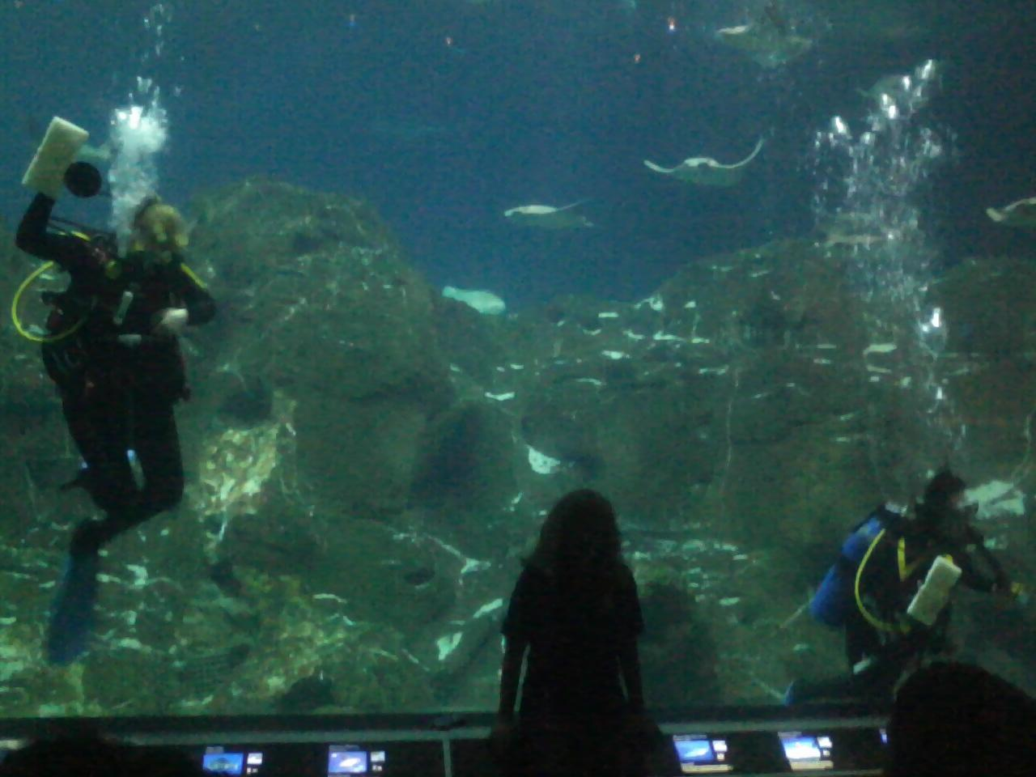

Tuesday
July 28, 2015

Host Organization | U.S. Environmental Protection Agency
Time | 8:45 a.m. – 3:00 p.m
Location | Edison New Jersey Environmental Center
Location Address | 2890 Woodbridge Ave.  Edison, NJ 08837-3679
Activity | Today we will be getting a tour of the EPA Region 2 offices, which includes a Green Parking Lot, Rain Gardens, the Regional Emergency Operations Center, and a Laboratory where they do chemical and microbiological testing to find pollutants in water, soil, or tissue samples. We may also enjoy a rare opportunity to meet the Region 2 Environmental Science and Assessment Director.
Notes | Please wear business casual attire: men please wear collared shirts, polo T’s OK, long dress pants, and dress shoes; women please dress appropriately and wear comfortable shoes for the tour.
Contact Person | Sabina Pendse (212-637-3574)
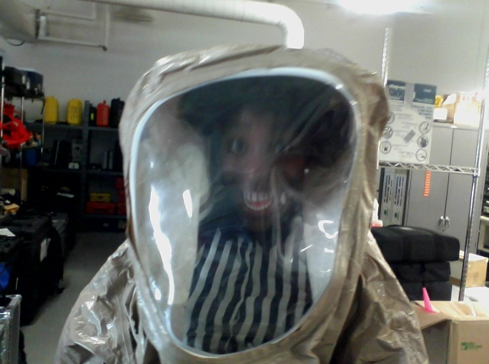

Wednesday
July 29, 2015

Host Organization | NJ Department of Environmental Protection
Time | 9:00 a.m. – 2:00 p.m
Location | Forest Resource Education Center
Location Address | 495 Don Conner Blvd  Jackson, New Jersey 08527
Activity | Today we will be visiting the Forest Resource Education Center. We will tour the state tree nursery and learn about forest ecology as we walk along one of the trails. We will meet a forester and learn the basics about forest management careers. Additionally, we will meet forest fire staff and learn about the equipment used for controlled burns and fighting fires.
Notes | Please wear clothing and shoes appropriate for hiking and exploring the forest.
Contact Person | Frank McLaughlin (609-633-8227)  Riche Outlaw (609-775-7455)  Forestry Center (732-928-0987)

Thursday
July 30, 2015

Host Organization | National Park Service
Time | 9:00 a.m. – 2:00 p.m
Location | Independence National Park
Location Address | Walnut Street between Front St and 2nd St, Philadelphia, PA
Activity | We will explore Independence National Park, home of the Liberty Bell, Independence Hall, and other historic sites from the American Revolution. A park ranger will guide us, enriching our tour historical and cultural significance. Additionally, we will learn about career opportunities at the park.
Notes
Contact Person | Sophie Sarkar (267-216-4218)  NPS Office (215-597-2136)
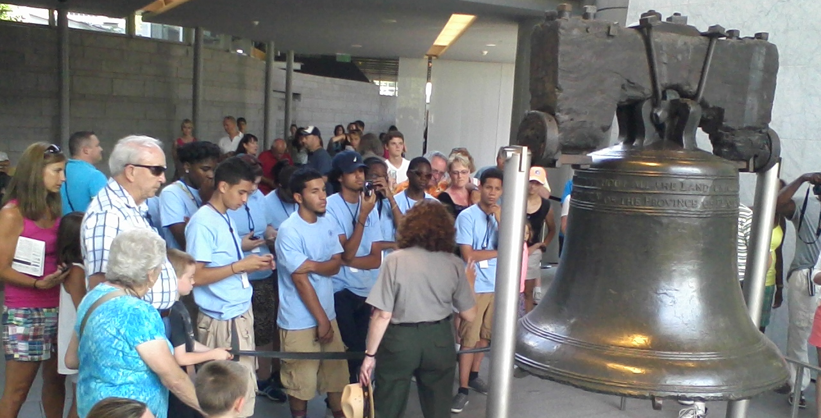

Friday
July 31, 2015

Host Organization | NJ Department of Environmental Protection
Time | 9:00 a.m. – 4:00 p.m.
Location | DEP Headquarters
Location Address | 401 E State St
Activity | The NJ DEP is a leader in the country for its pollution prevention efforts and innovative environmental management strategies. During our visit we will get a demonstration of the Geographical Information System tools that the DEP uses. We may be able to do a seek-and-find map activity using handheld GPS devices. At lunch we will meet some of the DEP Staff and discuss careers at the Department of Environmental Protection. After lunch we will drive to Ardent Parkway to visit the Radiology group and Geological Survey group to learn about underground water monitoring.
Notes | Business Casual Dress
Contact Person | Matt Bennett (856-345-9453)

Monday
August 3, 2015

Host Organization | Urban Promise Academy
Time | 9:00 a.m. – 2:00 p.m
Location | Urban Promise Campus
Location Address | 3700 Rudderow Avenue, Pennsauken, NJ
Activity | Vegetable and butterfly garden day:  We will work in the gardens and learn about insectary plants, growing food in the city, and why both can help Camden’s rise.​
Notes | Wear shoes and clothes you don’t mind getting soiled.
Contact Person | Rebecca Bryan (856-986-8594)

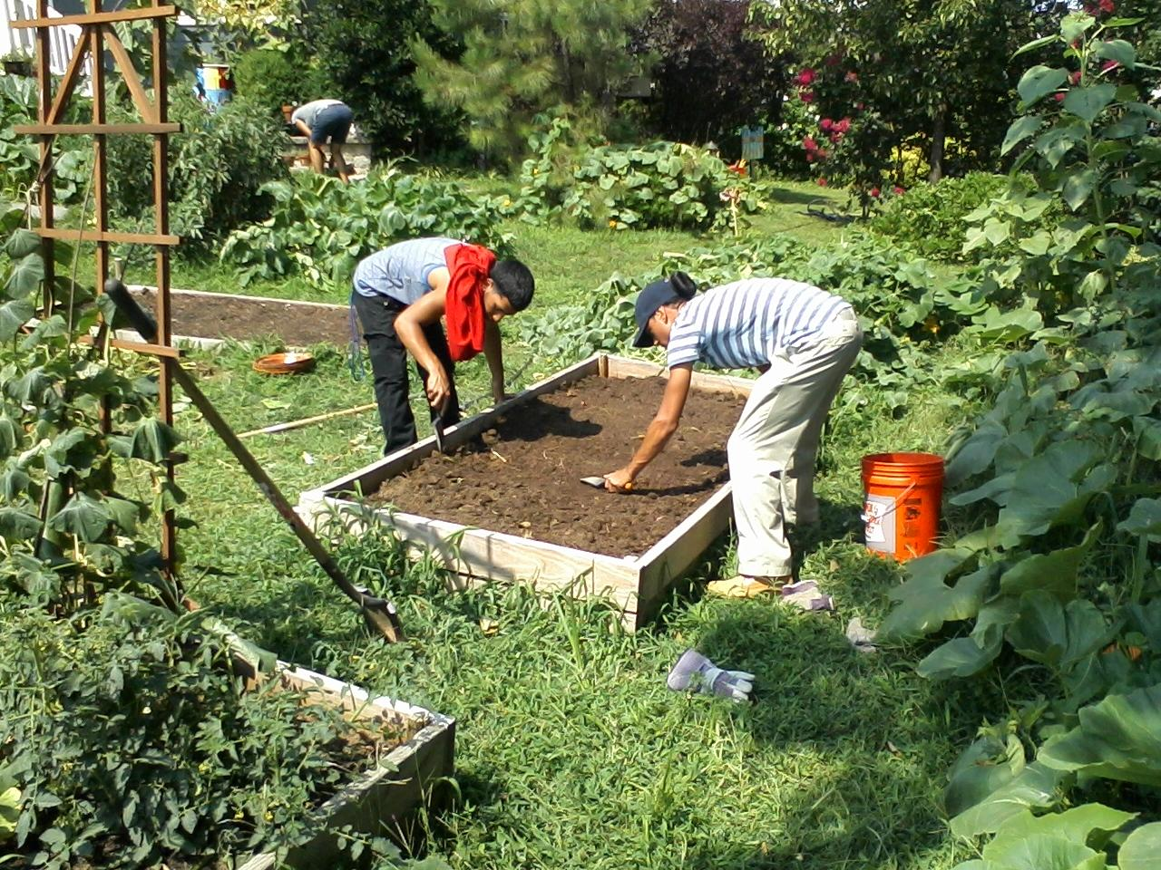

Tuesday
August 4, 2015

Host Organization | Camden County Environmental Center
Time | 9:00 a.m. – 2:00 p.m.
Location | Camden County Environmental Center
Location Address | 1301 Park Boulevard  Cherry Hill, NJ
Activity | Green Arts Development Day with Adviser Nathan Maruso, former Peace Corps Volunteer and Mentor to Youth in Philadelphia. Today, Donta Rose will lead us in reviewing our progress for the Camden Green Fair and 3-0n-3 Basketball Tournament. Adviser Nathan will present on his time in the Peace Corps in Kenya. James will lead us in a 20 minute dance workout and then we will prepare the courts and the grounds to look sharp for the big day tomorrow!
Notes | Wear clothes for gardening
Contact Person | Matt Bennett (856-345-9453)

Wednesday
August 5, 2015

Host Organization | Camden County Environmental Center
Time | 9:00 a.m. – 2:00 p.m.
Location | Camden County Environmental Center
Location Address | 1645 Ferry Ave
Activity | Camden Green Fair and 3-0n-3 Basketball Tournament.
Notes | Wear CCMUA Shirts
Contact Person | Matt Bennett (856-345-9453)

Thursday
August 6, 2015

Host Organization | Partnership for the Delaware Estuary
Time | 9:00 a.m. – 2:00 p.m
Location | Brandywine Creek State Park
Location Address | Thompsons Bridge Rd. parking lot  Wilmington, DE (van to follow Dee Ross)
Activity | Interns will participate in a fresh water mussel survey. Fresh water mussels play an important role in helping to filter and clean our rivers and streams. We will get to put on wading gear and go into the Brandywine Creek to seek out mussels living in the river-bottom! After lunch the group will head to the Alapocas ball field to do a clean up along the trails by the river.
Notes | You will get wet on this ride! Wear clothes and shoes okay to get muddy.
Contact Person | Dee Ross (610-299-6191)

Friday
August 7, 2015

Host Organization | CCMUA
Time | 9:00 a.m. – 2:00 p.m
Location | CCMUA
Location Address | 1645 Ferry Ave  Camden, NJ
Activity | Rain Date of 3-on-3 Basketball Tournament and Camden Green Fair. Otherwise today will be a Pizza Party and Slide Show Review of all the pictures we took this year! Optional basketball pick-up game afterwards.
Notes | Enjoy the rest of your Summer, aye?
Contact Person | Matt Bennett (856) 345-9453

