Link to Cranbury's Recycling Ordinance Chapter 120-Recycling; http://ecode360.com/6664280 whcih includes Enforcement and Violations/Penalties.

Below is a copy of the Recycling Ordinance:
Chapter 120:Recycling
[HISTORY: Adopted by the Township Committee of the Township of Cranbury 9-27-2010 by Ord. No. 09-10-14. Subsequent amendments noted where applicable.]

§ 120-4Recycling responsibilities.
Chapter 120:Recycling

§ 120-1Definitions.

§ 120-2Mandatory recycling items

§ 120-3Recycling requirements.

§ 120-4Recycling responsibilities.

§ 120-5Construction/demolition waste/recycling requirements.

§ 120-6Enforcement.

§ 120-7Violations and penalties.

§ 120-1Definitions.
As used in this chapter, the following terms shall have the meanings indicated:
AGREEMENT
The agreement between the municipality and the authority for the provision of recycling and marketing services.
ALUMINUM CANS
Food and beverage containers made entirely of aluminum.
AUTHORITY
The Middlesex County Improvement Authority, a public body corporate and politic of the State of New Jersey, organized by the County pursuant to the County Improvement Authorities Law (N.J.S.A. 40:37A-44 et seq.).
AUTHORITY-COLLECTED RECYCLABLES
The following designated recyclables generated within the geographic boundaries of the Township of Cranbury, which include newspaper, aluminum cans, glass and plastic containers, steel cans, corrugated cardboard, mixed paper and textiles.
BOARD
The Board of Chosen Freeholders of the County of Middlesex, New Jersey.
COMMENCEMENT DATE
The date upon which the Authority and the municipality agree that the Authority, through its contractor, will commence the provision of recycling services.
COMMINGLED CONTAINERS
Twenty-gallon plastic containers to be used by the residents to place plastic containers, glass containers, aluminum cans and steel cans at the curb for collection by the contractor, or such other container designated by the Authority for such use.
CONTRACTOR
The contractor selected by the Authority to provide the recycling services pursuant to the recycling contract.
CORRUGATED CARDBOARD
Boxes and packaging generally made from wood pulp and consisting of two smooth sides with a corrugated inner layer. Brown paper grocery bags are included.
COUNTY
The County of Middlesex, New Jersey.
COUNTY PLAN
The Middlesex County District Solid Waste Management Plan, adopted by the Board pursuant to the Solid Waste Management Act,^{[1]} which provides for the collection, disposal and/or recycling of solid waste generated with the geographic boundaries of the County, as the same may be amended from time to time.
COUNTY-WIDE RECYCLING PROGRAM
The collection and marketing program for Authority-collected recyclables established by the County and the Authority for all participating municipalities in the County and funded in part with RRIT funds allocated for this purpose.
DEP
The New Jersey Department of Environmental Protection or any successor agency.
DESIGNATED RECYCLABLES
All recyclable materials that are designated by the County in the County Plan as materials that must be source-separated from municipal solid waste at the point of generation. On the date of this chapter, the recyclables designated by the County in the County Plan are newspaper, aluminum cans, glass containers, corrugated cardboard, steel cans, plastic containers, mixed paper, textiles, leaves, motor oil and brush from residential and commercial sources. Amendments to this list include masonry/paving material, rechargeable batteries, tires and white goods from residential and commercial sources. Additional recyclables include electronics, fluorescent bulbs, plastic film and wood scraps from commercial, industrial and institutional, governments and office parks. The County may add or delete certain recyclable materials to designated recyclables from time to time pursuant to a duly adopted amendment to the County Plan approved by the DEP.
ELECTRONIC WASTE
Televisions, VCRs, computer equipment (including, but not limited to, CPUs, monitors, keyboards, scanners, modems, printers, and cables), laptops, telephones, irons, fluorescent lamps, fluorescent bulbs, compact fluorescent bulbs, and undamaged mercury-containing devices (including, but not limited to, thermostats and thermometers).
FLUORESCENT BULBS
Lamps that contain mercury.
GLASS CONTAINERS
All glass containers used for packaging food or beverages.
JUNE 2, 1994 AMENDMENT
The amendments to the County Plan (Nos. 1994-2 and 1994-3) adopted by the Board on June 2, 1994, that, among other things, established the County-Wide Recycling Program.
MASONRY/PAVING MATERIAL
Asphalt, block, brick, cinder, and concrete.
MAY 17, 2007 AMENDMENT
The amendment to the County Plan (No. 2006-2) adopted by the Board of Chosen Freeholders in December 2006 and certified by the NJDEP on May 17, 2007, for municipalities to update their recycling ordinances.
MIXED PAPER
Glossy inserts, magazines, telephone books, junk mail, colored paper, computer paper, office paper, paperboard (chipboard and pressboard), nonmetallic wrapping paper, softcover books, hardcover books with covers removed and fine paper.
MIXED PAPER CONTAINER
A covered eight-gallon container in which residents will place mixed paper at the curb for collection by the contractor, or such other container designated by the Authority for such purpose.
MOTOR OIL
A petroleum-based or synthetic oil whose use includes, but is not limited to, lubrication of internal combustion engines, which through use, storage or handling has become unsuitable for its original purpose due to the presence of impurities or less of original properties.
MUNICIPALITY
The Township of Cranbury, a municipal corporation of the State of New Jersey.
MUNICIPAL SOLID WASTE
I.D. Type 10 Waste as defined by N.J.A.C. 7:26-2.13(g)(l)(i).
NEWSPAPER
Paper of the type commonly referred to as "newsprint" and distributed at stated intervals, usually daily or weekly, having printed thereon news and opinions and containing advertisements and other matters of public interest.
PLASTIC CONTAINERS
Soda bottles made of PETE (SRI code No. 1) and milk, water and laundry product bottles made of HDPE (SPI code No. 2).
PLASTIC FILM
Stretch/shrink wrap, plastic shopping bags; only for warehouses, retail establishments and supermarkets with 25 or more employees.
RECHARGEABLE BATTERIES
Nickel cadmium (Ni-Cd), nickel metal hydride (Ni-MH), lithium ion (Li-ion) and small sealed lead (Pb).
RECYCLING ORDINANCE
Chapter 120, §§ 120-1 through 120-7 of the Code of the Township of Cranbury, the ordinance enacted by the municipality establishing the mandatory municipal recycling program implemented in accordance with the Solid Waste Management Act and the County Plan, as the same will be amended by the municipality to include the additional designated recyclables as set forth in § 120-2, and as the same may be amended in the future from time to time for other purposes.
RECYCLING SERVICES
All of the duties, obligations, and services to be provided by the contractor that are related to the collection, transportation, separation, processing, storage, sale or disposition, or any combination thereof, of the Authority-collected recyclables and the return of same to the economic mainstream in the form of raw materials or products.
RESIDENTS
Private, commercial and institutional residents of the municipality that are required to recycle designated recyclables pursuant to the Recycling Ordinance.
STEEL CANS
Tin-plated, bi-metal and other ferrous food and beverage containers.
TEXTILES
Clean, dry clothing or other fabric measuring at least one foot by one foot in size.
TEXTILE BAG
A special bag to be provided by the Authority for the collection for textiles, or such other container to be designated by the Authority for such purpose.
TIRES
Rubber-based scrap automotive, truck, and equipment tires.
WHITE GOODS
Washers, dryers, ranges, refrigerators, air conditioners, outside grills (including gas tanks for grills), water heater tanks, freezers, stoves/ovens, dishwashers, metal storm doors (without glass window inserts), humidifiers/dehumidifiers, water coolers, metal sinks, and residential kitchen exhaust fans. The preceding list of white goods is not exhaustive; should a question arise concerning whether an item is considered a white good, residents should contact the Department of Public Works for clarification. [NOTE: All devices that contain CFCs must be properly evacuated by licensed individuals prior to disposal with the Township, and all CFCs recovered must be sent to an EPA-approved reclaimer.]
WOOD SCRAPS
Unfinished lumber from new construction projects, including pallets. "Unfinished" shall mean non-chemically-treated (not pressure treated, impregnated with preservatives, insecticides, fungicides, creosote, or other chemicals, and not painted, resin-coated or otherwise surface treated, and not laminated or bonded; and not similarly altered from its natural condition). Only for new construction sites.
[1]
Editor's Note: See N.J.S.A. 13:1E-1 et seq.

§ 120-2Mandatory recycling items
A. All residents, commercial, industrial and institutional, governments and office parks of Cranbury Township shall recycle, or cause to be recycled, the following categories of recyclables:
(1) Newspaper.
(2) Aluminum cans.
(3) Glass containers.
(4) Plastic containers.
(5) Steel cans.
(6) Corrugated cardboard.
(7) Mixed paper.
(8) Textiles.
(9) Motor oil.
(10) Leaves.
(11) Brush.
(12) Masonry/paving material.
(13) Rechargeable batteries.
(14) Tires.
(15) White goods.
(16)Electronic waste.
B. All commercial, industrial and institutional, governments and office parks shall additionally recycle, or cause to be recycled, the following categories of recyclables:
(1) Plastic film.
(2) Wood scraps.

§ 120-3Recycling requirements.
Pursuant to the Recycling Act, each resident, commercial, industrial and institutional, government and office park of Cranbury Township shall be required to comply with the recycling plan of Cranbury Township. This plan incorporates the Middlesex County Recycling Plan to meet the state-mandated recycling goals. To effectuate and implement the Township Recycling Plan, it is hereby required that:
A. The Township of Cranbury hereby adopts this chapter to provide for recycling within its borders pursuant to the Recycling Act adopting herein the Middlesex County Recycling Plan as its official municipal recycling program; and
B. All residential and commercial contracts for solid waste collection and/or disposal within Cranbury Township shall be consistent with this chapter and the Middlesex County Recycling Plan.
C. The Township of Cranbury shall provide for a collection system of leaves generated from residential premises and require that persons occupying residential premises within these municipal boundaries shall source-separate leaves from solid waste generated at those premises and, unless leaves are stored or recycled for composting or mulching by the generator, place the leaves for collection in the manner provided in § 69C, Code of the Township of Cranbury.
D. The Township of Cranbury shall, at a minimum, within 30 days after the adoption of this chapter and at least once every six months thereafter, notify all persons occupying residential, commercial, industrial and institutional, government and office park premises within these municipal boundaries of recycling opportunities and the source-separation requirements of its ordinance and the Middlesex County Recycling Plan. In order to fulfill the notification requirements of this subsection, this municipality may, in its discretion, place an advertisement in a newspaper circulating in the municipality, post a notice in public places where public notices are customarily posted, include a notice with other official notifications periodically mailed to residential taxpayers, or any combination thereof, as the municipality deems necessary and appropriate.
E. The Township of Cranbury shall prepare and distribute additional literature and other educational materials describing, among other things:
(1) The municipal recycling program established pursuant to the Recycling Ordinance;
(2) The County-Wide Recycling Program and the recycling services to be provided within the geographic boundaries of the municipality;
(3) The designated recyclables to be source-separated;
(4) The manner or method of preparing source-separated material for collection; and
(5) The location and schedules for collection. All such literature and other educational materials shall be prepared in accordance with written guidelines established by the Authority and shall be approved by the Authority prior to distribution.
F. On the commencement date, the Authority will cause the contractor to commence the provision of recycling services for the Authority-collected recyclables for all residents. The Authority-collected recyclables shall be collected by the contractor at curbside at:
(1) All single-family or duplex residential locations.
(2)All multifamily dwellings with four or less units, and all small businesses. All multifamily dwellings with five or more units, schools, public buildings, hospitals, and other institutions shall deposit the Authority-collected recyclables in on-site containers to be provided by the contractor.
G. The contractor shall collect Authority-collected recyclables on a biweekly basis. Collections will occur Monday through Friday and, at the contractor's option, on Saturday, except for legal holidays, between the hours of 7:00 a.m. and 6:00 p.m.
H. At the time of placement of recyclable materials designated for collection by the recycling plan of the Township of Cranbury at the curb or street side of residential units, said materials shall be considered the sole property of the Middlesex County Improvement Authority and shall be considered a conscious contribution by that resident to the County Recycling System for collection by the Middlesex County Improvement Authority or its agent.

§ 120-4Recycling responsibilities.
A. The contractor will be responsible for the collection at the curbside only for Authority-collected recyclables that have been separated and prepared for collection as noted in § 120-4B(1).

B. Residents must separate, prepare items as follows:
(1) Recyclables.
(a) Corrugated cardboard must be placed at the curb in segregated, twine-tied bundles (no wire) no greater than 12 inches in height.
(b) Mixed paper, including office paper, Kraft bags and newspaper, must be placed at the curb in the mixed paper container.
(c) Glass containers, aluminum, cans, plastic containers and steel cans shall be commingled in a commingled container.
(d) Textiles shall be segregated in the textile bag.
(e) Any Authority-collected recyclables that are not prepared for collection in this manner will be left at the curb by the contractor.

C. White goods and electronic waste recycling. White goods and electronic waste shall be recycled in the township by one of the following means:
(1) A scheduled curbside pickup of white goods and electronic waste by the Department of Public Works. Curbside pickup shall occur once a month on a date set by the Department of Public Works. Residents shall be responsible to contact the Department of Public Works to schedule the curbside pickup. There shall be a per-item fee of $10 for curbside pickup, which shall be paid to the Township of Cranbury by the resident prior to pickup.
(2) Delivery of white goods and electronic waste by residents to a facility designated by the Department of Public Works during a time and date as determined by the Department of Public Works. There shall be no charge to the resident for the delivery of white goods and electronic waste.

§ 120-5Construction/demolition waste/recycling requirements.

A. Pursuant to Plan Amendment 2006-2, at the time of issuance of any building permit, the building code official will provide written instruction on proper disposal and recycling of construction and demolition waste and furnish a Notification of Construction/Demolition Activity Form that must be filled out by the permitted and faxed to the Middlesex County Division of Solid Waste Management (MCDSWM) within 48 hours of issuance of a municipal permit. The following mandatory materials must be kept separate from the garbage and recycled by any construction/demolition site with Middlesex County:
(1) Corrugated cardboard.
(2) Masonry/paving materials (including concrete, asphalt, brick, block and cinder).
(3) Wood scraps (for new construction sites only).
(4) Tires.
(5) Paper (newspaper and mixed paper).
(6) Bottles and cans (glass, aluminum, steel and plastic).
(7) Leaves and brush.
(8) White goods (washers, dryers, ranges, refrigerators, and air conditioners).
(9) Fluorescent bulbs, computers and televisions.

B. All waste materials must be brought to a licensed solid waste facility. All recyclables must be brought to a permitted recycling facility. Recycling must be in place on site throughout the entire construction phase.

§ 120-6Enforcement.
The enforcement of the Recycling Plan of the Township of Cranbury shall be provided individually and severally by the Township of Cranbury with regard to enforcement of this chapter and/or Middlesex County Improvement Authority, and/or the New Jersey Department of Environmental Protection.

§ 120-7Violations and penalties.
Any resident or small business of the Township of Cranbury who is found to have violated the provisions of the chapter shall be subject to the following procedures and penalties:
A. A warning on the first three occasions that said chapter is violated; and thereafter
B. A fine of up to $500 per day of violation depending upon the extent of and circumstances of the violation to be assessed pursuant to N.J.S.A. 13:1E-9 by the Middlesex County Improvement Authority, as authorized hereby and pursuant to the inclusion of the section within the Middlesex County Solid Waste Management Plan.

Here is the link for Accepted Materials Recycling Flyer: http://www.mciauth.com/curbside/CRANBURY%20Recycling%20Brochure%202016%20Blue.pdf

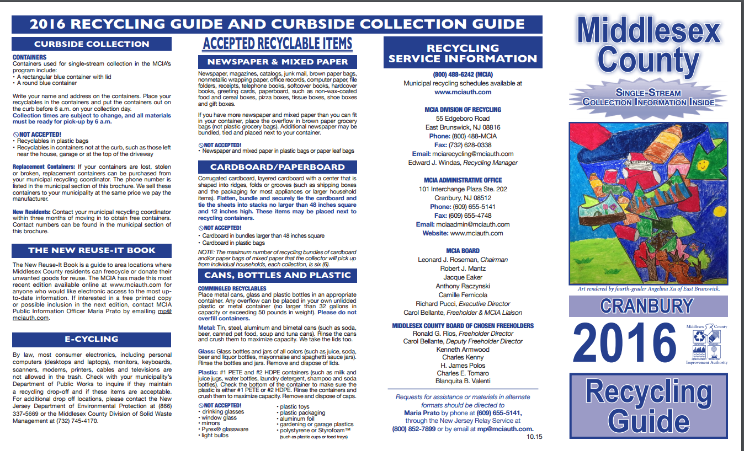

Here is the link for the township newsletter on recycling article on page 14; http://www.cranburytownship.org/newsletters/2nd-Quarter-2016-Newsletter.pdf and also to the Cranbury Twp recycling webpage
http://www.cranburytownship.org/recycling_main.html

Page 14 of 2nd Quarter Cranbury Township Newsletter: Recycling Article

