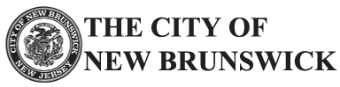

Navigation
NBPD Installs New “Project Medicine Drop” Box To
Help Residents Dispose of Unused Medications and

Prevent Prescription Drug Abuse
by Jbradshaw on August 15, 2016 in All Posts, News, Press, Public Safety
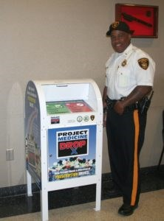
Lt. Raymond Trigg of the NBPD stands
next to the department’s new Project
Medicine Drop box, located in the lobby of
police headquarters, 25 Kirkpatrick Street.
The New Brunswick Police Department is pleased to announce its participation in Project Medicine Drop, an important component of the New Jersey Attorney General’s effort to stop the diversion and abuse of prescription drugs, including highly addictive opiate painkillers.
Through this initiative, the State Division of Consumer Affairs installs secure “prescription drug drop boxes” at police departments, sheriff’s offices, and State Police barracks across New Jersey, allowing citizens to safely dispose of their unused, excess, or expired prescription medications.
Members of the public are invited to visit Project Medicine Drop sites and drop off any unused prescription medications anonymously and with no questions asked. Most Project Medicine Drop sites make this service available 24 hours a day, seven days a week, 365 days a year.
Translate »
The New Brunswick Police Department has conveniently located a drop box inside the main entrance of police headquarters located at 25 Kirkpatrick Street.
“The New Brunswick Police Department had dedicated its resources to bring about positive progress in our State’s fight against substance abuse,” said Police Director Anthony A. Caputo. “This initiative is an important component of New Jersey’s effort to halt the diversion and abuse of prescription drugs.”
By giving New Jerseyans a safe and secure method to dispose of unneeded medications, Project Medicine Drop helps prevent the abuse of these drugs. This initiative also protects New Jersey’s environment by keeping these drugs out of landfills and out of the water supply.
More information about Project Medicine Drop, including the full list of Project Medicine Drop locations, can be found at www.NJConsumerAffairs.gov/meddrop.
About jbradshaw
Public Information Officer for the City of New Brunswick. 732­745­5004.
View all posts by jbradshaw
→
 New Brunswick Police Department, Project Medicine Drop  Another Group Goes Green!

62
nd Mayor of New Brunswick
James Cahill
How can we help you?
Translate »
Contact My Office
Message from the Mayor
Need a Number?

Telephone Numbers for New Brunswick Municipal Offices
Hub City Monthly Videos

What's Happening in the Hub City? Check out our monthly video blog of news and events in New Brunswick
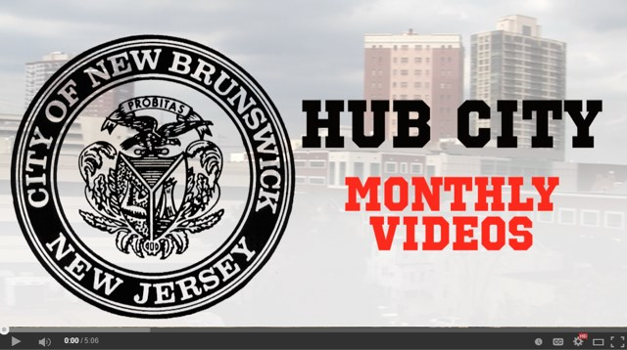
Community Calendar

 |  |  |  | « |  | SEP 2016 |  | »
S |  |  | M | T |  | W |  | T |  | F |  | S
28 |  |  | 29 | 30 |  | 31 |  | 1 |  | 2 |  | 3
 | 4  11  18  25 | 5  12  19  26 |  |  | 6  13  20  27 |  | 7  14  21  28 |  | 8  15  22  29 |  | 9  16  23  30 |  | 10  17  24  1
 | Popular Posts
Celebrate Independence Day in New Brunswick!
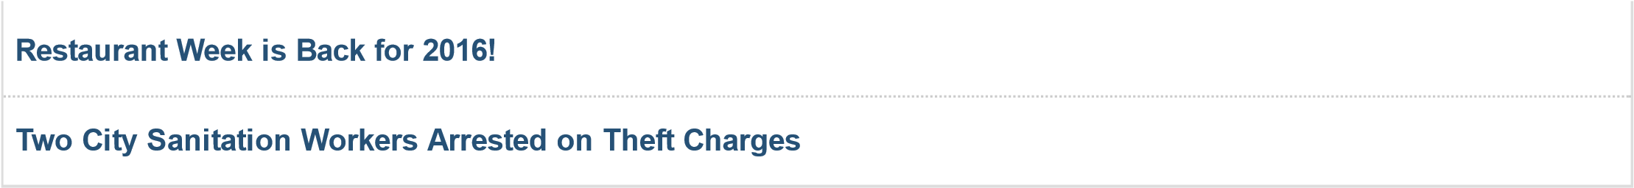
Translate:
Select Language
Powered by
Translate
Search...

Information on Ongoing Revaluation in the City of New Brunswick

More Info!
Paid Sick/Safe Time Notice

Paid sick/safe leave is now a law in the City of New Brunswick. Please click the link below for more information on this ordinance. 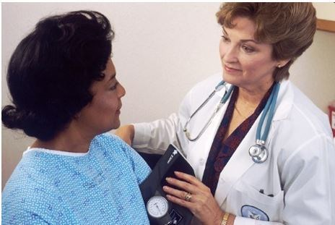
More Info!
Residential Recycling & Trash Collection Info.

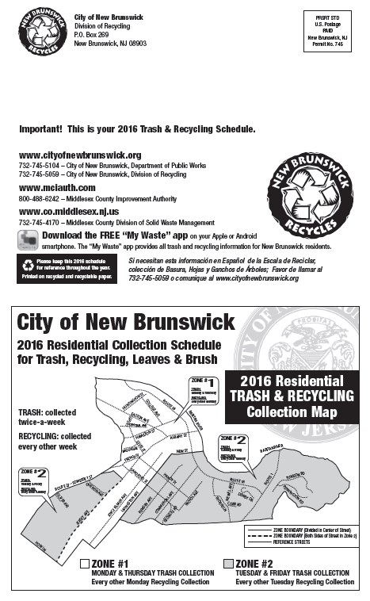
Trash and recycling guides for 2016 are now available!
City Hall, 78 Bayard Street, New Brunswick, NJ 08901­0269. © 2016 The City of New Brunswick. All Rights Reserved.

