Green Festival
Green Festival - 8th Annual!
April 16, 2016 - 9 a.m. to 2 p.m. along Irvin Ave.
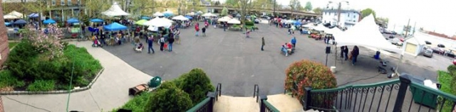
*Please stay tuned for more information as we are working on the details, thank you!*
Celebrate spring and all things green by joining your friends and neighbors at Collingswood’s eighth annual Green Festival, located just off Haddon Avenue on Irvin Avenue near the PATCO High Speed line.
At the festival, we invite you to explore the following:
-Local sustainable food, organic gardening, water conservation, renewable energy, environmentally-friendly construction, and more
-Learn about smart green living from local activists and experts
-Enjoy al fresco dining from local restaurants while enjoying live music
-Learn about local activity involving nearby Newton Creek and our area’s own old growth forest, Saddler’s Woods
-Buy shade trees, backyard composters, and rain barrels at low, subsidized prices
-Buy produce and products from local farmers and specialty organic vendors
-Buy objects d'art made from recycled materials by local artisans
Get an idea of what to look forward to by checking out last year’s Facebook page and viewing a video from the first-ever Green Festival produced by Collingswood TV.
Green Festival activities will include:
-Special presentations and exhibits from experts and environmental advocates.
-Activities for kids: Fun Zone including face-painting, sidewalk chalk drawing, games, arts and crafts, and more in the area behind the Old Zane School (Kitchen & Associates).
-Bike Share and Bike Rodeo: At the Bike Share tent learn to tune up your bike from mechanic volunteers and sign up for the Bike Share program (a mere $25 to rent a bike for one year). The nearby bike rodeo area offers a series of fun bike-centric activities for kids and their bikes.
Green Festival on-site recycling:
-Paper shredding: Free paper shredding will be available from 10am to 1pm under the Speedline.
-Electronics recycling drop off: Bring any electronic item that can be recycled or refurbished - old TVs, monitors, laptops, radios, FAX machines, keyboards, DVD players, stereo equipment, typewriters, VCRs, scanners, printers. Drop off between 9am and 2pm in designate area. Note: don’t bring disassembled or broken equipment that cannot be reused.
-Household hazardous waste collection - courtesy of Camden County: For drop off, drive or walk up to the Collingswood public works garage (adjacent to the Green Festival) at 713 N. Atlantic Ave. between 8:30 am and 3:00 pm. Click to learn more about what is acceptable for drop off.
Join us!
Interested vendors and volunteers may call Commissioner Leonard at 856-858-4545 or email jleonard@collingswood.com.
Note: this information is preliminary and subject to change – please refer back to this page for updates.

From the Collingswood website: http://www.collingswood.com/arts/greenfestival

