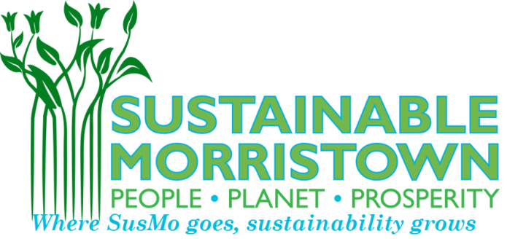
Festival Earth 2017 Participant agreement
www.sustainablemorristown.org
Thank you for your crucial support of Morristown’s sustainability! We look forward to your participation in Festival Earth, being held on Saturday, May 6, 2017 from 11am to 2pm. The event will take place *rain or shine* at the Vail Mansion Lawn, located at 110 South Street, Morristown.
To ensure that the fair runs smoothly, maintains environmental integrity, and is an overall success, we ask you to comply with the following rules:
- Vendors must be set up and operational by 10:30 am on the day of the event. Exhibitors are required to "man" their booths for the entire duration of the event. Vendors may begin setting up at as early as 9:00 am. You will be able to pull your car around to unload and load your materials at your table.
- If cancellation is necessary, vendors and/or participants must provide immediate notice Sustainable Morristown (prior to May 3rd).
- The Festival Earth Committee & the Town of Morristown shall not be held liable for any damages and/or injuries incurred by any exhibitor/vendor/participant/organization while on the fair site.
- GREENING OUR GREEN FAIR: One of our missions is to run a carbon-neutral, nearly zero-waste event. We ask you to comply with the following: Do not bring anything to the fair that is not recyclable. For example, anything such as balloons, Styrofoam, plastic utensils, etc. are prohibited. Please refrain from use of plastic as much as possible. Try to avoid generating electricity where possible. ALL VENDORS SELLING PRODUCTS AT THE FAIR MUST USE MINIMAL, ENVIRONMENTALLY RESPONSIBLE PACKAGING. PAPER BAGS FOR ALL PURCHASES WHERE A REUSABLE BAG IS NOT PROVIDED. VENDORS SHOULD OPT 100% RECYCLED PAPER FOR HANDOUTS AND TO RESERVE HANDOUTS FOR CONSUMERS SERIOUSLY INTERESTED IN THEIR PRODUCT OR SERVICE.
- We want to encourage education, wellness, shopping local, bicycling, walking, and environmental efforts like re-use, limiting plastic bags, anti-idling efforts, and composting using our composting areas – there will be people providing direction on what you can compost and recycle.
- Participation fees will not be refunded to vendors and/or participants who cancel due to rain. The event will be held rain or shine. It will only be canceled due to SEVERE weather being forecasted – we will notify you via phone and email in the case of severe weather.
Please direct all inquiries & questions to: lauren@sustainablemorristown.org

