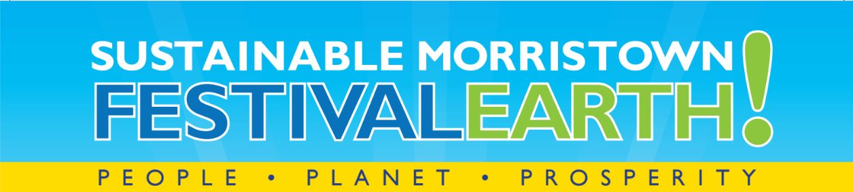

About Sustainable Morristown:

- Sustainable Morristown mission: Promoting and supporting a sustainable future for the Morristown community through leadership, education, and action.
- Our vision is of a community-wide collaboration working together to ensure the economic, environmental and social well-being of Morristown residents, visitors, and future generations.
- Website and social media:
  - Website: www.sustainablemorristown.org
  - Facebook: https://www.facebook.com/sustainablemorristown
- We are a Division of Sustainable Jersey: http://www.sustainablejersey.com/

Festival Earth Sponsorship Details:

- Date and Time:
  - Saturday, May 6th, 2017
  - 11am – 2 pm

- Location:
  - The grounds of the Vail Mansion, 110 South Street, Morristown, NJ

- Web details:
  - http://sustainablemorristown.org

- Audience:
  - Festival Earth draws attendees from the greater Morristown area and includes families, business owners, non-profits, institutions, and local officials. Many of the attendees are mission committed and are affluent and college educated. We will also target people who are less informed about sustainability practices and are interested in taking some initial steps.

- Partner Status:
  - We offer Partner Status for a limited number of companies providing value-in-kind for the event. This includes:
  - Earth, Wind, and Fire Sustainable Participation Levels (See Invitation details)
- Exhibit space, table and chairs
- Listing on flyers, event banner, Facebook page, Sustainable Morristown website event page, etc. as detailed on invitation form.

- Sponsorship Deadline:
  - April 1st is encouraged to maximize promotional opportunities: we will begin daily event promotion beginning on Earth Day, Friday, April 14th and running through Earth Day (April 22) and through the event.
  - April 10th - final deadline

- Event overview:
  - Earth Day is not the only time to celebrate the planet. Festival Earth is a collaboration of area corporations, local businesses, nonprofit organizations, governmental agencies, and schools to promote the people, planet, and prosperity of the Morristown community.
  - We are receiving an interesting group of participants, exhibitors, and vendors. Past years have included:
Sustainable Living Expo, Presentation Stage, Arts Showcase, Farmers’ Market, Hybrid – Electric Auto Show, Healthy Foods Pavilion, Valet Bike Parking, and much more. The Sustainable Living Expo featured vendors and exhibits ranging from hydroponic gardens to solar energy and holistic wellness. Dozens of booths will be set up this year around the Vail Mansion Green to showcase things like sustainable agriculture, food, transportation, wellness, and energy solutions, and electric cars.
  - Festival Earth will be a near-zero waste event, including compost and recycling stations.
  - We encourage all exhibitors to include an interactive component at their booth.

- Event Marketing:
  - We will run marketing from April 10 until after the Festival. The marketing plan includes daily Facebook/Twitter posting (using hashtag #FestivalEarth), along with e-blasts, flyers, online calendar listings, and a media partnership.
  - For Sponsor details:
    - Lauren Cranmer, Board President, Sustainable Morristown
    - lauren@sustainablemorristown.org
    - 856-912-6586
or
    - Your Sustainable Morristown contact

