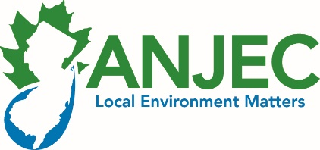
2016 Open Space Stewardship Project
GRANT AWARD OFFER/NOTIFICATION 5/12/16

To: Ann Marchioni, Caldwell Environmental Commission (Essex Co.)
From: Elizabeth Ritter, Deputy Director eritter@anjec.org
Re: Understanding Open Space and Pollinator Gardens

Congratulations! ANJEC has selected your project for a grant of $1500. If your Environmental Commission accepts this grant and commits to provide all of the inputs, tasks, and deliverables contained in the proposal you submitted to our office, please sign, scan and return this form to eritter@anjec.org (or fax to 973-539-7713).
This document and your grant application will serve as the grant agreement.

This is a 1-year grant. Projects must be completed by May 31, 2017. Two thirds of ANJEC’s contribution will be mailed to you at the municipal address when we receive this signed agreement. ANJEC will remit the balance when the environmental commission has completed all tasks and deliverables, and submitted documentation to ANJEC. Be sure to maintain records (vouchers) of project expenditures, in-kind labor, outreach materials and activities; you will need them to obtain your final payment. ANJEC will reimburse budgeted project expenses that have been paid out by the municipality through a signed voucher(s), up to the amount of the grant. ANJEC reserves the right to withdraw financial support if the project does not maintain progress or falls significantly behind schedule.

Please note that brief progress reports are mandatory and due at ANJEC via e-mail on September 7, 2016 and January 11, 2017 to eritter@anjec.org. ANJEC will provide a format for the reports. We ask that you invite ANJEC to the kickoff and all public events related to the project so that we can send a staff member to attend if one is available. Signage or documents produced with grant funding should display the ANJEC logo & tagline.

Direct outreach to inform and engage residents about your project and raise the profile of the environmental commission in the community is a required element of this grant. Please remember to take photographs as the project progresses. Each project must submit at least 5 photos, and copies of outreach materials (postings, press/newsletter articles, flyers, brochures, etc.). ANJEC may use these for education and outreach efforts.

We the undersigned members of the Environmental Commission accept this grant under the terms described above. We will insure that all tasks, inputs and deliverables are completed by May 31, 2017, will submit quarterly reports, and will submit final documentation to ANJEC by June 15, 2017 to request reimbursement.

____________________________________________ ______________________________
Environmental Commission Co- Chairperson - name e-mail address
___________________________________________ ______________________________
Signature day phone or cell

____________________________________________ ______________________________
Environmental Commission Co-Chairperson - name e-mail address
____________________________________________ ______________________________
Signature day phone or cell

Assn. of NJ Environmental Commissions (ANJEC) PO Box 157, Mendham, NJ 07945 973-539-7547

