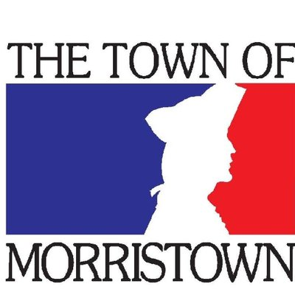
Animal Census Totals
2016-2017
- Dogs: 628
- Cats: 154
2015-2016
- Dogs: 615
- Cats: 167
2014-2015 (hang tag and education efforts)
- Dogs: 579
- Cats: 105

Contact: Samantha Judson
Animal Control/Cruelty Investigator
Town of Morristown
(973)292-6731

