Why Buy Fresh, Buy Local?
Great taste and freshness help strengthen the local economy support family farms safeguard your family’s health and protect the environment
Locally grown foods reduce the community’s carbon footprint, improve access to fresh local foods, improve the community’s social fabric by creating gathering places focusing on food, and can increase consumption of fruits and vegetables by improving access to healthy food.
Buying local food keeps farms and commercial gardens profitable by keeping food dollars local and re-circulating money spent on food in the local economy.
Here is a list of Farm Stands/Restaurants that use local agriculture and groceries that sell NJ produce in Morristown.
- Grow it Green Farm Stand
- Morristown Farmer’s Market
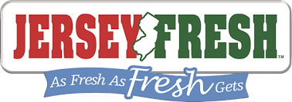
- Winter Farmer’s Market
- Kings Grocery Store
- Whole Foods Grocery Store
- Green Life Natural Market Morristown
- Wightman’s Farm
- Urban Table
- Town Restaurant
- Harvest Restaurant

