Smoke-Free and Tobacco-Free Public Places, Non-Expiring, Points: 10
- Narrative Summary
In November 2013, the mayor of Madison signed Ordinance 46-2013 to prohibit smoking in public parks and recreational areas. The ordinance was reported on by the Madison Eagle and Madison Patch and a video of its passage remains on the Patch web site. Signage in support of the ordinance has been installed in Madison parks. Karen Blumenfeld, executive director of Global Advisors for Smokefree Policy (GASP), a tobacco control non-profit located in Summit, New Jersey, was instrumental in providing information and support for the ordinance.
- Signed and Date Ordinance
Ordinance posted on the Madison Borough website: http://www.rosenet.org/ArchiveCenter/ViewFile/Item/282
- Evidence that the Ordinance was Implemented
Madison Patch article, “ ‘100 Percent Smoke-Free’ Parks New Law in Madison,” November 22, 2013, http://patch.com/new-jersey/madison/100-percent-smokefree-parks-new-law-in-madison (includes video of ordinance passing and comments made in town meeting)
Madison Eagle article, “Puffing away at public places in Madison is now against the law,” 22 November, 2013, http://www.newjerseyhills.com/madison_eagle/news/puffing-away-at-public-places-in-madison-is-now-against/article_4d6b8dd2-529b-11e3-a379-001a4bcf887a.html (also hosted on NJGASP website: http://www.njgasp.org/wp-content/uploads/2014/06/MadisonEagle_sf_parks_11-22-13.pdf)
- Education & Outreach Materials:
After the resolution was passed, signs were posted at all parks including playgrounds, ball fields, or recreation areas. Playgrounds include: Dodge Field, Delbarton, and Lucy D. Anthony.
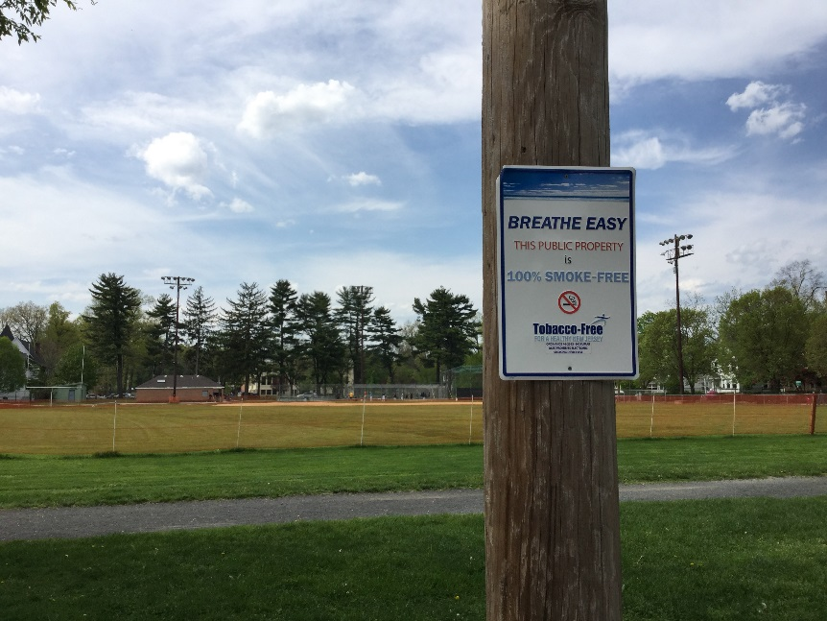 | 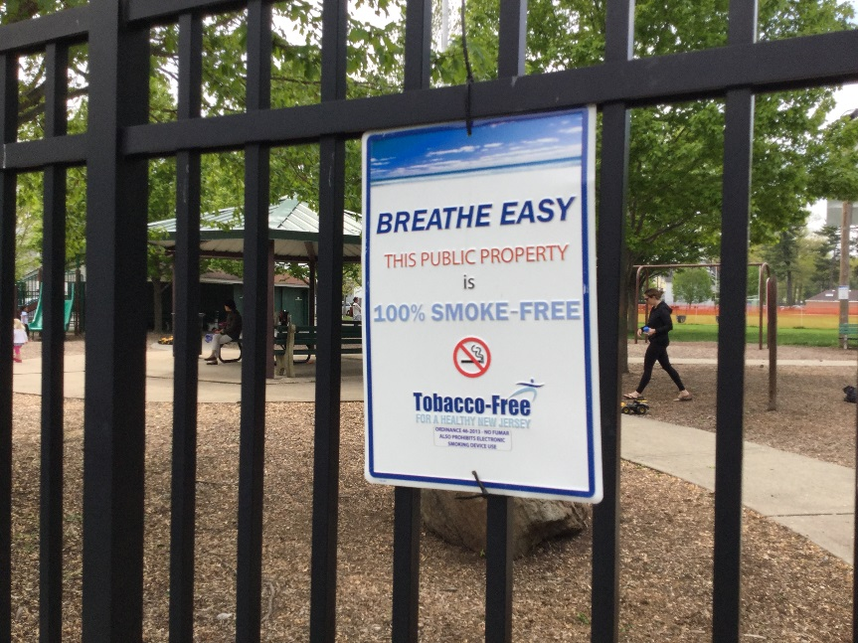
Photos: Recreation space, Dodge Field, and at Playground Entrance, Dodge Field, Madison, New Jersey (date: 9 May 2016).

